|  |
| --- |
| Bournemouth School: 55119  James Cocker - Student  6029 |

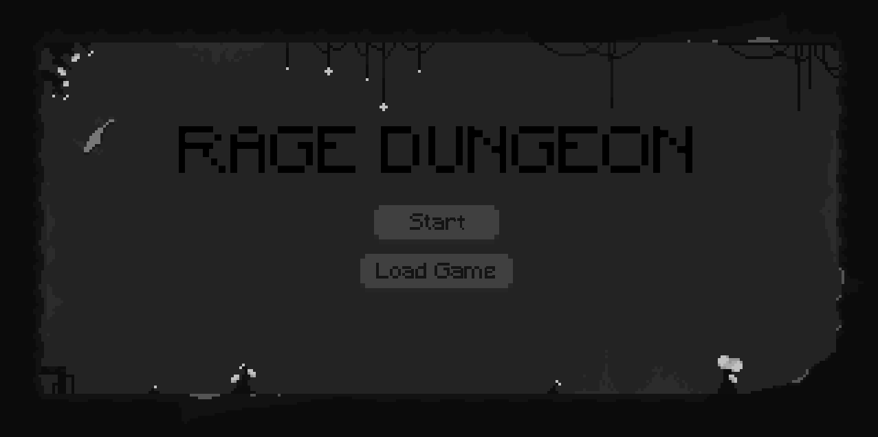

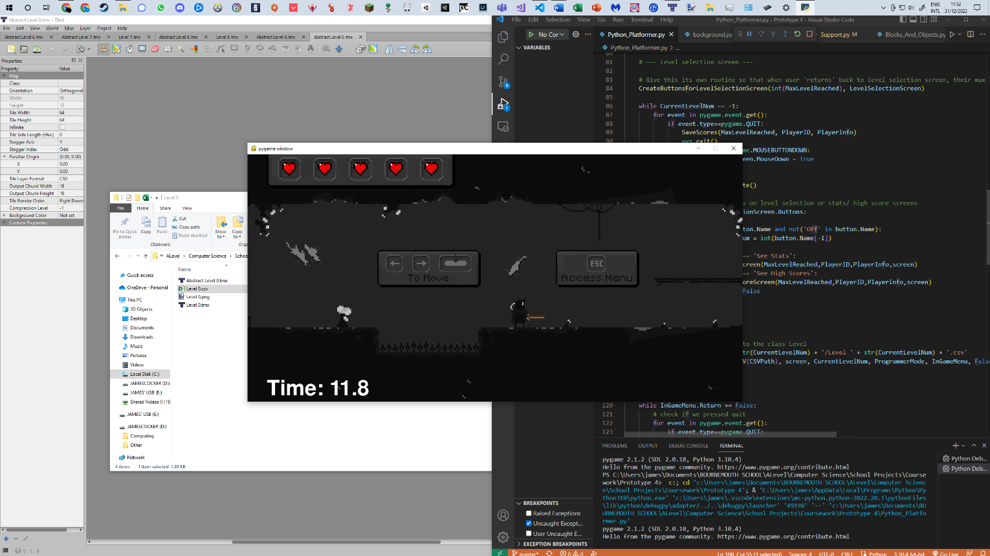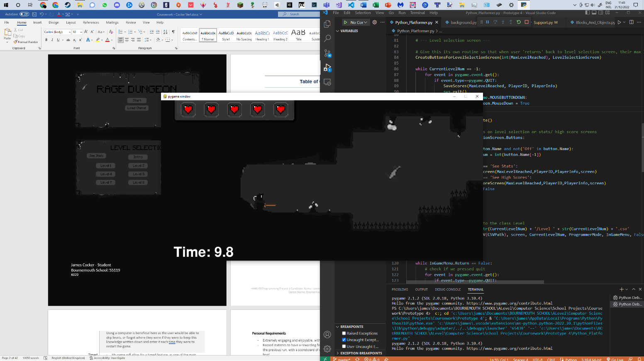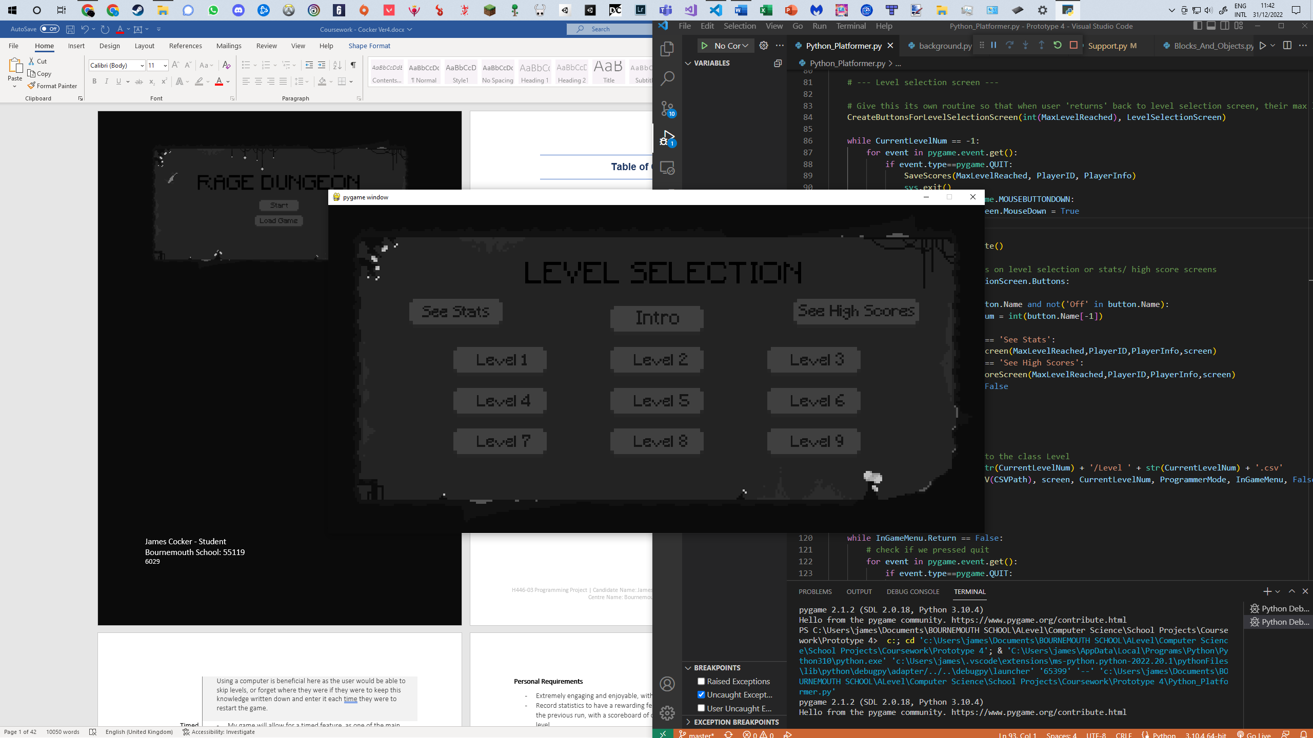

**Table of Contents**

*Analysis*

My Project 2

Features Suitable for Computational Methods 2

My Stakeholders 3

Existing Solutions 5

Proposed Solution 15

Design

Decomposition 28

Structure of the Solution 30

Algorithms and Dry Runs 32

Usability Features 43

Key Classes and Variables 44

In-Development Test Data 51

Post-Development Test Data 54

Development

Prototype 1 – Scrolling Tiles 57

Prototype 2 – Implementing Player 60

Prototype 3 – Block Types and Background 69

Prototype 4 – Animated Objects, UI, Blinding Spider 84

Prototype 5 – Level design, Level Selection Menus, Scoring System, Wheel Bot, Player Abilities 98

Code Listing 113

*Evaluation*

Post Development Testing 155

Usability Testing 163

Evaluation of Success Criteria 167

Addressing Unmet Success Criteria 171

Addressing Unmet Usability Features 173

Maintenance of the Solution 173

Limitations of the Solution 174

Conclusion 174

Future Development Summary 175

*Bibliography*

Bibliography 176

**ANALYSIS**

# **My Project**

My project will be to design a sleek, physics-based 2D platformer - without a game engine - using just the libraries in Pygame. It will be used to create an engaging game by allowing the user to build up interesting skills, combine them to create challenging puzzles and stringing it all together to seize the attention of a wide array of clients and get them to thoroughly enjoy their spare time.

# **Features Suitable for Computational Methods**

|  |  |
| --- | --- |
| **Feature** | **Justification** |
| Real-Time Physics | * My game will need to analyse collisions, jumping, projectile motion and more all in real time. If this is not carried out my game will appear to lag. This will mean my program will need to run in an efficient loop, ensuring the collisions or physics checks are performed multiple times per second.   Using a computer is beneficial here as these calculations will not be able to be processed at human speed. Millions of checks will be performed every few seconds, and the result displayed directly to the user. |
| Game Design | * Will have an aesthetic look and feel – with a pixel art touch for sprites and, to keep the game from feeling jarred, the entire game * Music to fit in with the retro theme * A full-screen experience   Using a computer is necessary here as they must be able to view the graphics output by the computer |
| Data Storage | * My game will have an encrypted login method, using file handling to store these, to ensure the player’s progress is saved and can be returned to at any time * Timed levels and high scores can also be kept on file, with one user being able to see the top 5 or so   Using a computer is beneficial here as the user would be able to skip levels, or forget where they were if they were to keep this knowledge written down and enter it each time they were to restart the game. |
| Timed | * My game will allow for a timed feature, as one of the main aims in a platformer would be to complete them with a competitive nature, in as little time as possible * This will appear in the form of a timer in the corner of the screen, which will be able to be toggled on or off in settings * The default setting will be for this feature to be on   Using a computer is beneficial here as keeping track of your own time, under a competitive nature would result in errors, a lower accuracy and an unfair balance to the game. |

# **My Stakeholders**

**Student: Ramis Bhatty**

Ramis is a student attending Bournemouth School. I have chosen Ramis as I will be able to get fast, straightforward, honest feedback. Ramis is an ideal stakeholder as he studies computer science, physics, mathematics and further mathematics. This means I will be able to receive realistic feedback, as someone also taking computer science, from someone with the same skillset we have both been taught.

**How will he use the solution?**

Ramis will use my program as a way to enjoy his free time. Ramis has been playing games for many years and is the target market age for my game. He would be using my program typically on weekends, when he has the most available time, although it will only be worth him spending time on my program, over others, if it truly engages him. A good example of a game that Ramis thoroughly enjoyed would be Hollow Knight; I will research further into this game.

**Why is it appropriate for his needs?**

This is appropriate as Ramis finds himself being typically bored during his spare time without a game to enjoy, whilst talking with friends. Being the target market for my application, I believe Ramis will be able to take the most out of investing time into play testing, and eventually playing my game.

**Personal Requirements**

* Extremely engaging and enjoyable, with a similar feel as the game ‘Hollow Knight’
* Record statistics to have a rewarding feeling after completing each level faster than the previous run, with a scoreboard of others who have also attempted the same level
* The use of OOP, with objects and classes, as well as other complex techniques

**Software Engineer: Mark Cocker**

Mark is also an ideal candidate as he will be able to propose ideas that will also be realistic to my program, but also might push my skillset to expand. For example, I will be using GitHub for my project’s storage now as it will be an easy way to look back on previous versions, store prototypes, and share my updated project with him each time I reach a point I’ve decided to back it up.

**How will he use the solution?**

Mark will use the solution to relieve stress. He would use my program as a way to relax, and be a distraction from the stresses of project management he encounters at IBM. Mark will be able to compete against timed scores or add his. Although it might have a competitive nature to it, if he wishes to play through the game without a timed pressure, he would be able to also do that, going through the levels with the timing feature turned off.

**Why is it appropriate for his needs?**

Work stress for Mark can be easily seen. Due to recent work at home requirements, he feels like his home is blurring the line between stress and relaxation. Also due to no commute time Mark finds it difficult to stop working at points, and commonly finds himself working up until, or throughout meals; missing time with his family. My project aims to eliminate this feeling.

**Personal Requirements**

* Allow the timed feature of the game to be toggled
* Consistent rewarding feeling: New skills to try to master spread throughout the game
* Uses GitHub to store/ backup project
* Does not overload the user with information to begin with: No steep learning curve

**Persona: An Experienced Game Tester**

This persona will be a 25-year-old man who professionally plays games and writes detailed reviews on them as his career. He has plenty of experience with platform style games, 2D, 3D and plenty of advice on how most games come to be successful in their respective fields.

**How will he use the solution?**

My persona will use the solution over their weekdays, benchmarking it against other games and constantly comparing features of each. He will use my solution to help interpret what makes for a good feature in other games. The persona would like a simple, baseline of a project to see what features are ideal in each platformer of this genre.

**Why is it appropriate for his needs?**

This persona’s career depends on him being able to test, interpret and create lists of suggestions for his client on what need to be added to their game. This will mean a simple program like mine – not too specialised – is ideal for him as it can be used to create a list of essential features, and gives him more experience playtesting what makes a good theme for the player; along with things such as skillsets, as what makes an overall game engaging.

**Personal Requirements**

* All the basic features of a typical platformer; such as: blocks that reset the player, small enemies and a balanced weapon system
* To have a consistent theme throughout the game
* To engage the users in various ways

# **Existing Solutions**

**Solution 1: Celeste**

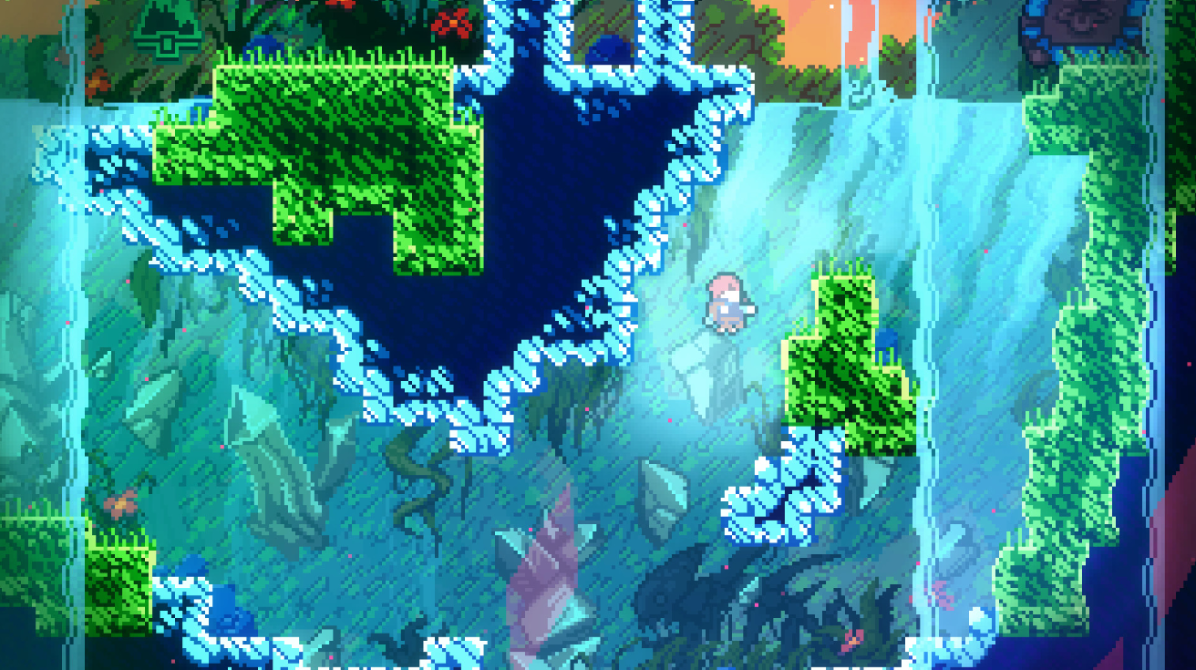

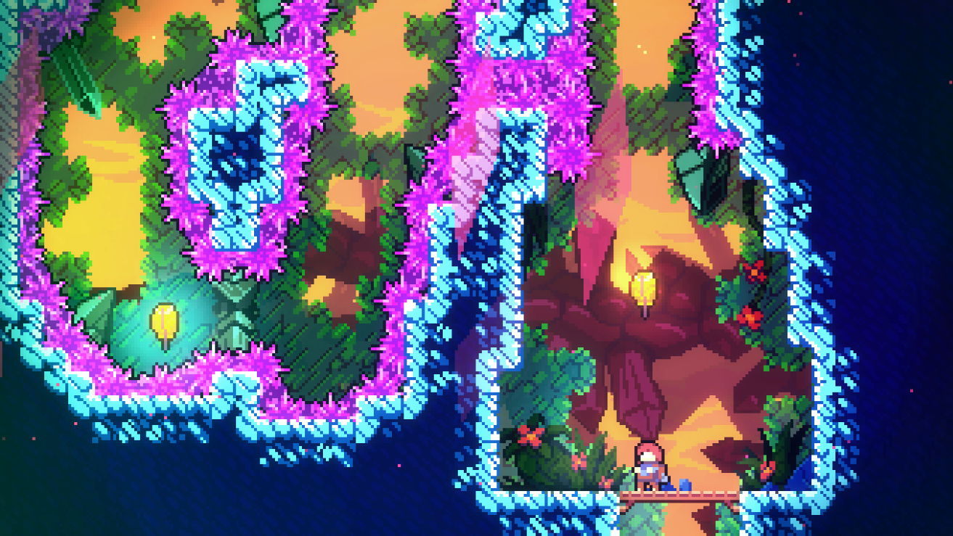

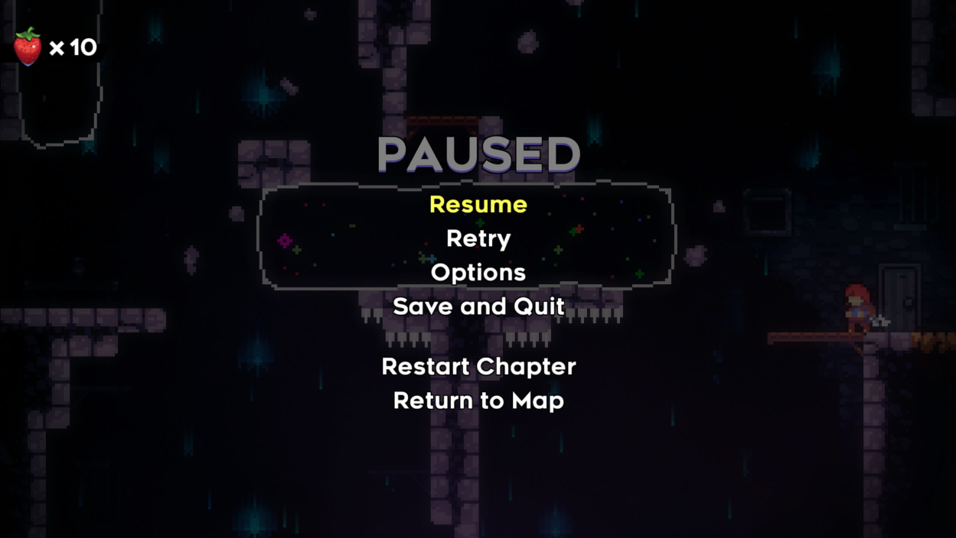

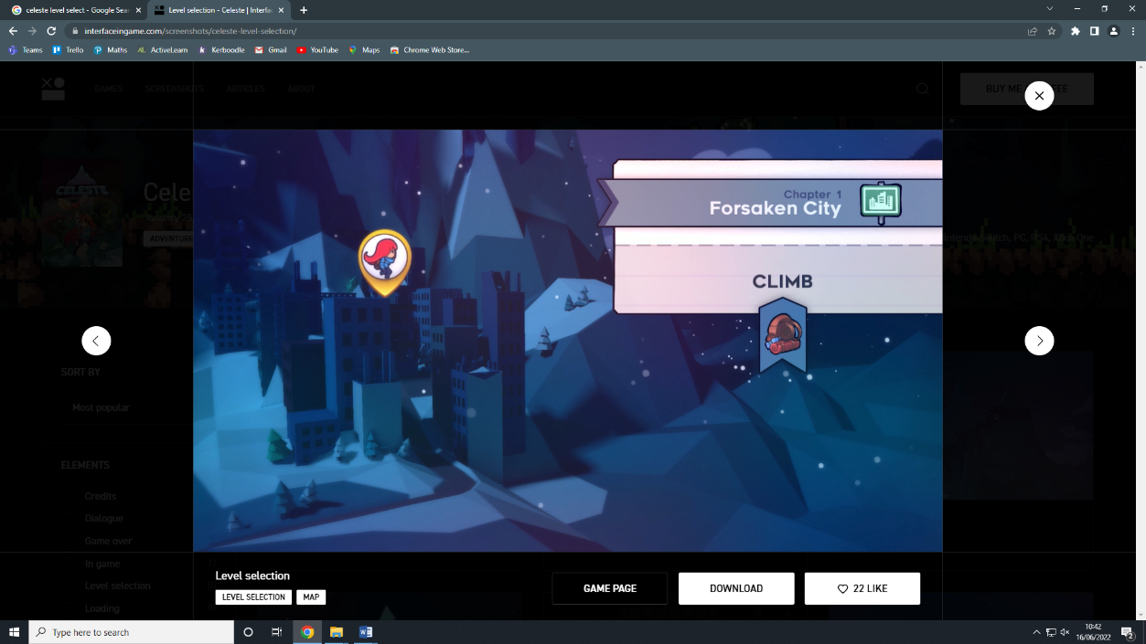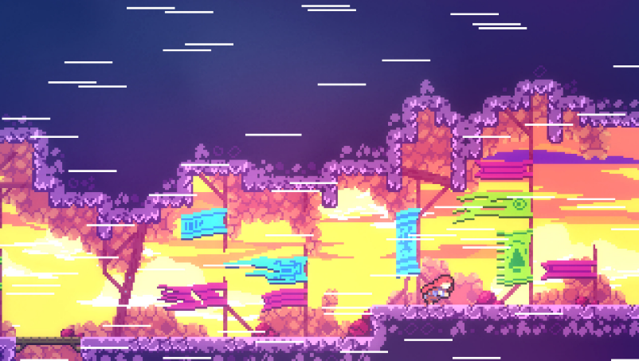

**Overview/ Plot**

Celeste is a 2D platformer game in which player control Madeline, the main character, as she climbs mount Celeste. We uncover the reason for her to be climbing this mountain when the game reveals Madeline is battling depression, an uncommon plot which brings you closer to the character and motivates the player to help Madeline in her quest.

**Gameplay**

This platformer is based around trial and error. Each time you die in Celeste you save your progress from the previous area and teleport back to the last checkpoint. There are no repercussions in Celeste from dying, making it more relaxing to play, however a death tally is kept, and the levels are timed. In some cases, Madeline must perform certain obstacles under a certain time before proceeding onwards.

Over the course of the game, Madeline obtains quite few skills as the player herself as what keeps this game entertaining are the surroundings. For example, mountainous areas house extreme winds, changing direction and directly affect the player by pushing the character and changing the physics in the game. The skills Madeline is given throughout the game are wall jumps and double dashes, comparatively small to other games, but this demonstrates how not all characteristics of the game have to be over the top to make an excellent overall game.

Some extras this game has include strawberries. Strawberries are collectables that the player can choose whether or not they would like to pick up, the only affect they have on the game is achievements, and for the player to view how many strawberries, compared to the total amount of strawberries, they have collected during a level. This gives the user a sense of wanting to be a completionist on each level, seeing how they could have done more. I believe this to be an excellent feature as not only does it encourage replaying levels (increasing the overall time the game would be enjoyed for the player), but also gives them an extra – optional – challenge which adds on to the game’s difficulty.

Another extra in this game is each level’s ‘B - Side’. A cassette tape will appear to the Madeline and if gotten, the player can go through the whole level again using the mechanics of its respective chapter, but significantly harder. Combined with strawberries, this game captures the feeling of desire from the user. The feeling of just wanting to gather everything, that one item that is just out of reach, is one that I’ve never felt with any other – and is the main feature I will be taking away from this platformer.

**Other**

The menu system in this game is something else that I found to be quite unique. As the player progresses up Mount Celeste in game, the menu allows them to visualise the mountain and traverse an overview of it when choosing a chapter to play. In a way it feels like each time you go through this menu, you get a sense of just how much progress you have achieved, as there is never a percentage you can see elsewhere, its nice to be able to know how much closer you are to completion than the last time you logged on.

|  |  |  |
| --- | --- | --- |
| **Feature of this Solution** | **Identified Approach**  **for my Solution** | **Justification for Approach** |
| Collectables | My game will include optional collectable items | * Makes game more enjoyable * Will encourage player to replay levels * Makes use of the human’s psychology for desire as motivation |
| Checkpoints | To include frequent checkpoints | * If player repeatedly fails a specific part of the game, they can reach it much faster and feel less frustrated * A greater sense of accomplishment * Faster progression |
| Immortal Character | To give my player multiple lives, but not to be invincible | * I would not like my game to be too forgiving, therefore if a player dies too many times I believe they should have to redo the whole area, instead of respawning at a checkpoint |
| Changing environments | To have various themes and environmental changes | * More engaging over many hours of play * Creates some self-motivation, as it will involve me constantly creating new art and abilities for players in certain areas |
| Menus | To create menus that stand out and represent its respective area | * Gives a sense of progression for the user * Reduced confusion when remembering where exactly they left off playing |
| Character backstory | To give my main character a name and relatable backstory | * Brings the game into perspective more, and will add a nice touch to the overall feel of moving closer towards an end goal * Motivation for the player having a direct impact on what happens with the character with their struggles |
| Tutorials | Tutorials on player movement in the beginning of the game, and any new skills later down the line. | * Will help clarify any difference in key binds between games, for example the user may be use to the arrow keys and will not realise the game used ‘wasd’ for movement |
| Player animations | To include animations for my character | * Will bring my character to life with things such as dust particles or bending their knees when jumping/ landing from a jump |

**Solution 2: Dead Cells**

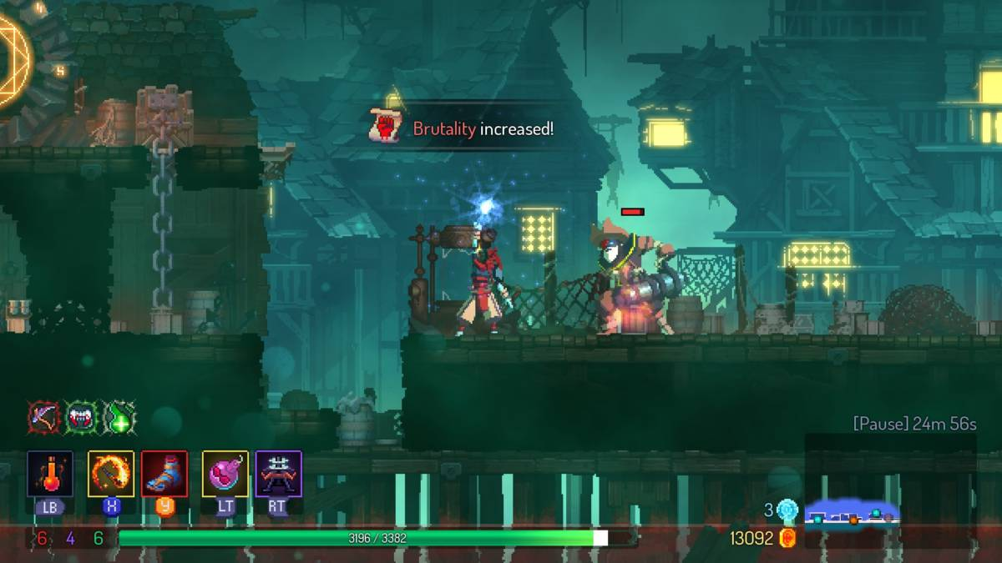

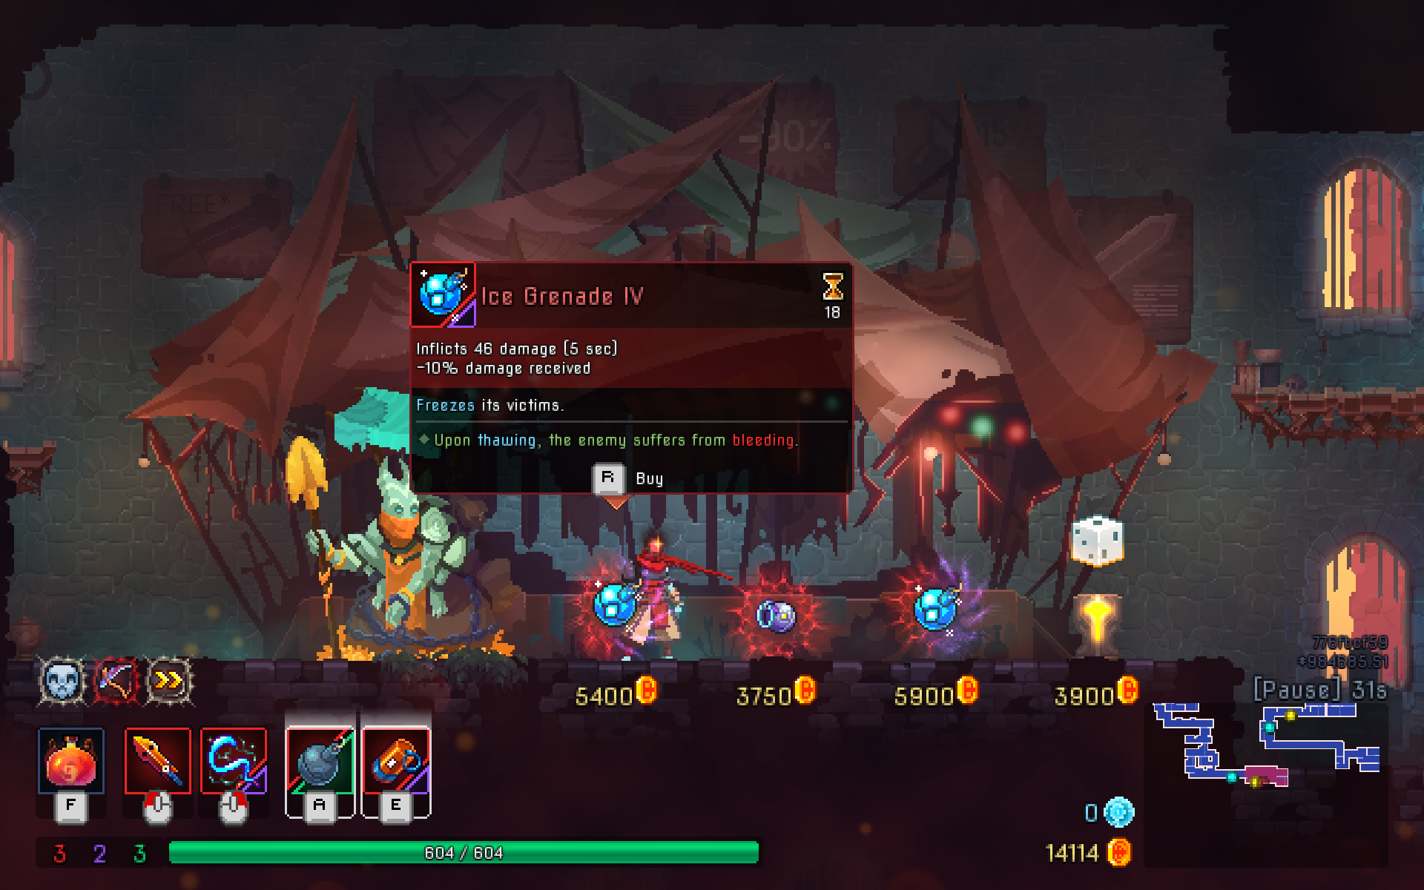

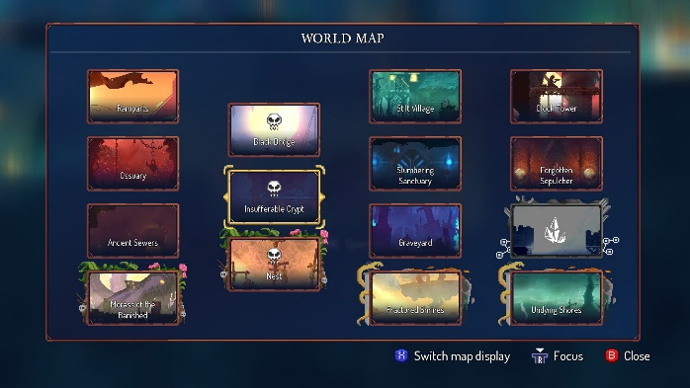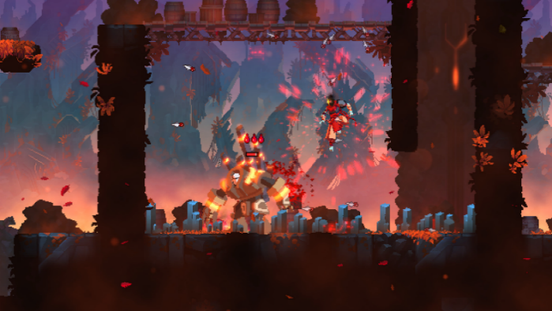

**Overview/ Plot**

Dead cells is a fast-paced rogue-like. The Prisoner awakens in the depths of the island's prison, possessing no memory of how they got there. A soldier encounters the Prisoner and mentions that they can no longer die. The Prisoner tries to escape the prison, but their head is forced back to the depths as soon as its body is destroyed. Between subsequent escape attempts, the Prisoner learns that that the island was once a mighty kingdom that fell when a plague known as "The Malaise" transformed most of the kingdom's citizens into mutated monsters.

**Gameplay**

I chose this game as it possesses an almost opposing view to the platformer game as Celeste. Dead Cells is not so forgiving compared to Celeste, once the player reaches death, they must complete the entire game again, keeping only the ‘dead cells’ which can be used in an upgrade system carried on throughout all playthroughs. Checkpoints are not available in Dead cells as the player only loses smaller chunks of health when hit by monsters, or by environmental factors such as spikes. The exception to this being if the player falls off the map, where they are placed back on where they jumped from, with a reasonable amount of health missing.

One of the main differences between Celeste and Dead Cells is the use of upgrades and skills. The player gains abilities such as wall jumps, ground dashes and many more when progressing through this game. For example, in the introduction stage there are places where the player must run up walls to reach certain areas and weapons, which are completely inaccessible to the player when they start the game, however they gain these over time, and when they next die, they can progress quicker and into different stages. I like these features, however the use of too many skills may confuse the player and might overcomplicate my program for little need; therefore, skills won’t be as big of a focus as they are in this game.

Another difference are the weapons and monsters. I am intrigued by this, and I feel like it does make an extremely big impact as to what type of game I would like to create. Personally, I believe basic creatures are necessary to get the user to switch between platforming and progressing in a fighting sense. Again though, I would like to keep my game on the simpler side and not got as far as to create anything like bosses. Each weapon however is in one of 3 classes: survival, tactics or brutality. I feel like this gives the player more choice over what style of gameplay they want to have, such as long range or close range, an excellent addition to most games I know which do this, as it also means they might be willing to replay the entire game under a different class. This sort of strategy and building up an arsenal of weapons, armour and abilities which all complement each other is something I would love to add to my game; although if I am only keeping the fighting in my game to a minimum, I have decided to leave this aspect of the game out as well.

Yet another unique feature of Dead Cells are the shops. Dead cells use them to spend money collected by monsters, to achieve even faster progression and more abilities. I would implement shops as a way to do similar, such as upgrading the player’s weapon or gaining more skills (e.g. buying a set of wings to increase jump time); however, an alternative way to do this would be to let the player pick up these objects over time, and make them feel like they have earned the abilities handed to them, rather than have to fight more creatures scattered scarcely around the map. Even though I still consider them to be essential, I now realise that shops, or similar, would most likely not work if I plan to keep my combat in this game to a minimum.

**Other**

The menus (as seen in the final screenshot) used for level selection are extremely similar to the ones I imagine implementing into my game. Each chapter, level or area has a specialised pixel art cover, and acts as a simple button, once clicked will take you through to the respective area.

|  |  |  |
| --- | --- | --- |
| **Feature of this Solution** | **Identified Approach**  **for my Solution** | **Justification for Approach** |
| Monsters | To only have small, basic mobs around the stage, linked to the theme of the area | * Combat will not be the main aim for my program * The addition of bosses or similar would be completely off-course for my project’s objectives, although smaller entities would provide more interesting gameplay |
| Weapons | To include basic weapons, including an upgrade system | * Some form of way for the player to fight against these mobs will be necessary |
| Weapon classes | To keep the combat for my game simple, without weapon classes | * Unnecessary for the scope and objectives of my game |
| Shops | To exclude shops, as combat will be kept to a minimum, hence not suiting my program’s needs | * Would encourage players to go back and mind-numbingly have to eliminate the small mobs scattered around the map |
| Skills | To have some basic skills the player can obtain over time, such as a double jump or wall run | * Will give slightly more stimulation to only platforming between objects * Seen as a basic necessity for this genre of game, as a way to keep the game engaging over time |
| Menu system | To use a similar level selection menu as Dead Cells, with basic buttons with corresponding artwork for that level | * A slick, simple way to not overcomplicate level selection whilst giving the player an overview of everything they have, and are yet to, accomplish |

**Solution 3: Hollow Knight**

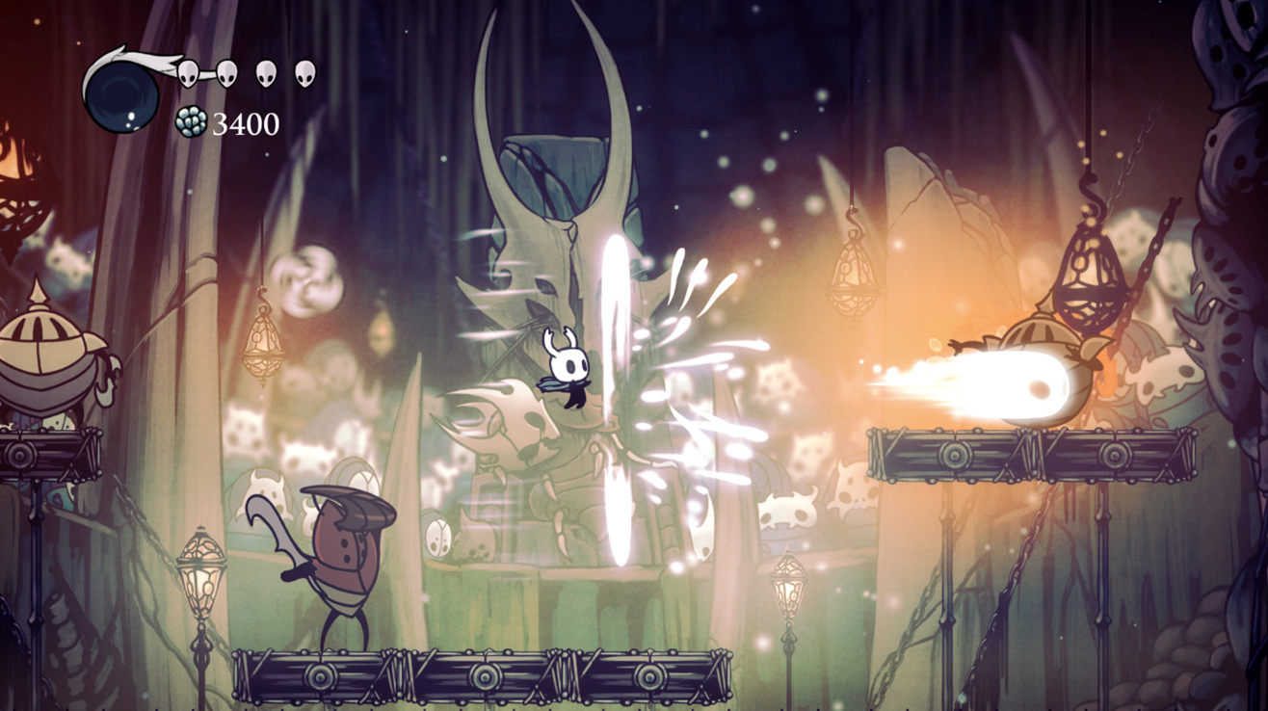

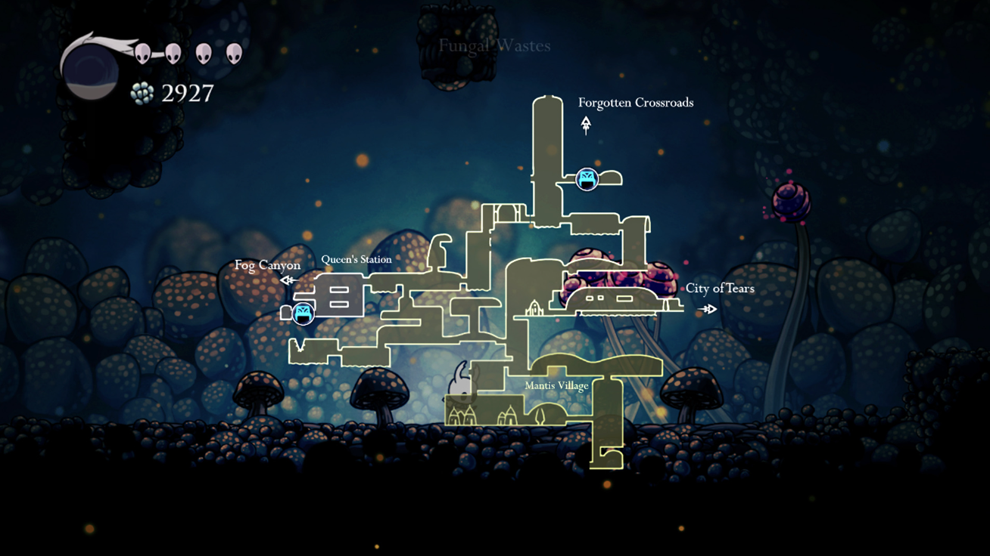

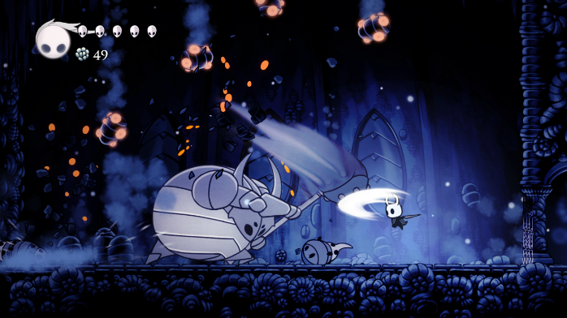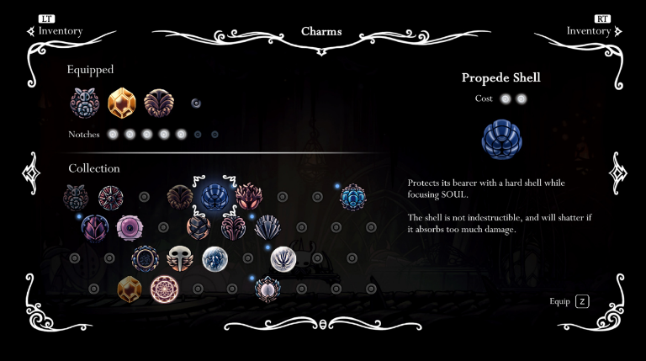

**Overview/ Plot**

Hollow Knight is a 2D side-scrolling Metroidvania open-world game that takes place in Hallownest, an underground kingdom. The player controls an insect-like, nameless knight while exploring the underground world. The Knight wields a Nail, which is a type of sword, that is used in both combat and environmental interaction. The game is open world in the sense that there is no level by level progression, you have to physically explore each area, navigating your way back and forth throughout the world.

**Gameplay**

This game follows the knight through an open-world game whilst they uncover secrets of the kingdom, and have the end goal of defeating the infection which has plagued Hallownest. The player progresses through the game by accessing an area, navigating their way through, then defeating the boss and unlocking an ability which allows them to further their way into the game. This is not always the case of course, one ability might access multiple areas, whilst others are only useful for combat. There are two types of skills/abilities in this game, charms and fixed. Charm abilities can be seen in the selection menu in the bottom right screenshot. The player is given a certain number of notches, and may use as man charms as notches allowed. For example, a charm that possesses a more potent ability might cost more notches than one which the player obtains in the beginning of the game. One charm, the ‘Wayward Compass’ allows the player to locate where they are on the map, another, ‘Dashmaster’ allows the player to dash more often, and downwards. Fixed abilities are those which stick with the player throughout their entire playthrough, such as the ‘Monarch Wings’, allowing the player to double jump.

I chose Hollow Knight as it has the ideal weapons and combat system. As previously stated, this game follows a knight who only wields a ‘nail’ used as a sword to interact with surroundings, and damage opponents. I am keenly interested with this as it represents precisely what is am trying to achieve; as you traverse from platform to platform small creatures occasionally creep out to try and knock you off and damage you. As this is quite a successful game, you can imagine as the player progresses they earn abilities such as spells which act as long-range weapons to damage foes. As much as I would love to implement something as a long-range attack, the reason Hollow Knight has adopted this is due to the variety of opponents it has and the increasing difficulty level of them as you progress; hence I will not be using long range attacks in my game. There is another feature I would like to implement into my game, and that is the feature of gathering certain materials, and using them to upgrade the nail, or close-range weapon. This is because I would like there to be some increase in difficulty and variety in the monsters in my game, and one way to counter this is the need to perform upgrades on your equipment.

**Other**

In terms of level selection and other characteristics of this game, there is not much to say. As Hollow Knight is open world, the main title screen, as well as a settings menu is all there is to this game. However, this game does not place you exactly where you were when you last logged off, it uses benches dotted around Hallownest to act as save areas. Whilst on a bench you recover any missing lives and have the ability to swap out charms.

|  |  |  |
| --- | --- | --- |
| **Feature of this Solution** | **Identified Approach**  **for my Solution** | **Justification for Approach** |
| The Nail/ Sword | To implement a close combat weapon | * Requires player to gain more character control * A greater difficulty for the player than allowing them a long-range attack (requires them to close the gap between them and the foe whilst dodging projectiles) * Allows for an abstract, straight forward system for players to quickly understand |
| Nail Upgrades | To include a way to pick up loot that will allow the user to upgrade their combat weapon | * Lets the user feel like they are progressing through the game, not like they are stuck with the same weapon throughout the entire playthrough * Means the player will be able to feel their progress making a difference (e.g. when they slay monsters that use to take 5 hits in 1) |
| Merchants | To incorporate a travelling merchant the user will come across frequently | * Gives the user a method to upgrade their combat weapon * Allows me to include features such as turning money collected by monsters into valuable items to the user, such as an extra life, or extra defence – more flexibility with features I think are lacking down the line |
| Simple, Attractive UI | To create a UI that fits all themes of my game. It will allow the user to pause, change the settings or leave | * A sleeker UI will be a big contributor to a good-looking game * Will create a way for the user to save and exit whilst keeping their progression * Will allow the user to perform actions such as resetting key binds, turning down the music or change display settings |

# **Proposed Solution**

**Essential features**

|  |  |
| --- | --- |
| **Identified Feature** | **Justification** |
| Collectable items | Having the basic essential features was one of my stakeholder’s wishes, however I would not have failed to leave out such an essential part either way. Collectables incentivise exploration, as well as giving the user an additional objective, aside from that of completing the game. What makes a game more enjoyable to play is the feeling of being fully immersed, and for many people that happens when their brain is focused on multiple objectives. The flicking between platforming, combat and collectables will be what makes my game stand out. |
| Frequent checkpoints | My solution is meant to be an enjoyable way to spend free time. The user might feel aggravated by the repeated death toll of a difficult area, being sent right back to the beginning of the level each time. Frequent checkpoints will give my user a more satisfying sense of achievement once they realise they have finally passed that section they were stuck on. They will also progress quicker, as a death will not impact them as much as they would in other games; for example, Dead Cells. |
| Finite Lives | To slightly counter the frequent checkpoints, if the player loses the set amount of lives that is given to them, then they must restart the whole area. I am confident that every game needs to have a sense of loss, so that progression feels all the better. It is also important to ensure the player is not so carefree, encouraging self-improvement. |
| Various themes and environmental changes | This feature will keep the player looking forward to the next stage, as well as ensuring gameplay remains interesting. When the player finally finishes an entire area, I want them to look forward and feel motivated to keep going with the next one. I believe doing this will also have a knock-on effect of keeping myself motivated. It will keep me creating new artwork, meaning less repetition in level design, designing new foes with environment-specific abilities. |
| Unique Menus | Giving artwork to my different areas will give my user a sneak peek to the different future paths they will be able to play. Moreover, having a clean look and feel will add to the overall quality of the game. |
| To give my main character a name and relatable backstory | Whilst having a nameless character might be more ominous or intriguing, I would like my game to be friendlier and more open. One way to do this, as seen in Celeste, is to give my character a set name, as well as a purpose for playing the game, linking to their backstory. |
| Tutorials | Tutorials are necessary for bringing in players who might be more inexperienced in the genre, helping them feel like learning the controls is something anyone could do, something simple and straightforward. Another reason is abilities, from game to game one thing that changes throughout them all is key binds for separate abilities. Each time a new skill is acquired, not only do you need the user to know how to, and practise it, you need them to know how to activate it in the first place. |
| To include animations for my character | Animations are another basic feature of almost every game that looks remotely realistic. A static image moving around the screen would look extremely unrealistic, making the user know that no time or effort has been put into making this game feel good to play. It is one of the most necessary features and I will include animations for every moving object in my game. |
| To only have small, basic mobs around the stage, linked to the theme of the area | Whilst combat is what makes most games enjoyable, I would like to stay true to my original goals and not centre my game around mobs. On the flip side, I believe something small, such as bugs that mean you can’t sit still for too long will encourage the user to practice and develop their player movement skills. It’ll also keep the player more engaged than just jumping from place to place, and the game becoming too repetitive. Another reason for adding mobs is currency. Currently, there would be no form of money circulating through the game, which would encourage the user to seek out and interact with more of these enemies, instead of jumping over them or ignoring them; a form of currency means weapon upgrades, extra health, and other valuables would help the player out in tough situations. |
| Simple Combat System | To counter the above-mentioned enemies, I will be implementing a simple combat system, where they player will obtain a close-range combat weapon and be able to hit in all directions. It will also act as a way to interact with the environment, e.g. hitting buttons or door levers. I will keep it simple with only one weapon to keep within the scope of my program. Having a combat system gives user an extra goal, on top of the smacking enemies and progressing, it means they are fighting to upgrade their sword, to make fights easier, when the enemies in the next area are harder. |
| Travelling Merchant | This is a feature I am looking forward to adding as this merchant will be the one to sell the user goods, and upgrade items (when the requirements are met). Introducing enemies into my game creates a large array of opening features and I will be intrigued to see how it all comes together. |
| Slick UI | A good user interface will be one of the things that will make my game stand out. It is one of the first features the user will see, and the one that makes a good impression. A good menu will mean my user won’t have to spend long periods of time finding specific features in the settings menu and will mean they would be more impressed by my overall game. |
| Recording Statistics (such as time taken) | Recording the amount of time a user takes to complete a level, or displaying how many deaths in a certain area adds a sense of competitiveness to my game. To me, there is no better feeling than managing to beat your best score on a level that you were originally frustrated by, or better yet beating a friend on the same one. By storing basic statistics of each player locally on their machine, I believe it to help with the desire and motivation to progress and improve; features every game should have. This will also require me to use file handling and encryption, putting more of my skills on display. |
| Implementation of OOP | Demonstrates my skills in programming to an A-Level standard. Additionally, it will probably come in use for creating objects such as enemies, walls and the player. For example, both my player and enemies will have a certain amount of health, meaning I could have a parent class of ‘Living Being’ storing attributes such as the health, and subclasses inheriting from that containing more specific attributes. |
| Togglable Timer | Although a competitive nature is something I would like to keep in my game, for users that feel overly pressured by such should not have to try and block it out of their field of vision, instead this feature should be able to be toggled on or off in settings. |
| Surplus of Skills and Abilities | A basic requirement for my game. This will ensure my game is enjoyable and will not become repetitive over time. As mentioned above, the user will acquire skills such as a double jump as they get further on in the game’s progression. This will allow me to create more varied and more difficult obstacles for the user to complete. |
| Storage using GitHub | GitHub is the leading place to store, edit and work on projects of any group size. Learning of its use now will be extremely beneficial in future and will give me a step up against other programmers when demonstrating, and putting to use, their skillset. |
| Consistent Theme | My retro pixel art theme is something I’ve been hooked onto for quite a while when it comes to my programs. To have the game a retro pixel art theme, then for my menus, UI and level design to not coincide with that would set back my game from feeling that professional. |

|  |  |
| --- | --- |
| **Identified Feature** | **Justification** |
| Collectable items | * Only one type of collectable item, “Golden Gear”, to keep the game simpler when detecting for collisions |
| Various themes and environmental changes | * There will only be 3 types on environment due to time restrictions |
| Windows Only | * Python files can be easily ported over to make it an executable (.exe file) * Mac requires a ‘.app’ file, this would require installing and learning how to use different 3rd party programs. As I will never be running my program on a mac, I do not believe this is necessary for the scope of my program |
| Basic Enemies | * The enemies within my game will most likely not have features such as flying, or pathfinding. Their purpose is to give the user a small separate goal therefore I will not spend too much time perfecting them * The enemies I produce will vary between environments, however I plan on around 5 differing types in the game, with their abilities suiting the area that they are based in |
| Simple Combat System | * As there will be 3 environments and 3 sets of variations in enemies, I will only include 3 sword upgrades. These upgrades will only increase weapon damage to slay the monsters with more ease |
| Travelling Merchant | * The travelling merchant will have a simple button interface. The user will be able to see the item, as well as its price, but there will be no inventory, storage space, or selling of items allowed |
| Recording Statistics (such as time taken) | * The statistics will not be put online, therefore you will only be able to see the names, times and deaths of players who are on the same machine. * To see speed runs of people elsewhere, they could manipulate the number, and may be inaccurate to what they truly achieved. This means that unless somebody else players on the same machine the program is downloaded on, you won’t be able to see anyone else’s scores for each level |
| Skills and Abilities | * There will only be a handful of fixed abilities. I cannot define each one yet however I plan on making about 3-5 in total * Each ability will impact the usability of the game, especially when abilities are used in combination; therefore, I will keep my skills extremely basic so that they will not heavily affect the platforming mechanics |
| Windowed Experience | * Due to Pygame placing objects on the screen a certain pixel length across, my game must be viewed in full screen. Different monitor resolutions will be considered, however they must still be in full screen |

**Limitations**

**Software and Hardware Requirements**

|  |  |  |
| --- | --- | --- |
| **Identified Feature** | **Requirement for Solution** | **Justification for Requirement** |
| OS | Windows Only – Windows 7  or above | Project will come as a .exe file, therefore only able to run on windows |
| CPU | 1.6+GHz Clock speed, 2 cores | Program will be running frame updates and collision detection millions of times per second |
| GPU | For best performance, use integrated graphics | A GPU of good capability will ensure frames are loaded faster, resulting in smoother gameplay |
| RAM | 2GB or more | The application will be memory intensive as it is a game |
| Display | RGB Monitor | Program will be displaying images in an RGB format, which will not render correctly on a monitor of anything not inclusive of RGB |
| Hard Disk | At least 1GB of free storage space | Program will need to store images for sprites and backgrounds, as well as audio files and more |
| Other Hardware | Mouse and keyboard | Necessary inputs for the game to run |
| Optional Hardware | Headphones/ speakers | Sound is not necessary, but can be played when in game |

**Requirements Specification**

|  |  |
| --- | --- |
| **Requirements to Implement Essential Feature** | **Justification for Requirement(s)** |
| Collectable items  1. Implement the ‘Golden Gear’ as an item that can be collected in specific areas throughout the game | * This collectable will incentivise exploration, as well as give the user an additional objective, aside from that of completing the game * I have named it the ‘Golden Gear’ as my entire game will be themed around a steampunk, pixel art character |
| Frequent checkpoints  2. After each major obstacle, include a respawn location for the player | * Frequent checkpoints will lead to faster progression. It will also give users a more relaxed playthrough as they will not be sent to the start of each level every time they lose a life |
| Finite Lives  3. Give the player 5 lives  4. If the player loses all lives, they should be sent back to the start of the area, not just the checkpoint  5. Give the player the ability to gain these hearts back throughout the level | * Giving the user 5 chances is enough for any person to complete an obstacle when trying hard enough – encourages progression * Gives the player something to lose. With a sense of fear comes a greater feeling of achievement in what they are accomplishing * It will be inevitable that they lose lives from mistakes, but once they clear the obstacle(s) there should be opportunities to recover them, such as behind an optional, harder, obstacle – or the merchant through in-game currency |
| Varying Themes  6. Create 3 biomes: Underground, Jungle and Corruption  7. Each of these themes should have different art (e.g. background), different enemies and different difficulties | * Due to time restraints, I feel 3 sets of creating and editing pixel art is enough to encompass an entire game whilst making the player feeling like they are progressing * Each of the 3 areas needs to be different in a specific way, otherwise they would just be the same area. The ways most games undergo this is through music, biomes, the types of material that can be found. My game will step up the difficulty in mobs and mix up the art style. The platforming itself should also be made harder with the user of more specialised abilities in combination. |
| Unique Menus  8. Create a pixel art cover for each environment  9. After they navigate (click on) the specified environment, give them the choice of its levels | * Gives my level selection a common theme, and will act as a teaser for that area * After selecting the area/ environment they wish to play, they should be greeted with the levels I have created for it |
| Backstory for Main Character  10. Upon beginning the game, the user should be greeted with information about the player  11. The game should give more information about the player as the game progresses | * In order to introduce the character as having a purpose as to why the player should bother to complete the game * To keep the user a little bit in the dark at first. To keep them guessing as to what happened and why the knight needs to complete his quest |
| Tutorials  12. There should be a tutorial at the start of the game – outlining player controls and where they can be changed  13. There should be a tutorial whenever the player picks up a new skill or ability | * To ensure the user knows the controls, and start the game of easier with a comfortable feel – where there shall be a steady curve in difficulty throughout the game * Necessary for the player to know what the ability can be used for, so its not left out or forgotten when playing |
| Character animations  14. Character should look realistic when moving with a range of frames to show specific details (such as the character’s legs bending when jumping) | * Required for a good look and feel, as well as fluid character movement |
| Basic Mobs  15. Include 2 small mobs that will aim to kill the player  16. Have these mobs step up in difficulty when the environment changes | * Enough of a variety to keep the player engaged, whilst not overloading myself with time restraints * So that the player does not feel like these enemies only become easier when they upgrade their swords, otherwise there would be not point in sword upgrades at all |
| Combat System  17. Give the player a sword which can hit mobs above, to the left and to the right of the player  18. Allow the user to upgrade their sword with materials and money gathered from playing the game. This should be available from the travelling merchant | * A feature inspired by Hollow Knight. Rather than just having the ability to hit left and right, feeling like you can also attack flying enemies above you makes the game feel more comfortable to play * As a way to counter the increasing difficulty of the mobs, and to make the player feel like they are progressing in the game as they pour time and effort into it |
| Travelling Merchant  19. The merchant should sell health, special abilities and sword upgrades to the user  20. The merchant should appear the player at the end of each level – or more | * To put the money collected by mobs to use. Also gives the user a way to gain health back, a method to realistically upgrade their sword and gain abilities * To give a consistent feel to let the player know that they will always be able to heal, buy abilities or sword upgrades at least once per level |
| Slick UI  21. A pixel art themed user interface across entire game, such as in all text, menus or settings  22. Settings will include options such as volume level, togglable timer and key bind resetting | * A user requirement: will mean my gameplay will be more fluid and the game overall will feel more professional * To let the user fiddle around and change the game until it feels right to them |
| Recording Statistics  23. Statistics such as time taken to complete each level, along with a corresponding user, will be stored on a text file  24. The text file will be encrypted | * To create a high-score table and show the user what other player (other their previous self) have been able to achieve. This puts pressure on the user to perform each action more efficiently, getting use to the player movement more and become more invested in the game * To demonstrate simple encryption skills, such that the data cannot be modified to best suit the player’s interest |
| Implementation of OOP  25. To have living objects defined under a parent class, with child classes including the player and enemies  26. To have all objects in my game to come under some form of class | * To demonstrate A-Level programming skills, as well as a way of practising them myself. OOP is also a clever way of organising objects into simple trigger-reaction methods, such as collision detection * A requirement to restrict what I’m able to program without OOP – a way to ensure that I follow the OOP paradigm |
| Togglable Timer  27. To store the players recorded time for each level on a text file, and have this able to be toggled off in the settings  28. Give the user the choice if they would like to have the timer displayed on screen | * Timer should be togglable if the user would prefer a more relaxed, or a more fast-paced play style. Storing each time to compile a high score table and for comparison of times against oneself and other players * An extra setting on top of the timer in case the user wishes to record their times, but would not like it to be displayed to them |
| Skills and Abilities  29. Give the user a double jump in the jungle environment  30. Implement special abilities that can be bought from the travelling merchant; e.g. swimming in acid | * Each major game includes a double jump feature, therefore making it an essential requirement for mine, whose game is trying to replicate their playability. * To create some mystery into the game, or to allow the user to combine two or more extremely specific skills when trying to go past a specific obstacle |
| Storage using GitHub  31. To store my project, along with all its previous versions in GitHub | * To force myself into learning the best platform of program storage for future real-world applications in software development |
| Consistent Theme  32. To keep the environment theme consistent, as well as the art style (e.g. 64 bit pixel art) similar throughout my entire game | * To ensure the game feels fluid when playing, and again brings my program closer one of a professional standard |

**Success Criteria**

|  |  |
| --- | --- |
| **Requirements to Implement Essential Feature** | **Justification for Success Criteria** |
| Collectable items  1. Does the ‘Golden Gear’ appear often enough? | * It is essential that this collectable appears frequently enough to keep the collectors interested |
| Checkpoints  2. Does the Player respawn at the correct checkpoint if they lose a life? | * It is important that the game does not frustrate the player and send them to the wrong checkpoint |
| Finite Lives  3. Does the player have 5 lives?  4. Is the player sent back to the start of the level if all lives are lost?  5. Is the player given ample opportunity to earn lives back? | * Giving the user 5 chances is enough for any person to complete an obstacle when trying hard enough – encourages progression * Player should have a feeling of fear, of something to lose, in order to boost their sense of self achievement * It will be inevitable that they lose lives from mistakes, but once they clear the obstacle(s) there should be opportunities to recover them, such as behind an optional, harder, obstacle – or the merchant through in-game currency |
| Varying Themes  6. Are there 3 biomes? Do they have at least 3 levels each?  7. Does each biome have different enemies that increase in difficulty over time? | * Due to time restraints I feel 3 sets of creating and editing pixel art is enough to encompass an entire game whilst making the player feeling like they are progressing * Each of the 3 areas needs to be different in a specific way, otherwise they would just be the same area. The ways most games undergo this is through music, biomes, the types of material that can be found. My game will step up the difficulty in mobs and mix up the art style. The platforming itself should also be made harder with the user of more specialised abilities in combination. |
| Unique Menus  8. Does each environment have a pixel art cover?  9. Is a choice of levels displayed to the user after they navigate through the environment? | * Gives my level selection a common theme, and will act as a teaser for that area * After selecting the area/ environment they wish to play, they should be greeted with the levels I have created for it |
| Backstory for Main Character  10. Upon beginning the game, is the user greeted with information about the player?  11. Does the game give more information about the player as it progresses? | * In order to introduce the character as having a purpose as to why the player should bother to complete the game * To keep the user a little bit in the dark at first. To keep them guessing as to what happened and why the knight needs to complete his quest |
| Tutorials  12. Is there a tutorial at the start of the game? Does it outline player controls and where they can be changed?  13. Is there a tutorial whenever the player picks up a new skill or ability? | * To ensure the user knows the controls, and start the game of easier with a comfortable feel – where there shall be a steady curve in difficulty throughout the game * Necessary for the player to know what the ability can be used for, so its not left out or forgotten when playing |
| Character Animation + Movement  14. Does the character look realistic when moving? | * Required for a good look and feel, as well as fluid character movement |
| Basic Mobs  15. Are there 3 small mobs that will aim to kill the player?  16. Do these mobs step up in difficulty when the environment changes? | * Enough of a variety to keep the player engaged, whilst not overloading myself with looming time restraints * So that the player does not feel like these enemies only become easier when they upgrade their swords, otherwise there would be not point in sword upgrades at all |
| Combat System  17. Is the player given a sword which can hit mobs above, to the left and to the right?  18. Can the user to upgrade their sword with materials and money gathered from playing the game? | * A feature inspired by Hollow Knight. Rather than just having the ability to hit left and right, feeling like you can also attack flying enemies above you makes the game feel more comfortable to play * As a way to counter the increasing difficulty of the mobs, and to make the player feel like they are progressing in the game as they pour time and effort into it |
| Travelling Merchant  19. Does the merchant sell health, special abilities and sword upgrades?  20. Does the merchant appear at the end of each level? | * To put the money collected by mobs to use. Also gives the user a way to gain health back, a method to realistically upgrade their sword and gain abilities * To give a consistent feel to let the player know that they will always be able to heal, buy abilities or sword upgrades at least once per level |
| Slick UI  21. Is there a slick pixel art theme throughout all aspects of the game?  22. Does the settings include options such as volume level, a togglable timer and key bind resetting? | * A user requirement: will mean my gameplay will be more fluid and the game overall will feel more professional * To let the user fiddle around and change the game until it feels right to them |
| Recording Statistics  23. Are statistics stored on a text file?  24. Is the text file encrypted? | * To create a high-score table and show the user what other player (other their previous self) have been able to achieve. This puts pressure on the user to perform each action more efficiently, getting use to the player movement more and become more invested in the game * To demonstrate simple encryption skills, such that the data cannot be modified to best suit the player’s interest |
| Implementation of OOP  25. Are all the living objects defined under a parent class, with child classes including the player and enemies?  26. Do all objects in my game come under some form of class? | * To demonstrate A-Level programming skills, as well as a way of practising them myself. OOP is also a clever way of organising objects into simple trigger-reaction methods, such as collision detection * A requirement to restrict what I’m able to program without OOP – a way to ensure that I follow the OOP paradigm |
| Togglable Timer  27. Can the timer be toggled?  28. Is there a setting to hide or show the timer on screen? | * Timer should be togglable if the user would prefer a more relaxed, or a more fast-paced play style. Storing each time to compile a high score table and for comparison of times against oneself and other players * An extra setting on top of the timer in case the user wishes to record their times, but would not like it to be displayed to them |
| Skills and Abilities  29. Is the user given a double jump in the jungle environment?  30. Is the user given special abilities that can be bought from the travelling merchant? | * Each major game includes a double jump feature, therefore making it an essential requirement for mine, whose game is trying to replicate their playability. * To create some mystery into the game, or to allow the user to combine two or more extremely specific skills when trying to go past a specific obstacle |
| Storage using GitHub  31. Has the project, along with all its previous versions, been stored on GitHub? | * To force myself into learning the best platform of program storage for future real-world applications in software development |
| Consistent Theme  32. Are all the menus, environments and text pixel art? | * To ensure the game feels fluid when playing, and again brings my program closer one of a professional standard |
| Gameplay  33. Does the world move smoothly as the player traverses it?  34. Are the enemies removed if not in their correct positions?  35. Do all objects function correctly in all scenarios? | * For the game to be an enjoyable experience my game must not lag, or look to be lagging whilst the player traverses the obstacles * The enemies should have the same attributes of a player with death – they should be removed if inside tiles, touch a damaging tile or fall off the map * A vague but necessary test that covers all objects currently in the game to ensure the gameplay runs as intended |

**DESIGN**

# **Decomposition**

**Breaking the Problem Down**

|  |  |  |
| --- | --- | --- |
| **Aspect of Solution** | **Decomposition** | **Justification** |
| User Interface | * User interaction   + Mouse input   + Keyboard input * GUI Attractiveness   + 8-Bit theme * Validation on user input   + Text input * Menus   + In-game menu   + Level Selection menu   + Welcome menu   + User login menu | The user interface allows the user to interact with the solution. Because of this, it forms an integral part of the program – hence it must be broken down. By doing this, each user interaction can be individually tested and managed. |
| Gameplay | * Design:   + Consistent 8-Bit Style   + Sound effects   + Presenting information * Physics:   + Collisions between objects and the player   + Player movement * Controls:   + User input | The gameplay of my program is the main aspect which will affect the user’s experience. By decomposing this, the overwhelming problem of tackling every aspect of the gameplay can be broken down into separate, manageable steps. |
| User System | * Database Storage:   + Data to be stored   + How to store data * Login System:   + User login method   + Adding a user to the database   + Validation * Saving a Game:   + Saving a game within a txt file   + Reading a txt file into a game | The user system dictates how their information will be saved, managed and used. By decomposing these steps, the approach to tackling the problem becomes more manageable and easier to later test. |
| Leaderboard | * Reading in player data * Ranking player data | The leaderboard represents the sorting of player data in a text file into an abstracted, readable screen. Breaking this down into reading and ranking makes it easier to identify what methods are needed where. |
| Tutorial | * Explaining player controls | As the user will not know what controls the player has when playing my game, it is necessary they are taught this at the start of the game, and whenever they get new abilities. |

**Explanation and Justification for Decomposition**

Breaking the problem down is vital to creating my game. The game will include various menus, levels to play and forms of user input; each of which needs to be solved independently of each other. By decomposing the problem down into separate parts, my game can be more easily separated into smaller problems which can either then be solved, or further decomposed. I have chosen to break my game down in this way to more comfortably identify which parts of my game can be made through object-oriented programming, and which will require generic forms to stitch together these various objects together to form a part of a functioning platformer. Once solved, each of these problems will then be able to be tested individually and make the project easier to manage.

# **Structure of the Solution**

**Hierarchy Diagram**

The diagram below details the way in which I have determined to divide up my program. It consists of the forms and classes I will use to encompass my subroutines. The arrows in the classes section indicate which classes the child class inherits from.

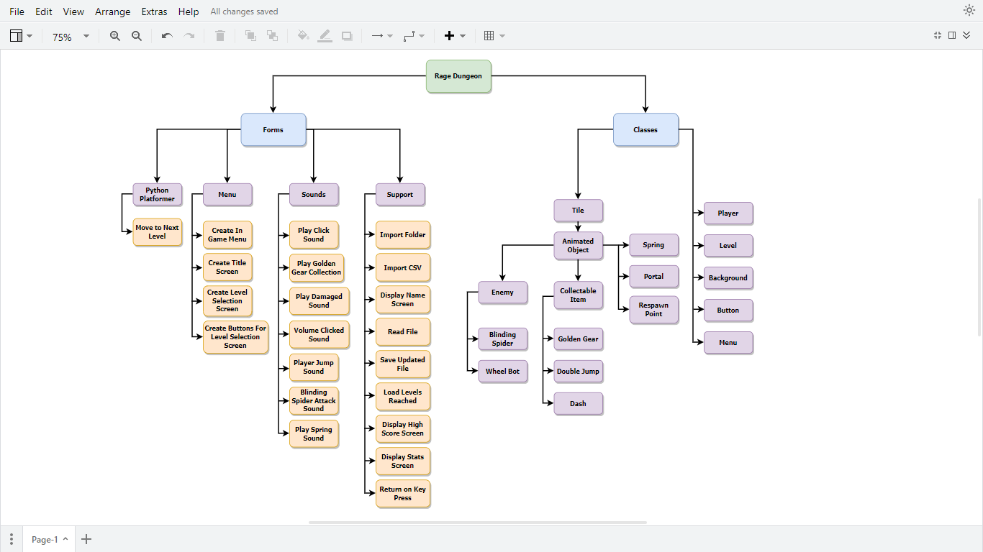

**Class Diagrams**

The class diagrams below are further decomposition of what I would like each class to be composed of. This includes their main variables and methods that each object created by them will need.

**Spring**

**Portal**

**Animated Object**

**Tile**

Animation: 2D Array

Status: String

Frame Index: Integer

Animation Speed: Float

Image: Image

Animations: 2D Array

Path: String

Animation Speed: Float

Animations: 2D Array

Path: String

Animation Speed: Float

Type: String

Image: Image

ResetLevel(Offset)

Update(XShift)

Animate()

Animate()

ImportAssets(Path)

Update(XShift)

**Blinding Spider**

**Wheel Bot**

**Enemy**

**Respawn Point**

Speed: Int

Size: 2D Array

AnimationPath: String

Speed: Int

Size: 2D Array

AnimationPath: String

Animation Speed: Float

Type: String

FacingRight: Bool

ID: Integer

Animations: 2D Array

Path: String

Animation Speed: Float

Death()

Animate()

Animate()

Path: String

Path: String

**Double Jump**

**Dash**

**Golden Gear**

**Collectable Item**

Animations: 2DArray

InitialYPos: Integer

UpperBound: Integer

LowerBound: Integer

MoveUp: Bool

Path: String

ResetLevel(Offset)

Update(XShift)

ResetLevel(Offset)

Update(XShift)

**Background**

Image: Image

**Menu**

**Level**

**Player**

Image: Image

DisplaySurface: Surface

DisplayingMenu: Bool

MenuType: String

Return: Bool

Buttons: Sprite Group

MouseDown: Bool

TimerFont: Font

CurrentLevelNum: Int

PlayerLivesAndAbilities: List

PlayerLives: Integer

HealthBarImage: Image

DistanceMovedX: Int

WorldShiftX: Integer

InGameMenu: Menu

MenuDisplayed: Bool

CollectedGoldenGear: Bool

GoldenGearImg: Image

LevelStartTime: Time

FinishedLevel: Bool

RespawnPoint: Vector

FrameIndex: Integer

AnimationSpeed: Float

Direction: Vector

PlayerSpeed: Integer

JumpSpeed: Integer

Gravity: Float

DashSpeed: Integer

IsJumping: Bool

Alive: Bool

DoubleJump: Bool

Dash: Bool

Status: String

FacingRight: Bool

**Button**

Type: String

Image: Surface

ResetLevel(Offset)

Update(XShift)

ResetLevel(Offset)

Update(XShift)

ImportAssets(Path)

Animate()

GetInput()

TestDashing(OnRight)

GetStatus()

ApplyDash()

ApplyGravity()

PlayerDeath()

Jump()

Update()

SetupLevel(Layout)

ScrollX(Player)

CollisionCheck(Player)

ChangePlayerLives(Amount)

CheckResetLevel(Player)

UpdateTimer(DisableTimer)

Run()

# **Algorithms and Dry Runs**

To help me in developing my program, I have broken down each subroutine into basic pseudocode of what I would like the subroutine to do. These routines are split between My forms and Classes. Each routine is justified and tested.

|  |  |  |  |
| --- | --- | --- | --- |
| **Function** | **Justification** | **Pseudocode** | **Explanation** |
| Move to Next Level | Once a level is beaten it must move to the next one. This is a subroutine as it can be called multiple times throughout the game. | CurrentLevelNum = CurrentLevelNum + 1  If MaxLevelReached <= CurrentLevelNum then  MaxLevelReached = CurrentLevelNum  Endif  CSVPath = ‘Levels/Level ’ + CurrentLevelNum + '.csv'  return Level(ImportCSV(CSVPath), screen, CurrentLevelNum, InGameMenu), PlayerLivesAndAbilities), CurrentLevelNum, MaxLevelReached | The code increments the level number by 1 if they are not playing a previous level, then returns the level for that specific level number from the Level class, as well as the new current level num and max level reached. |
| Create In Game Menu | Allows the main game file to create the in-game menu, along with its buttons. | menu = Menu ([Menu background image path], Screen, “In-Game Menu”)  ButtonsToMake = [[‘ArrowDown’, 200, 200], [‘ArrowUp’, 400, 200], [‘Volume’, 300, 200], [‘Timer’, 300, 250]]  menu.CreateButtons (ButtonsToMake, MenuOffset)  return menu | An instance of the Menu class is created with the name ‘menu’ and given the background image path, surface to be drawn on, and menu type. The buttons to be made are then created with the menu.CreateButtons subroutine. The menu is then returned. |
| Create Title Screen | Allows main game file to create the title screen with the buttons ‘start’ and ‘load game’. | menu = Menu ([Title screen background image path], Screen, “Title Screen”)  ButtonsToMake = [[‘Start, 500, 300], [‘Load Game, 500, 200]  menu.CreateButtons (ButtonsToMake, MenuOffset)  return menu | Creates the menu in the type ‘TitleScreen’. Create the 2D array of buttons and create them. |
| Create Level Selection Screen | Allows main game file to create the level seletion screen. As the buttons are repetative (level 1 button, level 2 button, etc) it is done in a for loop. | menu = Menu ([Title screen menu background image path], Screen, “Level Selection Screen”)  ButtonsToMake = [['Level 0',550,200],['Level 1',240,270],['Level 2',550,270],['Level 3',850,270],['Level 4',240,350],['Level 5',550,350],['Level 6',850,350],['Level 7',240,430],['Level 8',550,430],['Level 9',850,430],['See Stats',150,180],['See High Scores',900,180]]  return menu | Creates an instance of Menu and returns it with the “Level Selection Screen” type. |
| Import Folder | This function will be used to import images into an array and return that array. This is needed for all my animated objects and player. | SurfaceList = []  For i = 0 to i = NumOfImages  FullPath = Path + “/” + i  ImageSurface = LoadImage( FullPath )  SurfaceList.append( ImageSurface )  Endfor  return SurfaceList | This subroutine will be used by all of my animated objects in my game. The path and number of animation frames are passed in, and an array of images is returned. |
| Import CSV | This function is vital to creating the world for the player to play. | Contents = []  CSVFile = LoadFile( FilePath )  For Row = 0 to CSVFile.Length()  Contents.append ( CSVFile[Row] )  Endfor  return Contents | The function will take a path and return a 2d array of the values of each tile (where a spike could be of the value 220) |
| Display Name Screen | Necessary for my game to have a user login system. Their name is taken in as input and returned upon the enter key. | PressedEnter = false  NameText = “”  While PressedEnter = false  InputKey = GetInput()  If InputKey == system.EnterKey then  PlayClickSound()  PressedEnter = true  return NameText  Else  NameText = NameText + InputKey  Endif  NameScreenMenu.run( NameText )  Endwhile | Loop infinitely until the user presses the enter key. Once the enter key is pressed, return the characters inputted by the user. |
| Save Updated File | Required to save the player data back into the text file upon saving the game. | PlayersFile = OpenFile (FilePath)  FileText = “”  For Row = 0 to PlayersFile.Length()  For Element = 0 to PlayersFile[Row].Length()  FileText = FileText + PlayersFile[Row][Element]  + “,”  FileText += “\n”  Endfor  FileText += NewPlayerData  PlayersFile.Write( FileText )  Endfor | This code will take the filepath of the player data text file, and the new player data, then save it. |
| Load Levels Reached | Needed to load the level of the player if they select ‘play’ on the title screen, as it should read the text file and find their max level number reached. | Name = Name.upper()  Lines = ReadFile( FilePath )  For PlayerInfo = 0 to PlayerInfo = Lines.Length()  If Lines[ PlayerInfo ] == Name then  PlayerID = PlayerInfo  MaxLevelReached = Lines[ 1 ]  return PlayerID, MaxLevelReached  Endif  Endfor | Takes the player file path and name of player as inputs, and returns the max level that player reached as an output. |
| Display High Score Screen | Will show the user a list of the top times achieved for each level, along with that player’s name. This is required as it has been layed out by my specification. | AllListsOfLevelTimes = []  ListOfLevelTimes = []  IndexesOFTimes = [2,4,6,8,10,12,14,16,18,20]  OutputTextLocations = [(180,220),(180,270),(180,320),  (180,370),(180,420),(700,220),(700,270),(700,320),  (700,370)]  Lines = ReadFile( Path )  For LineNum = 0 to LineNum = Lines.Length()  PlayerInfo = Lines[ LineNum ]  For LevelNum = 1 to LevelNum = 9:  ListOfLevelTimes.append( PlayerInfo  [(IndexesOFTimes[ LevelNum ])])  endfor  AllListsOfLevelTimes.append( ListOfLevelTimes )  ListOfLevelTimes = []  endfor  SortedLevelTimes = []  SortedPlayerNames = []    For LevelNum = 1 to LevelNum = 9:  BestPlayer = ""  LowestTime = 9000.0  For PlayerNum = 0 to PlayerNum =  AllListsOfLevelTimes.Length():  CurrentVal = AllListsOfLevelTimes  [PlayerNum][LevelNum]  If CurrentVal != "-1" and float(CurrentVal)  <= float(LowestTime) then  LowestTime = CurrentVal  BestPlayer = Lines[PlayerNum][0]  Endif  Endfor  SortedLevelTimes.append(LowestTime)  SortedPlayerNames.append(BestPlayer)  Endfor    Background = LoadImage( HighScoreScreenPath )  Screen.Display( Background, (0,0) )  For LevelNum = 1 to LevelNum = 9  Text = "Level " + LevelNum + ": " +  SortedLevelTimes[LevelNum-1] +  " (" + SortedPlayerNames[LevelNum-1] + ")"    Screen.Display(Text,  OutputTextLocations[LevelNum-1])  Endfor  ReturnUponKeyPress(MaxLevelReached, PlayerID, PlayerInfoToSave) | The code here takes the image of the stats screen and player stats file as inputs, the outputs and displays a list of names and times for each level (level 1 to 9, where level 0 is the tutorial) |
| Display Stats Screen | Displaying the stats screen is needed to show the user their own personal best scores for each level they completed – as set out by my requirements. | GoldenGear = LoadImage( GoldenGearImgPath )  Screen.Display ( Background, (0,0) )  IndexesOFTimes = [2, 4, 6, 8, 10, 12, 14, 16, 18]    OutputTextLocations = [ (330,220), (330,270),  (330,320), (330,370), (330,420), (700,220),  (700,270), (700,320), (700,370) ]  For LevelNum = 0 to LevelNum = 8:  If PlayerInfo[(IndexesOFTimes[LevelNum])] != -1 then  If str(PlayerInfo[3+(LevelNum*2)]) == 'True’ then  screen.Display (GoldenGear,  (OutputTextLocations[LevelNum][0] - 50,  OutputTextLocations[LevelNum][1]))  Endif  Text = "Level " + str(LevelNum+1)  + ": " + PlayerInfo  [(IndexesOFTimes[LevelNum])] + "s"  Screen.Display(Text,  OutputTextLocations[ LevelNum ])  Endif  Endfor  ReturnUponKeyPress(MaxLevelReached, PlayerID, PlayerInfo) | This algorithm is called when the user presses the “see stats” button on the level selection screen. The algorithm inputs the menu and image for the golden gear, then outputs text onto the screen, displaying their best times achieved for each level (where only the best time is saved in the first place). |

|  |  |  |  |
| --- | --- | --- | --- |
| **Function** | **Input(s)** | **Process** | **Output(s)** |
| Move to Next Level | CurrentLevelNum = 3  MaxLevelReached = 5 | CurrentLevelNum = 4  CSVPath = ‘Levels/Level 4.csv’ | Returns Level 4 |
| Create In Game Menu | MenuBackgroundImg = ‘Assets/MenuImg’ | *Creates in-game menu under the name ‘menu’*  Sets ‘ButtonsToMake’ variable  Creates buttons on that menu | Returns In-Game Menu |
| Create Title Screen | TitleScreenMenu = ‘Assets/TitleScreenMenuImg’ | *Creates title screen menu under the name ‘menu’*  Sets ‘ButtonsToMake’ variable  Creates start and load game buttons on that menu | Returns Title Screen Menu |
| Create Level Selection Screen | TitleScreenMenu = ‘Assets/LevelSelectionScreenImg’ | *Creates title screen menu under the name ‘menu’*  Sets ‘ButtonsToMake’ variable  Creates level option buttons on that menu | Returns Level Selection Screen Menu |
| Import Folder | Path = ‘Assets/PlayerAnimations’ | Loop 1:  FullPath = ‘Assets/PlayerAnimations/0’  ImageSurface = LoadImage (‘Assets/PlayerAnimations/0’)  SurfaceList.append (ImageSurface)  Loop 2:  FullPath = ‘Assets/PlayerAnimations/1’  ImageSurface = LoadImage (‘Assets/PlayerAnimations/1’)  SurfaceList.append (ImageSurface )  Loop 3:  FullPath = ‘Assets/PlayerAnimations/2’  ImageSurface = LoadImage (‘Assets/PlayerAnimations/2’)  SurfaceList.append (ImageSurface )  …  Loop [last image number]:  FullPath = ‘Assets/PlayerAnimations/[last image number]’  ImageSurface = LoadImage (‘Assets/PlayerAnimations/[last image number]’)  SurfaceList.append (ImageSurface ) | Returns the completed surface list of the player animation images (to later loop through) |
| Import CSV | FilePath = ‘Assets/Levels/Level1.csv’ | CSVFile = LoadFile( ‘Assets/Levels/Level1.csv’)  Loop 1:  Contents.Append( CSVFile[0] )  Loop 2:  Contents.Append( CSVFile[1] )  Loop 3:  Contents.Append( CSVFile[2] )  … loops through every line in file | Returns Contents |
| Display Name Screen | NameScreenMenu | PressedEnter = False  NameText = “”  Loop 1:  InputKey = ‘J’  NameText = NameText + ‘J’  *Update Menu screen*  Loop 2:  InputKey = ‘A’  NameText = NameText + ‘A’  *Update Menu screen*  …  [Keep looping until the name ‘James has been inputted’]  Loop 3:  InputKey = ‘[ enter key/ carriage return ]’  PressedEnter = true | Returns ‘NameText’ (in this case ‘James’) inputted by the user. |
| Save Updated File | FilePath = ‘Assets/PlayersFile.txt’  NewPlayerData = ‘Harry, 0, -1, False, -1, False, -1, False, -1, False, -1, False, -1, False, -1, False, -1, False, -1, False,’ | PlayersFile = OpenFile ( ‘Assets/PlayersFile.txt’ )  Outer Loop 1:  Inner Loop 1:  FileText = PlayersFile[ 0 ][ 0 ]  Inner Loop 2:  FileText = PlayersFile[ 0 ][ 0 ] + PlayersFile[ 0 ][ 1 ]  … until all that player’s data has been added to file text (at loop 20)  FileText = PlayersFile[ 0 ][ 0 ] + PlayersFile[ 0 ][ 1 ] + … + PlayersFile[ 0 ][ 19 ] + ‘\n’  Outer Loop 2:  InnerLoop 1:  FileText = PlayersFile[ 0 ][ 0 ] + PlayersFile[ 0 ][ 1 ] + … + PlayersFile[ 0 ][ 19 ] + ‘\n’ + PlayersFile[ 1 ][ 0 ]  InnerLoop 2:  FileText = PlayersFile[ 0 ][ 0 ] + PlayersFile[ 0 ][ 1 ] + … + PlayersFile[ 0 ][ 19 ] + ‘\n’ + PlayersFile[ 1 ][ 0 ] + PlayersFile[ 1 ][ 1 ]  InnerLoop 3:  FileText = PlayersFile[ 0 ][ 0 ] + PlayersFile[ 0 ][ 1 ] + … + PlayersFile[ 0 ][ 19 ] + ‘\n’ + PlayersFile[ 1 ][ 0 ] + PlayersFile[ 1 ][ 1 ] + PlayersFile[ 1 ][ 2 ]  … until this inner loop reaches 20. The reason for 20 is because there are 9 levels. The player data should include the player’s name and max level num for the first 2 values ( PlayersFile[ x ][ 0 ] and PlayersFile[ x ][ 1 ] ). The other 18 values correspond to each level, which each have 2 things stored. The first stored value is the best time completed for that level (string value), the second is if they have got the golden gear for that level (bool value). See NewPlayerData input for an example.  Last outer loop:  FileText = FileText + NewPlayerData  PlayersFile.Write( FileText ) | Calls the write function to write the new file text to the players file (overriding it). |
| Load Levels Reached | Name = ‘James’ | Name = JAMES # Capitalising name for  validation purposes  Loop 1 (assuming the name JAMES is on line 2):  Nothing happens  Loop 2:  PlayerID = 1  MaxLevelReached = Lines[ 1 ] (for example 5) | Returns PlayerID and MaxLevelReached |
| Display High Score Screen | Path = ‘Assets/ Assets/PlayersFile.txt’  Screen | Lines = ReadFile( Assets/ Assets/PlayersFile.txt’ )  Outer Loop 1:  PlayerInfo = Lines[ 0 ]  # Appending all the level completion times from all players into a 2D array (ListOfLevelTimes)  Inner Loop 1:  ListOfLevelTimes.apend( PlayerInfo[2] )  ListOfLevelTimes.apend( PlayerInfo[4] )  ListOfLevelTimes.apend( PlayerInfo[6] )  ListOfLevelTimes.apend( PlayerInfo[8] )  …  ListOfLevelTimes.apend( PlayerInfo[20] )  Outer Loop 2:  PlayerInfo = Lines[ 1 ]  Inner Loop 1:  ListOfLevelTimes.apend( PlayerInfo[2] )  ListOfLevelTimes.apend( PlayerInfo[4] )  ListOfLevelTimes.apend( PlayerInfo[6] )  ListOfLevelTimes.apend( PlayerInfo[8] )  …  ListOfLevelTimes.apend( PlayerInfo[20] )  Outer Loop 2:  PlayerInfo = Lines[ 2 ]  Inner Loop 1:  ListOfLevelTimes.apend( PlayerInfo[2] )  ListOfLevelTimes.apend( PlayerInfo[4] )  ListOfLevelTimes.apend( PlayerInfo[6] )  ListOfLevelTimes.apend( PlayerInfo[8] )  …  ListOfLevelTimes.apend( PlayerInfo[20] )  … Until outer loop reaches all the players  AllListsOfLevelTimes.append( ListOfLevelTimes )  # Once a list of all level completion times is aquired, then sort through them  Outer Loop 1:  BestPlayer = “”  LowestTime = 9000 # So that there will always be a ‘quickest’ run  Inner Loop 1:  CurrentValue = AllListsOfLevelTimes[0][1]  *check if current value is better than the lowest time, if so then set the new ‘LowestTime’ and set ‘BestPlayer’ to their name *  Inner Loop 2:  CurrentValue = AllListsOfLevelTimes[0][2]  *check if current value is better than the lowest time, if so then set the new ‘LowestTime’ and set ‘BestPlayer’ to their name *  .. Keep looping until all player times have been checked for that level, then increment outer loop and check the next level. Append the best times and players to the lists ‘SortedLevelTimes’ and ‘SortedPlayerNames’. Repeat for all 9 levels to aquire a best player time, and name, for that level.  Loop 1:  Text = “Level 1: ” + SortedPlayerTime[0] + “( ” + SortedPlayerNames[0] + “ )”  Screen.Display(Text, OutputTextLocations[0])  # Where ‘OutputTextLocation’ is a list of predetermined co-ordinates for the text to be placed | Displays a menu with all the best level times, along with the player names, as a high sore page for each level. |
| Display Stats Screen | StatsScreenMenu  GoldenGearImgPath = ‘Assets/ GoldenGearImg.png’  PlayerInfo = [‘James, 10, 10.8, False, 40.6, True, -1, False, -1, False, -1 False, -1, False, -1, False, -1, False, -1, False,’] | GoldenGear = LoadImage(‘Assets/ GoldenGearImg.png’)  *display background image*  Loop 1:  If 10.8 != -1 then…  # Where 10.8 is a float (representing level completion time) found at PlayerInfo[ 2 ]  If ‘False’ == ‘True’ then  [ will not occur ]  Text = “Level 1: 10.8s”  *Display text at (330, 220)*  Loop 2:  If 40.6 != -1 then…  # Where 40.6 is found at PlayerInfo[ 4 ]  If ‘True’ == ‘True’ then  *Displays golden gear image at (280, 270), to the left of the level completion time text*  Text = “Level 2: 40.6s”  *Display text at (330, 270)*  Loop 3:  *Nothing happens as level time is -1, it has not been completed*  Loop 4:  *Nothing happens as level time is -1, it has not been completed*  Loop 5:  *Nothing happens as level time is -1, it has not been completed*  Loop 6:  *Nothing happens as level time is -1, it has not been completed*  Loop 7:  *Nothing happens as level time is -1, it has not been completed*  Loop 8:  *Nothing happens as level time is -1, it has not been completed*  Loop 9:  *Nothing happens as level time is -1, it has not been completed* |  |

# **Usability Features**

|  |  |  |
| --- | --- | --- |
| **Feature** | **Description** | **Justification** |
| Graphical Menu User Interface | The menus in my game will include simple buttons, which will be used to help navigate around my game. These menus will be made with the pixel art theme in mind. | By having an interactive menu, with clearly labelled, large buttons, the user will be able to get to their desired destination quickly. |
| Intuitive Controls | The user will use the left and right arrow keys to navigate the player left and right, along with the space bar to jump. Other special abilities will be made use of on similar places on the keyboard. | Controls found in my researched solutions, such as Celeste and Hollow Knight, make use of arrow keys and the space bar for basic movement. I have chosen to replicate this in my game to give users a familiar feeling when playing. Some other computer game user wasd as controls for movement, hence I also plan on adding the ability to change the controls within the in-game menu of my game. |
| Movement and Ability Tips | When starting the game, or coming across a new ability, the user should be prompted with the controls specifying how to use that ability. | Communicating how the user can move or use special abilities is vital to playing the game. If it wasn’t included then they would have to try every key to activate the ability. |
| Helpful sound cues | When the user is navigating menus and clicks a button, there will be a sound cue to let them know when they’ve pressed it. Other examples of sounds include jumping, collecting items or activating a respawn point. | Audible feedback to the user will ensure they know an action has taken place. This is important in cases such as the respawn point, if there is no feedback when the user activates a respawn point, they will not know if it has been activated, and might lead to confusion. |
| Adjustable music + sounds | The in-game menu will include buttons to turn down the music and sounds, or choose to mute them straight away. | Adjustable sound means users can play the game without disturbing others, if they wish to use their own music, if their headphones cannot be adjusted, or any other reasons. |

# **Key Classes and Variables**

|  |  |
| --- | --- |
| **Key Class** | **Justification** |
| Tile | The tile class is how my game will be pieced together. Each instance of the tile class will consist of attributes such as their type. For example, tiles may consist of walls, floors, platforms, enemy spawn points and more. More specific types of tiles, such as animated tiles will make use of this class by inheriting its methods, making the general tile class beneficial and essential. |
| Animated Object | This will be the main class to inherit from the tile class. The purpose of this class is to create a tile with an animation routine. This shared routine will give each object the ability to loop through a set of imported images during run time. This is necessary to adding movement and life to my game. |
| Respawn Point | The respawn point is a necessary class, inheriting from animated object, as it needs to record its own identification number so that the game can differentiate between each point. The reason it is a key class is because my game makes use of respawn points frequently, and forms quite an essential part of the gameplay – also outlined in my success criteria. |
| Enemy | This class, also inheriting from the animated object class, allows different types of enemies to have their own collision detection, movement, animations and more. |
| Collectable Item | This class inputs attributes such as starting position and image paths, and causes it to move up and down, acting as a ‘collectable’ in the game. Once collected, the respective methods will be called (such as giving the player an extra life). |
| Player | The player class is essential for the game to be played. This class will handle all the methods and attributes that the player needs when traversing the level. By having it as a class, one major benefit is the ease of creating a new player when spawning in a new game, or upon player death. |
| Level | This class is essential for the game to function - it will contain various functions to setup and run the level. Setting up the level will involve placing all the different types of tiles at specific places on the screen. Running the level will involve things such as collision detection, checking for inputs and much more. |
| Menu | The menu class will be needed to create all the menus, level selection screens, high score screens and every other screen that isn’t the game itself. This necessary class will take inputs such as a background image and various buttons to create – and run the respective methods when those buttons are clicked. |

|  |  |  |  |  |
| --- | --- | --- | --- | --- |
| **Variable Name** | **Data Type** | **Description and Justification** | **Validation needed** | **Justification** |
| Type | String | The ‘type’ variable will hold the type of tile it is. For example, a ‘damaging‘ tile should kill the player on impact. | None Needed |  |

**Tile**

|  |  |  |  |  |
| --- | --- | --- | --- | --- |
| **Variable Name** | **Data Type** | **Description and Justification** | **Validation needed** | **Justification** |
| Animations | 2D array | This array will contain sub arrays of each set of animation images. For example, the respawn point could have a ‘idle’ and ‘saving’ routines. | None Needed |  |
| Status | String | A variable to store what animation to run in the current moment, such as ‘Idle’. | None Needed |  |
| FrameIndex | Integer | The frame index represents the value of animation frame currently being played. | Between 0 and 1 less than the number of animation images. | So that an out of bounds error is not caused by the algorithm trying to fetch an item in the array that isn’t there. |
| AnimationSpeed | Float | The animation speed is a float that determines how quickly the animation frames of each animated object iterate through. | None Needed |  |

**Animated Object**

**Respawn Point**

|  |  |  |  |  |
| --- | --- | --- | --- | --- |
| **Variable Name** | **Data Type** | **Description and Justification** | **Validation needed** | **Justification** |
| ID | Integer | The integer value of the respawn point to uniquely identify each one. They are sorted by its y co-ordinates left to right. | The ID Number will need to be in an integer list of 1,2,3... up to the number of respawn points. | The respawn points must be in sequential order as the player cannot go back and set their spawn point at a previous point, hence they must be identified correctly. |
| Animations | 2D Array | This array will contain each sub array of animations. For example, the respawn point could have a ‘idle’ and ‘saving’ animation frames stored. | None needed |  |
| Path | String | A string which leads to the path where the animations can be found. | None needed |  |

|  |  |  |  |  |
| --- | --- | --- | --- | --- |
| **Variable Name** | **Data Type** | **Description and Justification** | **Validation needed** | **Justification** |
| AnimationSpeed | Float | The animation speed is a float that determines how quickly the animation frames of each animated object iterate through. | None Needed |  |
| Type | String | This variable describes what type of enemy it is, discerning each one. This will not uniquely identify each enemy, but instead gives a way to loop through all of one specific type of enemy. | None Needed |  |
| FacingRight | Bool | Used to specify if the enemy is facing right or left. | None Needed |  |

**Enemy**

**Collectable Item**

|  |  |  |  |  |
| --- | --- | --- | --- | --- |
| **Variable Name** | **Data Type** | **Description and Justification** | **Validation needed** | **Justification** |
| Animations | 2D array | This array will contain each sub array of animations. For example, the respawn point could have a ‘idle’ and ‘saving’ routines. | None Needed |  |
| InitialYPos | Integer | Gives the collectable item a way to move up and down between the initial y position and a set distance below (LowerBound). | None Needed | Could be any value on the screen. |
| lowerBound | Integer | The y co-ordinate of the top left of the sprite when it reaches the lowest point before it should turn around and move upwards. | None Needed | Could be any value on the screen. |
| MoveUp | Bool | A boolean keeping track of whether the collectable item is moving up or down in the current moment. | None Needed | Can only be true or false. |

**Player**

|  |  |  |  |  |
| --- | --- | --- | --- | --- |
| **Variable Name** | **Data Type** | **Description and Justification** | **Validation needed** | **Justification** |
| RespawnPoint | Vector | The respawn points represent the co-ordines of the player when they first touched the respawn point. This needs to be stored in order to place the player back to that position upon player death | Must correspond to the top-left of the player when they touched the respawn point | If the co-ordinates do not correspond then the player might spawn inside a wall and lag through the map |
| FrameIndex | Integer | The frame index represents the value of animation frame currently being played | Between 0 and 1 less than the number of animation images | If the number is out of those bounds, then the algorithm will produce an out of bounds error |
| AnimationSpeed | Float | The animation speed is a float that determines how quickly the animations of each animated object increments by | None Needed |  |
| Direction | Vector | The input from the player is what affects this variable, which then goes on to affect the player sprite. For example, if the player holds the left arrow then the first value of the vector will become -1. | None Needed |  |
| PlayerSpeed | Integer | This integer value is what the x-direction of the above variable is multiplied by. This then becomes the value to move the player by that frame. | None Needed |  |
| JumpSpeed | Integer | The jump speed is the value the player initially has when pressing the space bar. | None Needed |  |
| Gravity | Float | The amount the y-direction of the player is reduced by each frame. | None Needed |  |
| DashSpeed | Integer | The initial dash speed of the player when they press the shift key. | None Needed |  |
| IsJumping | Bool | A variable to determine if the player is jumping or not. | None Needed | Can only be true or false. |
| Alive | Bool | A variable to determine is the player is alive or not. | None Needed | Can only be true or false. |
| DoubleJump | Bool | A variable to store if the player has gotten the double jump or not. | None Needed | Can only be true or false. |
| Dash | Bool | A variable to store if the player has gotten the dash ability or not. | None Needed | Can only be true or false. |
| Status | String | A variable to store what animation to run in the current moment. | None Needed |  |
| FacingRight | Bool | A variable to determine if the player is facing right or left. | None Needed | Can only be true or false |

**Level**

|  |  |  |  |  |
| --- | --- | --- | --- | --- |
| **Variable Name** | **Data Type** | **Description and Justification** | **Validation needed** | **Justification** |
| CurrentLevelNum | Integer | An integer to keep track of the user’s current level. This is needed when accessing the level file itself, or other scenarios such as saving and exiting the game. | None Needed |  |
| PlayerLivesAnd  Abilities | List | This is a list which contains the number of lives, and what abilities the player has unlocked, eg: [4, True, False]. This is used when saving player data so their abilities and lives from their last level can be restored. | None Needed |  |
| HealthBarImage | Image | A variable used to contain the image of the health bar which will be found on the screen when the user is playing. This needs to vary when the user loses/ gains lives. | None Needed |  |
| DistanceMovedX | Integer | This integer value keeps track of the distance moved in the x direction when the user hits a respawn point. This means when the player dies, the world must move back by this amount, then the player is placed on the co-ordinates they initially touched the respawn point at. | None Needed |  |
| WorldShiftX | Integer | The amount the world shifts to the left or right by. When the user hits the right barrier of the screen, they must have their speed set to 0, and the world to move by the negation of their speed to give the illusion of running. | None Needed |  |
| InGameMenu | Menu | The in-game menu must be called when the user presses the escape bar. It is loaded upon game start-up so that items such as sound level stay consistent through each level. This means it must be stored under a variable which is passed in and out of the level each time a new one is loaded/ closed. | None Needed |  |
| MenuDisplayed | Bool | A boolean to state if the menu is currently being displayed. If it is, then this will mean the player should be unable to move. | None Needed | Can only be true or false. |
| CollectedGoldenGear | Bool | This bool will be flagged to true when the user collects the golden gear in game. This is not a list or array as there is only one golden gear per level. | None Needed | Can only be true or false. |
| GoldenGearImg | Image | This contains the image for the above stated golden gear. | None Needed |  |
| LevelStartTime | Float | When a level is loaded, it is taken to the nearest second and stored in this variable. To create a count-up timer, the current time must be subtracted from the level start time each frame. | None Needed |  |
| FinishedLevel | Bool | A boolean value to be called on to see if the level has been completed by the player. | None Needed | Can only be true or false. |

**Menu**

|  |  |  |  |  |
| --- | --- | --- | --- | --- |
| **Variable Name** | **Data Type** | **Description and Justification** | **Validation needed** | **Justification** |
| DisplaySurface | Surface | The variable is used to put all the items of the menu onto, so that this display surface can then be moved onto the screen. | None Needed |  |
| DisplayingMenu | Bool | A boolean to determine whether the menu is currently being displayed or not. | None Needed | Can only be true or false. |
| MenuType | String | Allows the game to perform various tasks within the same algorithms, without having multiple different classes for the different types of menus. | None Needed |  |
| Return | Bool | To be set to true if the user selects ‘return’ in the in-game menu. This needs to be an independent variable as the core algorithm cannot be reached from the menu routine, hence it needs to be the other way around. | None Needed | Can only be true or false. |
| Buttons | Sprite Group | The buttons all need to be within one sprite group so that they can all be looped through to check if they have been pressed. This is also useful when performing tasks all the buttons have, such as playing a click sound. | None Needed |  |
| MouseDown | Bool | Set to true when the user presses a button. Once it is determined which button has been pressed the individual routine is then carried out. | None Needed | Can only be true or false. |

# **In-Development Test Data**

Whilst my program is being developed, there will need to be checks done on each method to ensure they all work as intended. I have chosen to exclude methods inside the classes until after the development stage as they rely on one another to function, hence it would be difficult to test them individually throughout development. All the subroutines listed below contain important features necessary for my program to fill the success criteria.

|  |  |  |  |
| --- | --- | --- | --- |
| **Method** | **Input(s)** | **Expected Output** | **Justification** |
| MoveTo  NextLevel | User hits the portal and completes a level. | Returns an instance of the level class (the next level), the current level number, and max level reached. | The routine is needed to create a new level, increment values and reset others back to default. |
| CreateIn  GameMenu | User boots up the game, and presses the esc key once in a level. | Menu is created with the buttons ‘Volume’, ‘Timer’, ‘Return’, ‘Exit’. | This is needed to allow the user to change the volume level, disable the timer, return to the level selection or quit the game. |
| CreateTitle  Screen | User boots up game and enters their name. | The title screen with the buttons ‘Start’, ‘Load Level’ are created | The title screen is required to decide if the user wants to carry on from where they left off, or select a previous level to redo. |
| CreateLevel  SelectionScreen | User selects ‘Load Level’ from the title screen | Creates a menu with buttons to select levels 1 through 9, along with the high score and stats table. | Needed so that the user can play previous levels, to improve their time or go back to collect the golden gear. |
| PlayClickSound | User clicks a button on any menu. | Plays menu click sound effect. | User immersion when playing the game. |
| PlayDamaged  Sound | User takes damage within the game (e.g. jumps on a set of spikes) | Plays the player damaged attack sound effect. | User immersion when playing the game. |
| VolumeClicked  Sound | User turns the volume down. | Plays a sound effect for when the volume level is changed. | User immersion when playing the game. |
| PlayerJump  Sound | User pressed the space bar. | Plays a sound effect for when the player jumps. | User immersion when playing the game. |
| BlindingSpider  AttackSound | User is attacked by the blinding spider enemy. | Plays blinding spider attack sound. | User immersion when playing the game. |
| ImportFolder | Player loads into game. | Player animates correctly. | All animated objects need to animate for the game to run smoothly. This routine is used by all of them. |
| ImportCSV | Player Loads into world. | World loads correctly, with the correct tiles corresponding to the correct value in the CSV file. | Used by the level class to get the array of tile types upon its creation. |
| DisplayName  Screen | Game is loaded. | Displays a screen that prompts the user for their name, and returns their name upon the user pressing the enter key. | Their name will be used to save and read from the text file. This simplifies the login system to just be their name. As the program can only be used on a local computer I’ve deemed this to not be a security error. |
| ReadFile | User loads the stats screen. | The user should be able to view their stats and have access to any levels they have already completed. | Needed to help read in the file into lines of text that can be interpreted more easily, in lists. |
| SaveUpdated  File | User exits the game. | File is saved in the correct format, with each player’s info on separate lines, and each value separated by a comma. | Allows data to be saved when a player exits the game. |
| LoadLevels  Reached | Player enters their name upon loading the game and clicks the ‘Load level’ button from the title screen, or the ‘Return’ button from the in-game menu. | If the user is already in the save file then read and restore their abilities and return these values (setting lives back to 5). If they are not in the file, then create a new save location and write this into the file. Set and return the lives and abilities of the new player. | This routine is used to check their name against the save file to see if they are already there. If they are, then restore any abilities they have achieved and return them. If not, then the program will create a new slot to save to so that the new player can access this data in future. |
| DisplayHigh  ScoreScreen | User selects the ‘Highscores’ button from the level selection menu. | The method will search each player’s time for each level and displays the player who achieved the lowest time score. | The high score screen is a part of my success criteria, and an important part of a game focused around completing levels in a timed condition. |
| DisplayStats  Screen | User selects the ‘Show Stats’ button from the level selection menu. | The method should display the user’s time scores for each level, as well as if they have collected the golden gear. | The player will want to have an overview of their own scores, before replaying levels and attempting to beat their score. |

# **Post-Development Test Data**

To assess the robustness of the finished program all the main aspects of my game will be assessed, ensuring each success criteria will be evaluated upon the project’s completion. This will be tested for by giving my program normal, extreme, and erroneous data for each of the main classes in my game.

|  |  |  |  |
| --- | --- | --- | --- |
| **Aspect To Test** | **Input(s)** | **Expected Output** | **Justification** |
| **Tile Class** | **Normal:** Player death. | To move all the tiles by the amount the player has moved since reaching the last checkpoint. | Needed so that the entire world can be ‘reset’ with one method, for example on the player’s death. |
| **Normal:** Player holds the right arrow key until they hit the right boundary, where Xshift = -7 (where 7 represents the player speed). | To shift all the tiles to the left by 7 each frame. | Used when the player tried to move past the boundary on the screen. This prevents the player character from disappearing from the screen. |
|  | **Extreme:** Player performs a dashing ability whilst on the border of the boundary. | To take account of how far the player has travelled each frame, move the world by the negation of that value, and ensure the player does not move past that boundary. | If the player were to perform a dash against the boundary of the world then, due to the varying speed of the dash, it could have some unexpected outcomes. |
|  | **Erroneous:** N/a |  |  |
| **Animated Object Class** | **Normal:** Game is started | Each animated object adds all lists of images for each animation. | Needed for the update method, to loop through the images in the current animation state. |
|  | **Extreme:** Player dashes through a respawn point | The respawn point animates and saves the current co-ordinates of the player correctly. | Once acquired, the dashing ability will help the player traverse the world quicker, hence it might be used more often than intended for specific jumps – this must be addressed when it comes to animated objects, especially respawn points. |
|  | **Erroneous:** N/a |  |  |
| **Enemy Class** | **Normal:** Enemy hits a damaging tile | Kill the enemy. | This is to prevent the enemy from making specific jumps or navigation impossible to the player. |
|  | **Extreme:** Enemy collides with player whilst dashing. | To kill the player. | No matter what action the player is doing, they must be stopped and perform their death routine if struck by an enemy. |
|  | **Erroneous:** Enemy becomes stuck inside a tile/ wall . | To kill the sprite. | If any collision detection does not work correctly, the enemy might end up inside tiles (walls). To prevent this from impacting the gameplay this must be checked for and prevented in advance. |
| **Collectable Item Class** | **Normal:** Game is started | Move the object up and down between two y values. | To create the illusion that the object is floating and needs to be collected. |
|  | **Normal:** The player makes contact with the collectable item | The item is removed from the screen, plays a collection sound and the player acquires the item. | This must be prevented so that collectable item’s can always be collected and not appear to move faster than the frame rate. |
|  | **Extreme:** N/a |  |  |
|  | **Erroneous:** N/a |  |  |
| **Level Class** | **Normal:** Game is started | To Initialise the Level, setting all attributes to default, e.g. setting ‘FinishedLevel’ to false. | Values must be restored so that the level can be played. |
|  | **Normal:** Game is started | To loop through each value in the level layout and create the corresponding tile for that predefined value found in the CSV. This routine also arranges the respawn point ID’s. | Routine is necessary to creating the level with the tiles in their corresponding places. |
|  | **Normal:** Player hits boundry and shifts world. | To scroll the level left and right depending on the players x co-ordinates, setting the Xshift value used by Tile and AnimatedObject update functions. | Moving level left and right is needed to keep the player from leaving the screen. Once the player hits the boundary, and is still holding the arrow key to move in that direction, the Xshift is set as the negation of the player’s speed. |
|  | **Normal:** Player collides with tiles | The collision between the type of tile and player is identified and the corresponding routine is put into motion. | Required to detect collisions between the player sprite and any other sprites they may be touching. |
|  | **Normal:** Player dies | To reset the level at the corresponding checkpoint upon player death. This routine also controls the animations of the respawn points themselves, as well as resetting the tiles in the level and other attributes. | This routine controls where the player goes after death. This is required for the player to continue playing after they die, a required feature of my game. |
|  | **Extreme:** Player toggles the timer on and off repeatadly. | To calculate the time that has elapsed since the level began and render that value onto the screen if the user hasn’t disabled the timer. Retain this value so that it can be rendered once again if the user decides to enable the timer once more. | The timer should always be available to the player and should not be ‘locked’ off when toggled to be so. The timer should be flexible and allow the player to change their mind mid level – multiple times. |
|  | **Erroneous:** N/a |  |  |
| **Menu + Button Classes** | **Normal:** User navigates through the menus/ presses escape and brings up the in-game menu. | For each location in the 2D array of button locations create an instance of the button class. Render these buttons on a surface, along with the menu background, and place onto the screen. | This is necessary for the menus to work – the buttons must appear in the correct locations assigned to them. |
|  | **Extreme:** User clicks an area of the screen where the button from one menu overlaps the button from the next. | The initial button that had been pressed should be the only one registered as clicked. | This is to stop the game from clicking through multiple menus with one click. |
|  | **Erroneous:** N/a |  |  |

**DEVELOPMENT**

# **Prototype 1 – Scrolling Tiles**

Main File

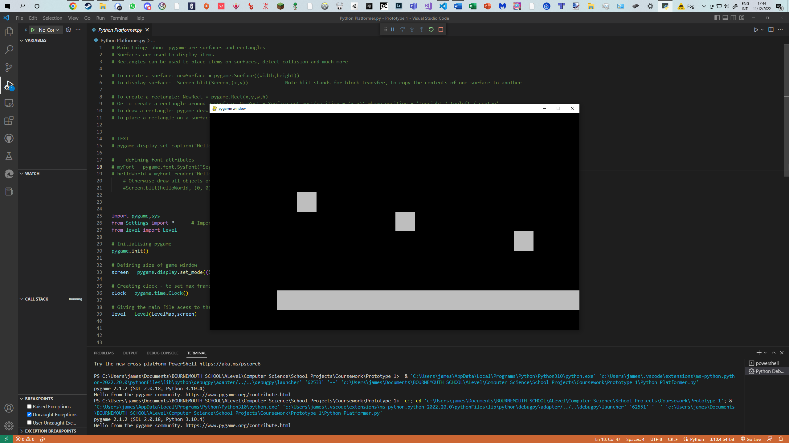

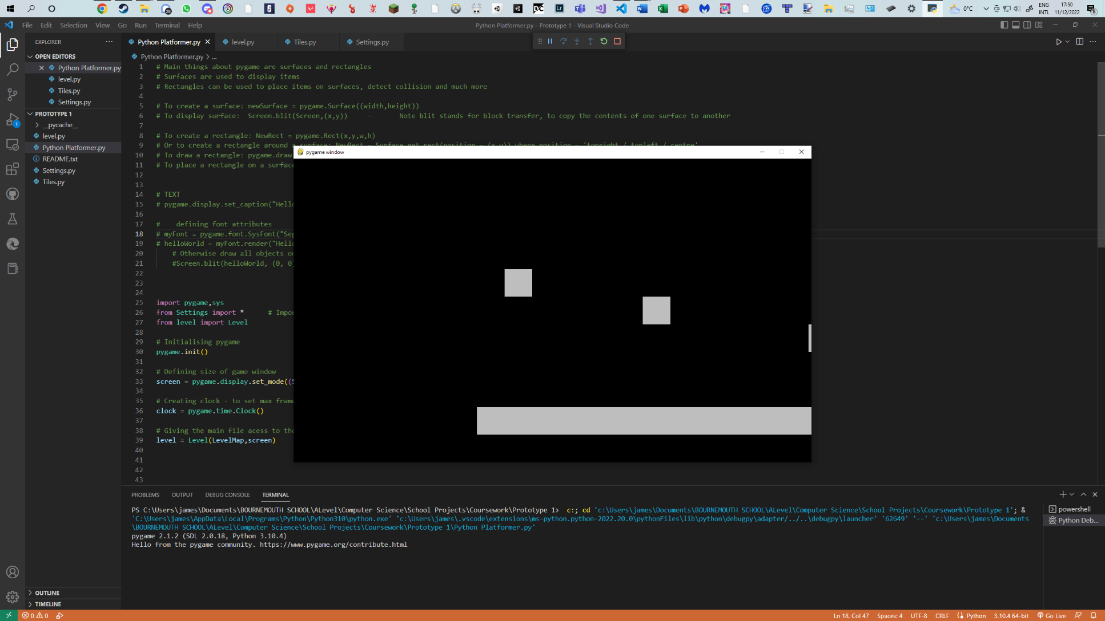

Current File Listing

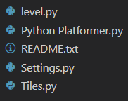

**Overview and Justification**

For my first prototype, I wanted to be able to import an array of characters and draw tiles on the screen. Incorporating OOP into this process allowed me to easily loop through each tile (white square) and move it along to the right or left by an integer value every frame.

This is necessary as my final game will be made from the player jumping from platform to platform (using these tiles), hence a dynamic, iterative level creation based off a 2D array is ideal. Moving the tiles horizontally is also needed as the player will need to traverse this world moving left and right. Lastly, using OOP and separate files will create more modular and dynamic code – both requirements laid out in my specification.

**Problems**

Whilst doing this prototype I found myself not having had any problems other than simple syntax errors in Pygame as this was my first time downloading and importing it.

To help me with this I used YouTube videos and Stack Overflow (see the bibliography).

**Validation**

This prototype needs no validation – the user is not able to use any form of keyboard input or interact with the game in any way possible. The user is only able to click on the exit button as seen in the top right of the screenshots (part of the PyGame interface), hence no validation is required.

**Testing**

Here, I am testing the input values for the world shift speed to ensure it moves left and right correctly, at the set speed.

|  |  |  |
| --- | --- | --- |
| **Input** | **Expected Output** | **Actual Output** |
| 1 | World to move slowly to the right | * World to moves slowly to the right |
| -10 | World to move quickly to the left | * World to moves quickly to the left |
| 10 | World to move quickly to the right | * World to moves quickly to the right |

**Review**

Features implemented successfully:

* A dynamic tile grid based on a 2D array
* Shifting the world along the horizontal axis
* Use of Pygame, classes and multiple files

Features implemented unsuccessfully:

* None

I am extremely glad with my first prototype as it was designed to demonstrate the achievement of passing in a 2D array and creating ‘Tile’ objects under the parent class of ‘Tiles’ – and I did just that. This can scroll right or left at any integer pace. The screenshots above are about 5 seconds apart. The tiles are linearly moving to the right by 1 pixel every 60th of a frame (this is because I have set pygame’s clock function to run my program at a maximum of 60 frames per second, and the code is called once per frame).

# **Prototype 2 – Implementing Player**

Main File

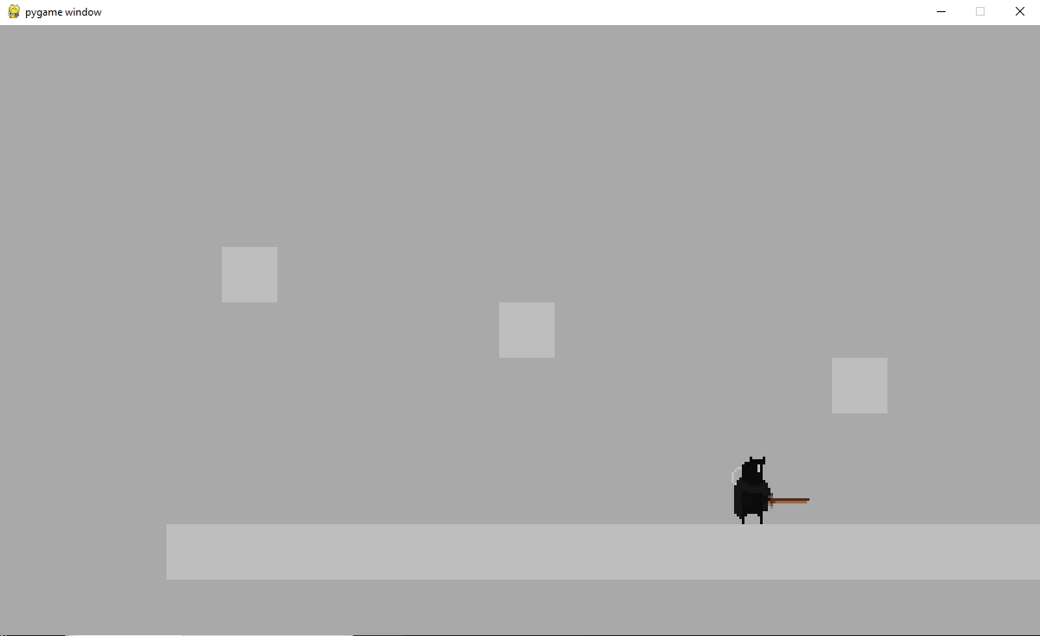

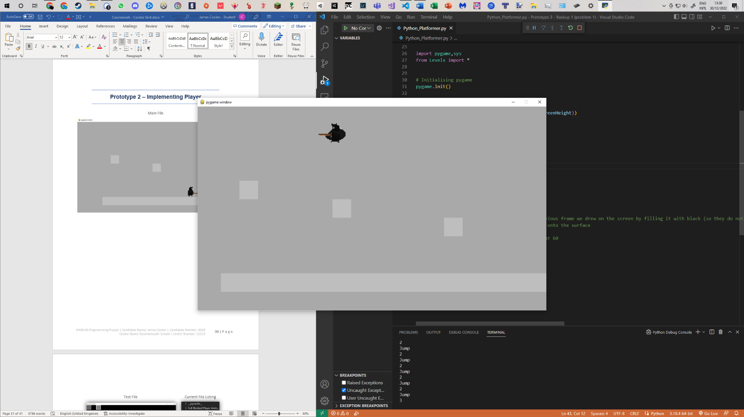

Current File Listing

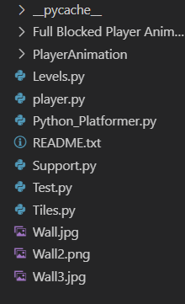

**Overview and Justification**

For the second prototype I wanted to add the player. The player should be able to move left, right, jump, have gravity, have collision checking and have animations for all the above.

This is necessary for my game as the platformer needs a player. I decided to add the player here as my previous prototype involved the successful implementation of scrolling tiles as separate objects which will be able to be checked for collision.

**Problems**

**Problem 1 - Collisions**

Detecting collisions in PyGame is extremely simple, and the [ ‘rect1.colliderect(rect2)’ ] format will work in most cases; however, it cannot tell where it occurs. For example, take the following code:

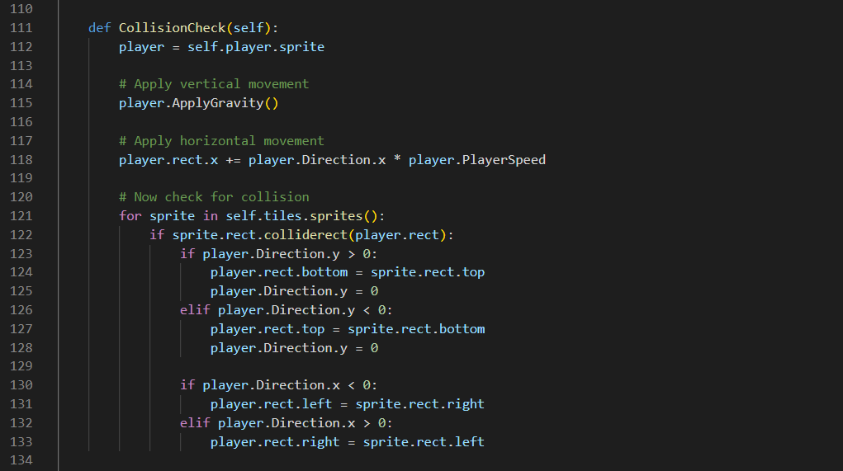

|  |  |  |
| --- | --- | --- |
| **Input/ Event** | **Expected Output** | **Actual Output** |
| Player standing on tile | Player remains stationary (gravity is applied but player is reset back to the top of the block each frame) | * Player remains stationary |
| Player colliding with tiles on the right and below | Player can’t walk any further as they have hit the block | * Player lags through the tile on the right and falls off the level |

Here, the horizontal and vertical movements are applied, then the collisions are to take place. For context, the player’s direction is used to determine whether the player is moving up, down, left, or right – in the form of a 2D vector. Once the player has been moved, it is then checking if the sprite’s rectangle (rect) has come into contact with the tiles. The problem here is that it does not consider the player to be moving in both directions simultaneously. Take the player falling off a ledge and hitting a wall on the right; if the player now collides with the right wall, it will flag as a collision in the y direction and will send the player on top of the tile, instead of the left. The x and y movements must be applied and checked separately. See the fixed code below.

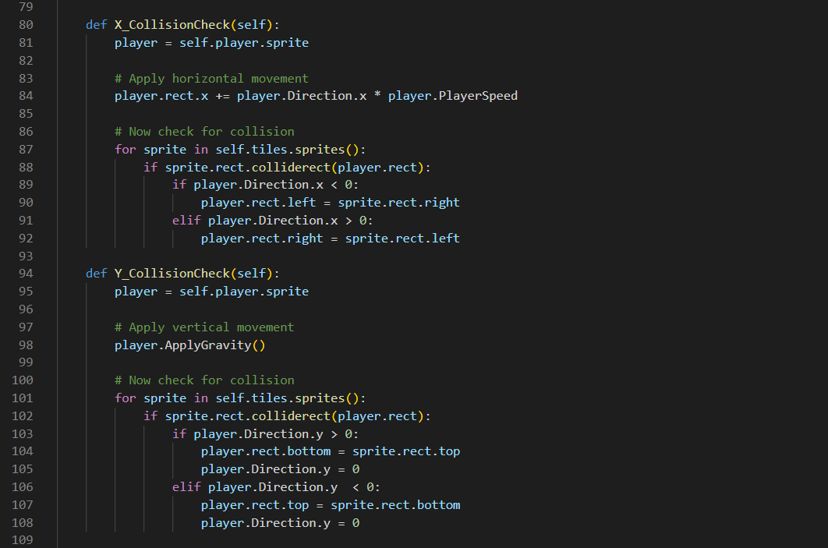

These routines are called in the level’s ‘run’ function, hence every 60th of a second.

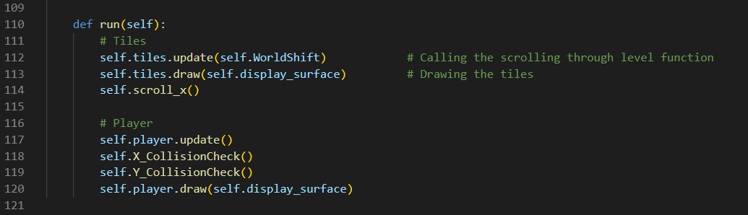

Below is a screenshot of the player standing on a ledge. It is currently a red rectangle as animation is something that should be added after collision and player movement.

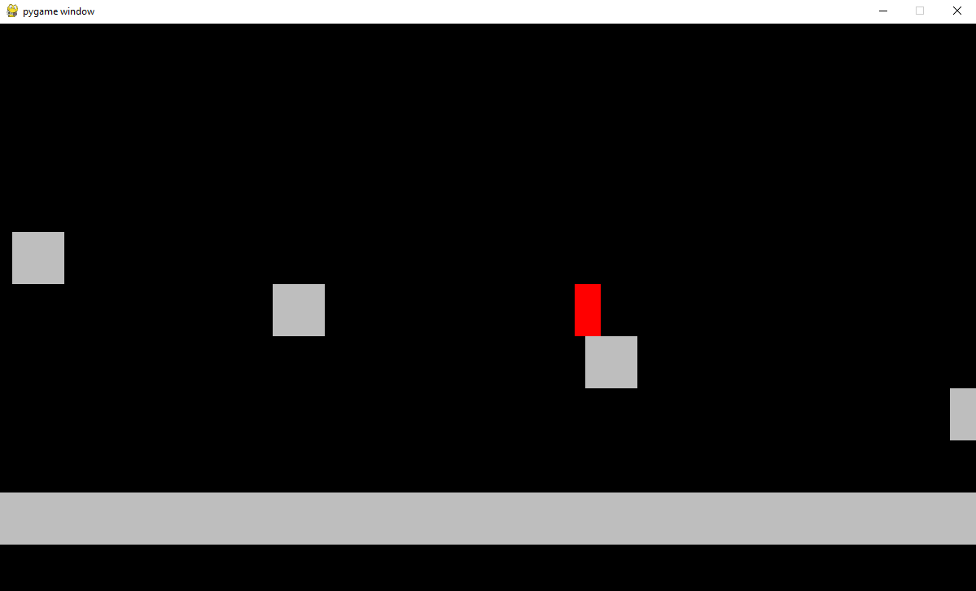

**Problem 2 – Player Jumping and General Status**

To help with your understanding of how my player jumps, please see this code snippet of my player input.

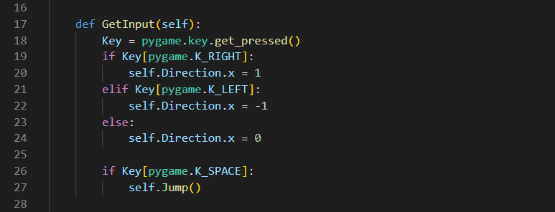

The player’s y direction is slightly different to how the x direction is used. When moving the player horizontally I switch their direction from 1 to -1. This is then multiplied by the player’s speed to then add on to their rect’s position. I decided not to use this method with the y-direction as the gravity needs to act directly on the number and not have to be multiplied up each time:

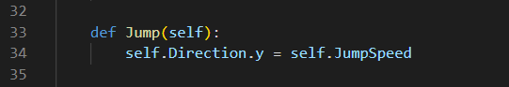

What if the player holds down the space bar? Well, their y direction (which is added directly onto their rect) is kept at their jump speed. A flag is needed to ensure they are on the ground. However, for the animation of my player, I will need to know if the player is running, idle, falling, etc. There is one solution to these problems.

State management: the solution to solving the jumping problem, and to help ease me into animating the player. Each state is a bool and now looks like this:

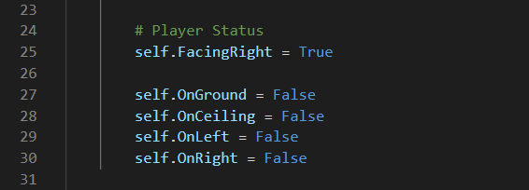

And so, the new state management can be used with the player’s input (and later use with animation)

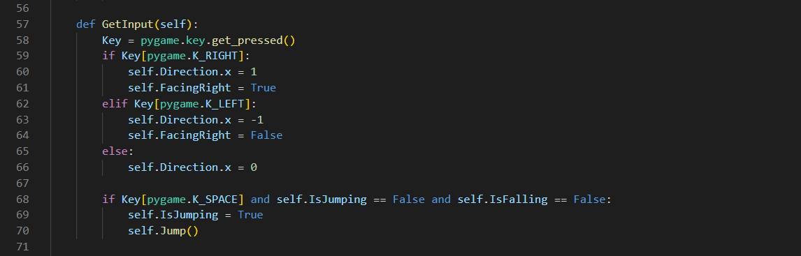

|  |  |  |
| --- | --- | --- |
| **Input/ Event** | **Expected Output** | **Actual Output** |
| Player jumping | Gravity is working as expected and ‘self.IsJumping’ is updated correctly | * Gravity is working as expected and ‘self.IsJumping’ is updated correctly |
| Player moving left | The attribute ‘self.Direction.x’ is set to -1 and ‘self.FacingRight’ is set to False | * The attribute ‘self.Direction.x’ is set to -1 and ‘self.FacingRight’ is set to False |
| Player moving right | The attribute ‘self.Direction.x’ is set to 1 and ‘self.FacingRight’ is set to True | * The attribute ‘self.Direction.x’ is set to 1 and ‘self.FacingRight’ is set to True |
| Player falling | Gravity is working as expected and ‘self.IsFalling’ is updated correctly | * Gravity is working as expected and ‘self.IsFalling’ is updated correctly |

**Problem 3 – Animation**

The problem I had here is that the image of my player was extremely small when standing still and normal size (but seemingly inside the tile) when walking. It was also difficult to see on the black background, so I have switched it to grey.

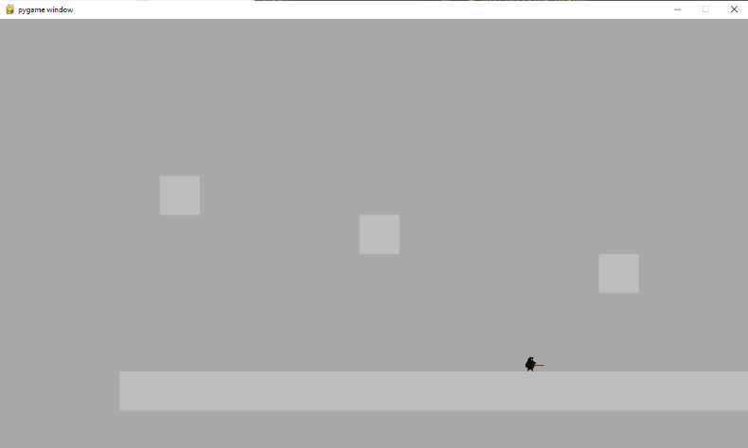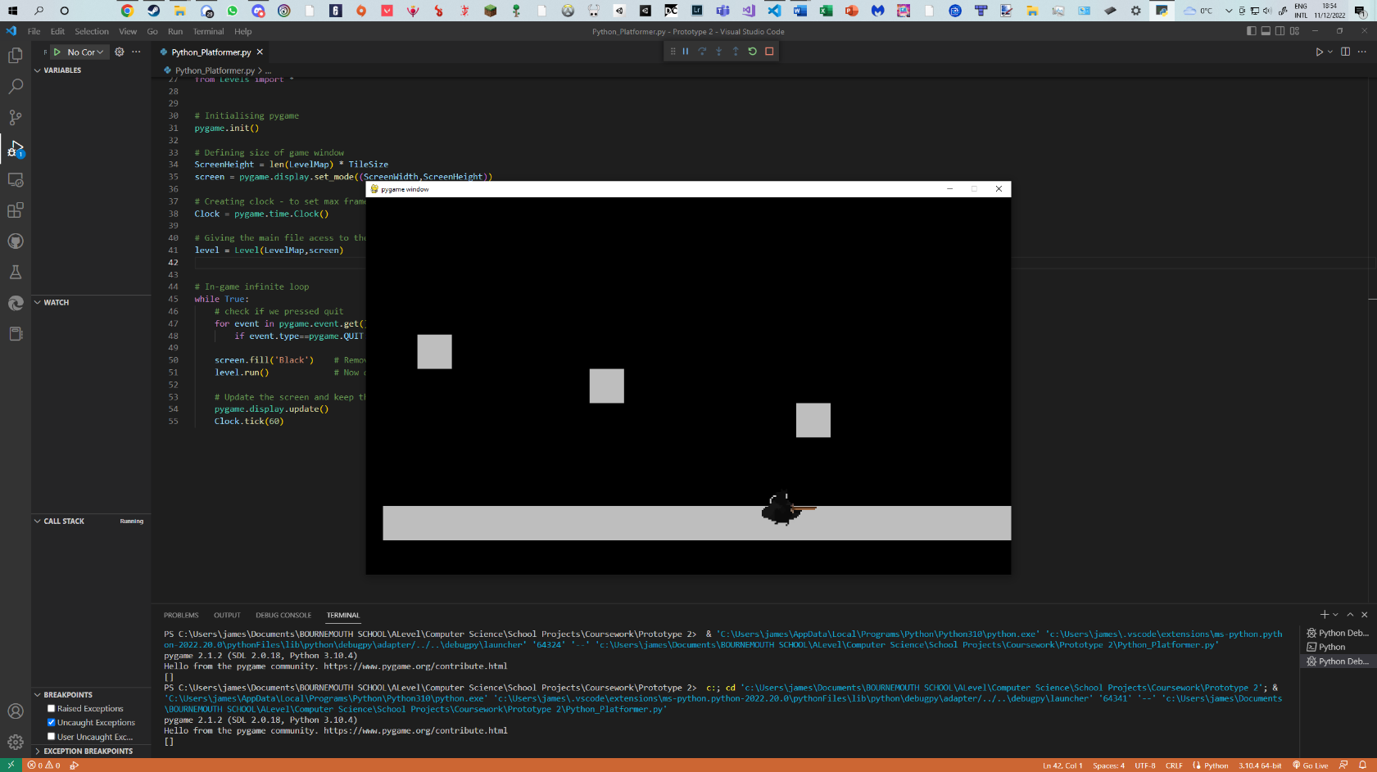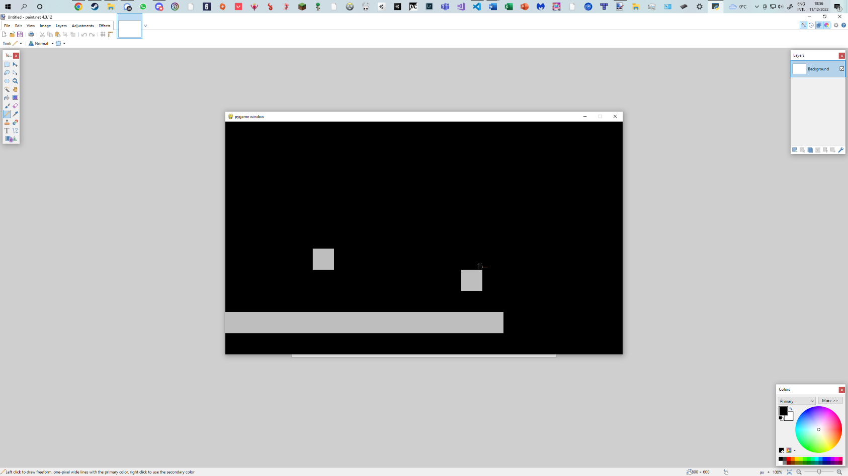

**Player**

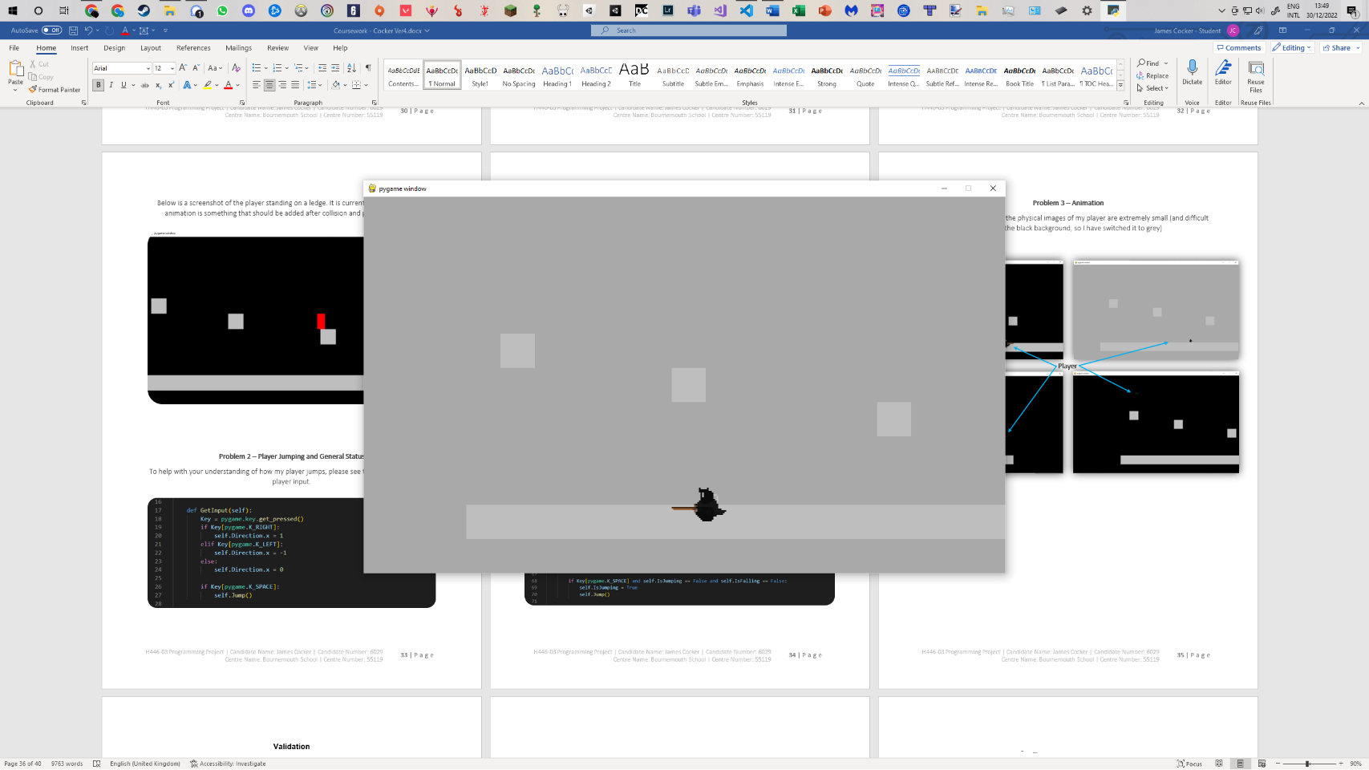

The solution did not seem obvious at first as the animations seemed to be running smoothly. The problem that I found it to be was the sprite size. Because the initial rectangle of my player was based on the first idle image it was the size of this idle image. So, when I upscaled the running animation and it seemed to be incorrectly displaying the sprite’s image inside the tile there were a couple things that needed to be solved afterward:

1) Setting the players rectangle for each image displayed – this is because the height of the player changes between different animations. For example, the first idle frame could be 16 high, but the next only 15.

2) Once obtained the new rectangle for the player sprite based on the animation frame, display the next image based on the previous one, but from the bottom middle. This is automatically done in the centre with PyGame but has the following problem; if the 16 high player is replaced by a 15 high player, the player won’t be seen to move upwards by 1 pixel, but instead it will grow by ½ a pixel into the floor, and ½ a pixel upwards.

My final animation procedure can be seen below:

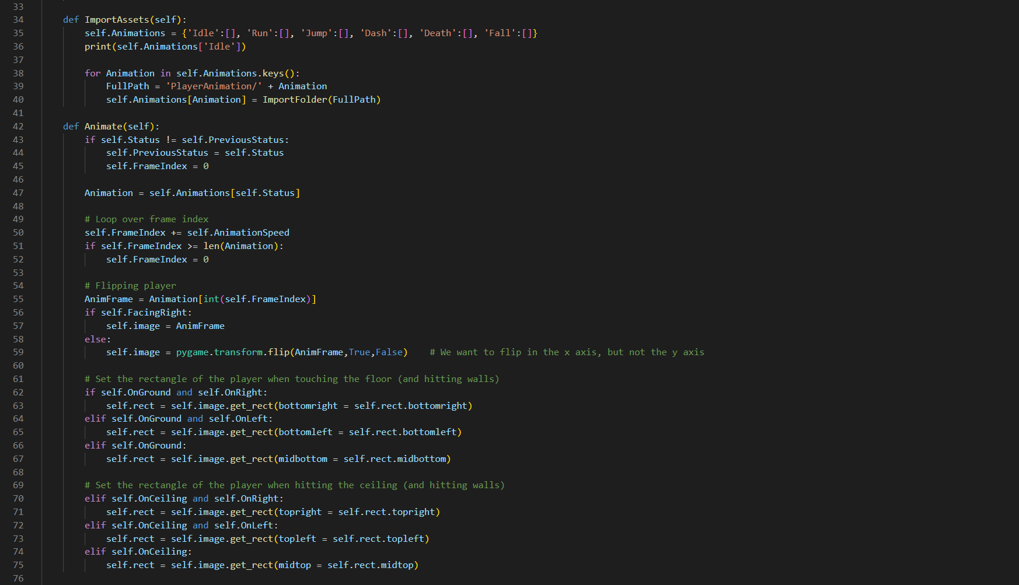

**Validation**

Currently, the user is able to fall off the map and crash the code after ~ 10 seconds. This will be due to an integer error as gravity is continually added and there is no terminal velocity/ point where the player dies off screen. This will be addressed in the next prototype.

As for the player inputs, only the arrow keys and space bar are currently checked as inputs, hence no validation is needed.

**Testing**

This will be testing the player movement, as well as the corresponding world shift.

|  |  |  |
| --- | --- | --- |
| **Input/ Event** | **Expected Output** | **Actual Output** |
| Right arrow key | Player to move to the right at a speed of 8, then for their speed to be set to 0 and world shift to -8. The animation should play correctly. | * Player moves to the right at a speed of 8, then their speed is set to 0 and world shift to -8. The animation plays correctly. |
| Left arrow key | Player to move to the left at a speed of 8 (-8 to the right), then for their speed to be set to 0 and world shift to 8. The animation should play correctly. | * Player moves to the left at a speed of 8 (-8 to the right), then their speed is set to 0 and world shift to 8. The animation plays correctly. |
| Space bar | Player jumps, and gravity brings them back down to the ground. The animation should play correctly. | * Player jumps, and gravity brings them back down to the ground. The animation plays correctly. |
| Player Falls off map | Player respawns at the player spawn point | * Code crashes after ~ 10 seconds |

**Review**

Features implemented successfully:

* Player: including movement, collisions, and most animations

Features implemented unsuccessfully:

* Player death animation

In this prototype I implemented the player and synced the scrolling of the world to when the player goes to the left or right of certain x co-ordinates on the screen. When the player hits this boundary the player’s speed is set to 0 and the world’s scrolling speed is set to the negation of the player’s speed. For example, if the player’s speed was 8 and they hit the right ‘boundary’ of the world they would then stop moving; the world would then move to the left by 8 (or move to the right by -8). Along with this, the player is now completely working, other than the death animation (as there is nothing to kill the player yet).

As the player implementation was a success, aside from the player falling off the map, I am pleased with how this prototype went. Being able to add all this brings me a lot closer to what I want my game to resemble, other than the player’s death animation.

# **Prototype 3 – Block Types and Background**

Main File

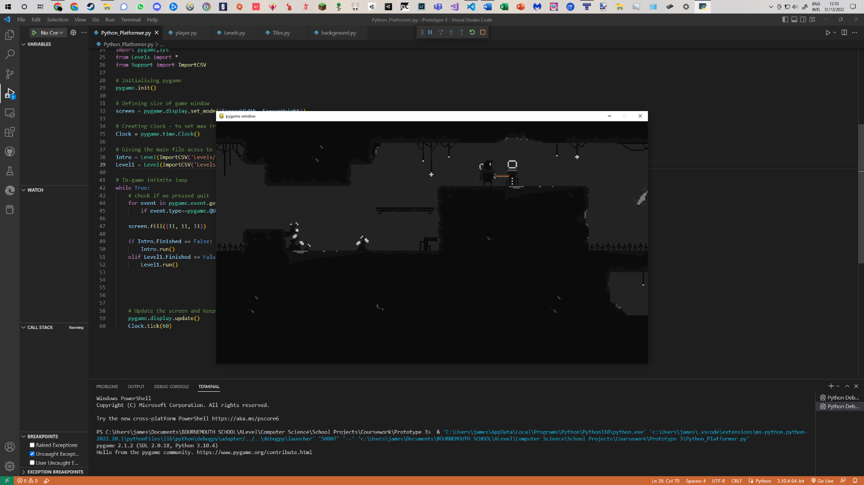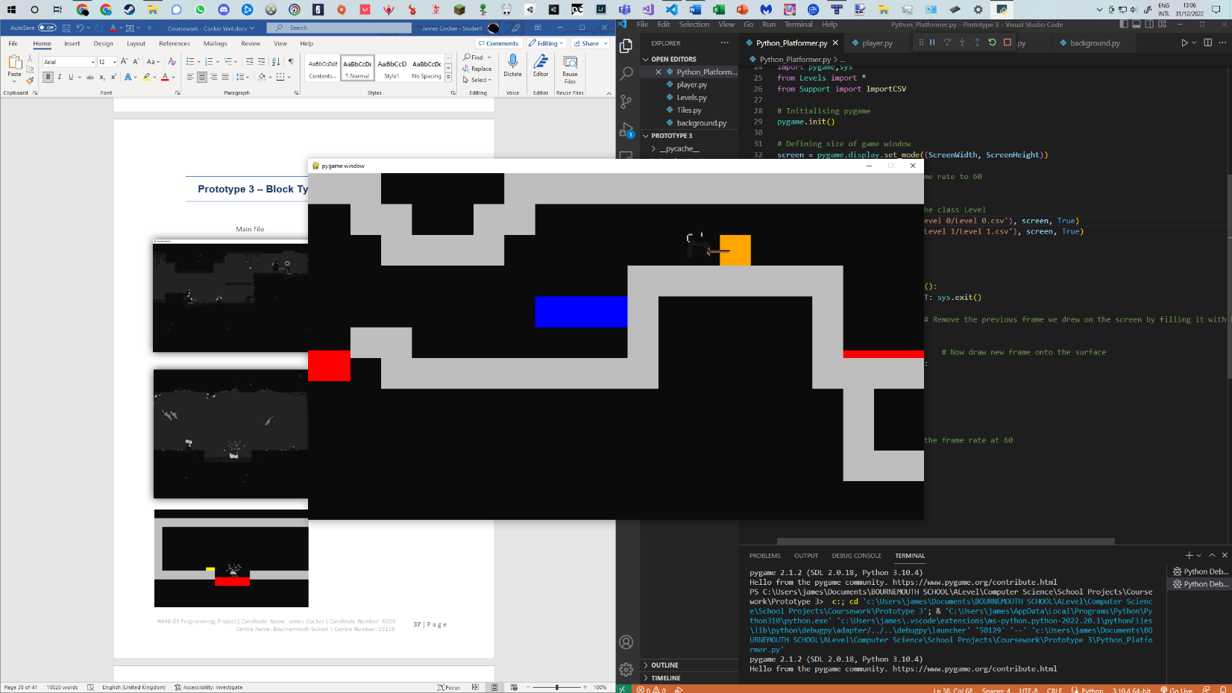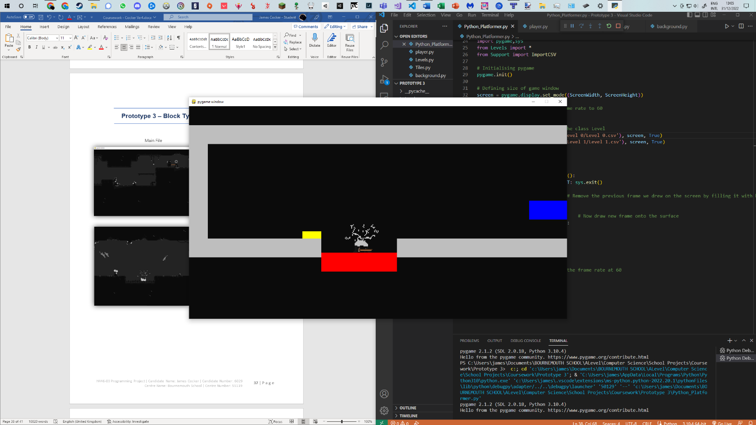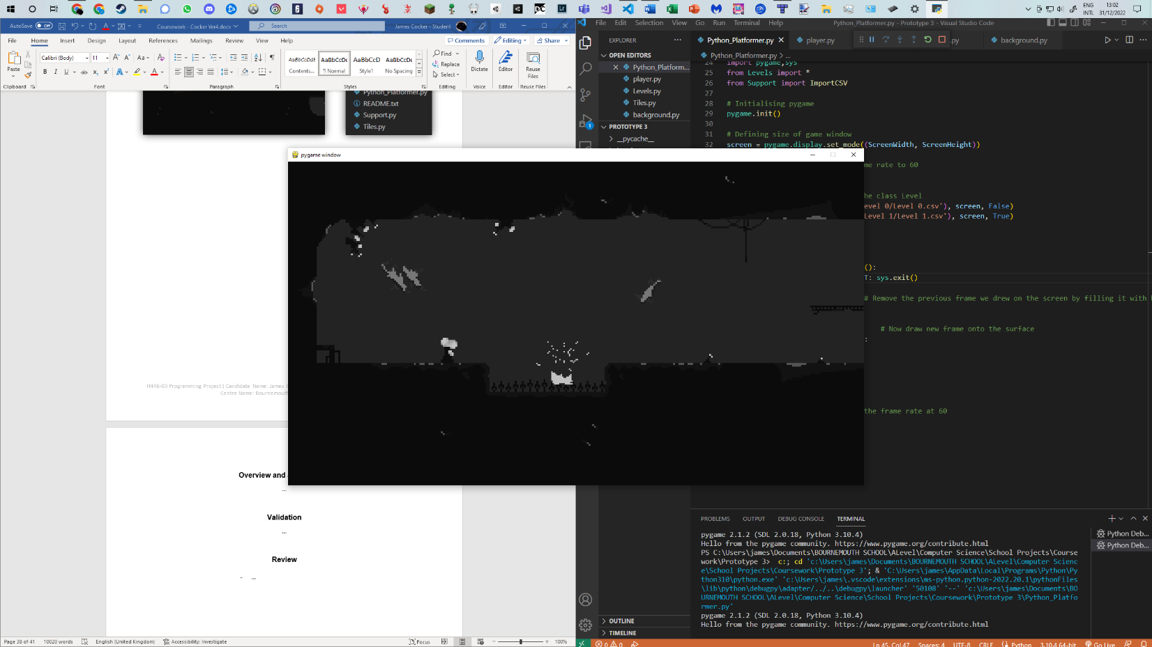

These are what the player will see

These represent the same scenarios, but with coloured tiles as to what the computer ‘sees’

Current File Listing

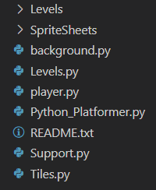

**Overview and Justification**

After having the player working, the next step was to get the world working. This is what I wanted to achieve in the 3rd prototype. For this to be successful, it needs to be easily tested and altered, along with having a pixel art style and engaging objects for the player (such as spikes, respawn points and platforms), all in OOP.

**Problems**

**Problem 1 – Creating the tiles/ Level Map**

From the last version of the 2nd prototype, the first problem I encountered was creating an array of tiles. These tiles needed to be easily altered for any problems with gameplay (e.g. If the player isn’t able to make a jump I need to move a tile closer to make the jump gap smaller), easily created, and have the 8-bit styled theme that I wanted throughout my game. The initial code for creating the map goes as followed:

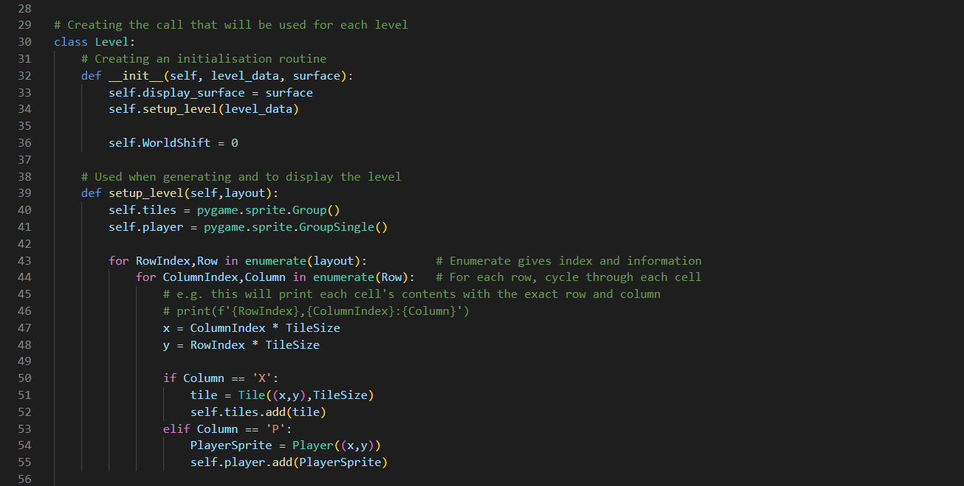

The ‘setup_level’ routine is called when a new level is made. The solution above passes in a 2D array and will create the tiles based off where it sees an ‘X’ (where a tile will be placed) or ‘P’ (the player spawn point). This style of a 2D array was something that appealed to me, but after playing around with setting each individual tile to an image, I quickly realised this would not be scalable for even 1 level. This is because I would need to edit a 2D text array every time I wanted to create levels or edit specific things – not impossible but its extremely hard to visualise and make it scalable for 9 entire levels when pinning an image to each tile. Before thinking it through I did in fact trial it in the 2nd prototype in a test file. This looked like the following:

Test File

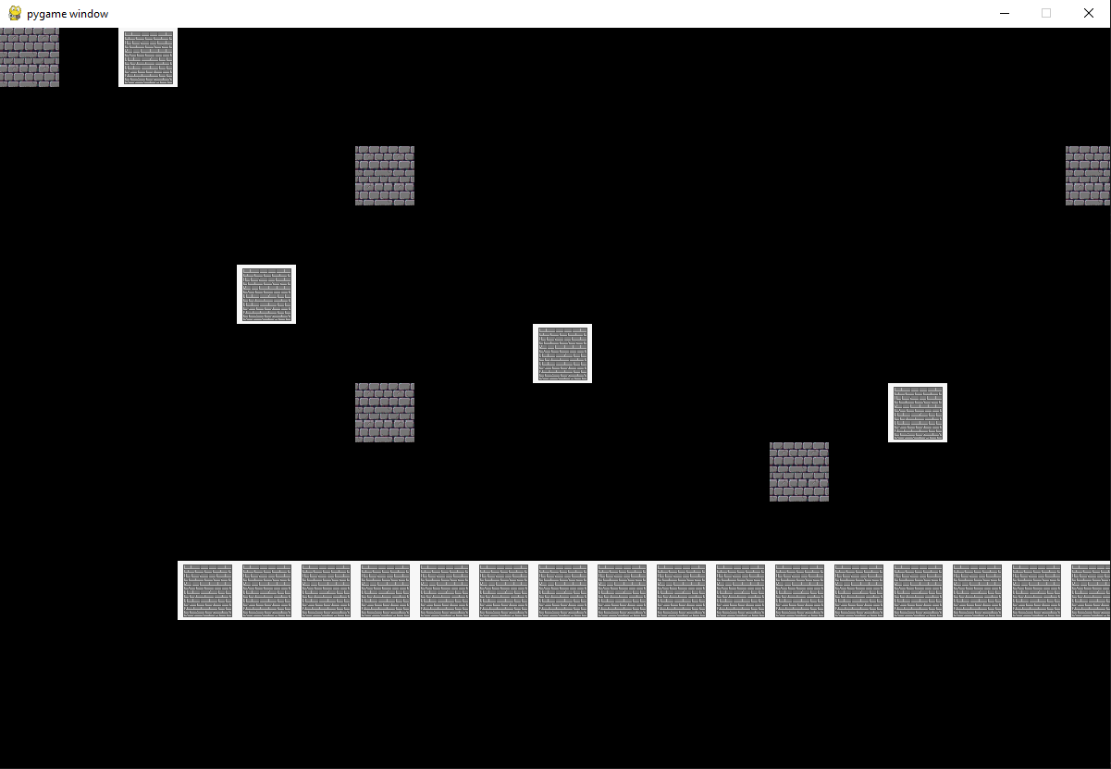

Researching online lead me to Tiled. This external piece of software was the solution to making quick changes to my levels whilst being able to visualise them on the screen. To explain the screenshot of Tiled below, on the right hand side is the palate, this palate can be used to ‘paint’ the sprite sheet onto the main canvas in the centre of the screen. As I already had a sprite sheet lined up for what I wanted to use this worked extremely well.

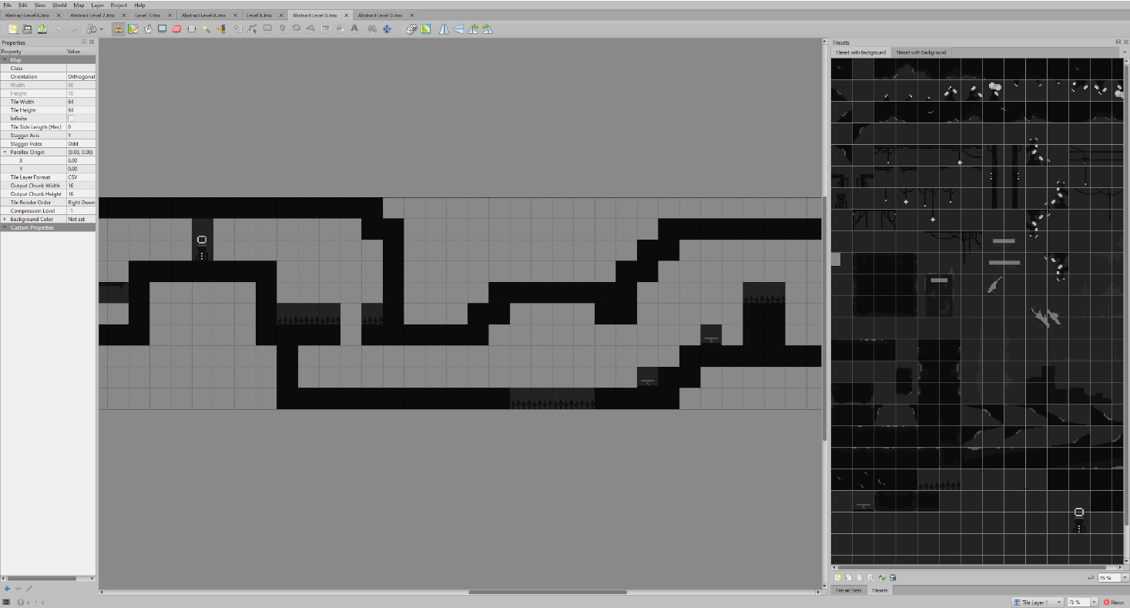

My solution for combining Tiled into my main project was to use a very handy exporting feature it has. This allows the canvas of tiles to be exported into a csv file – extremely like a 2D array. However, it gets better, Tiled can also export the canvas as a whole to a png. This meant I could import the basic abstracted tiles for what the player should interact and layer an image on top of this for what I would like the player to see. For this to work, the background image and the tiles would have to move in perfect unison when the player moves along the level – but I was confident it would work. This means for each level I planned on creating two things:

1) An ‘abstract’ file (such as the one above) which I would export into a comma separated value file for the computer to read in and take as the current level

2) The detailed level image file – where I would design (using the same tile set) the image that would actually be viewed by the player as they traversed the level. See the example of this, for the same part of the level above, in the screenshot:

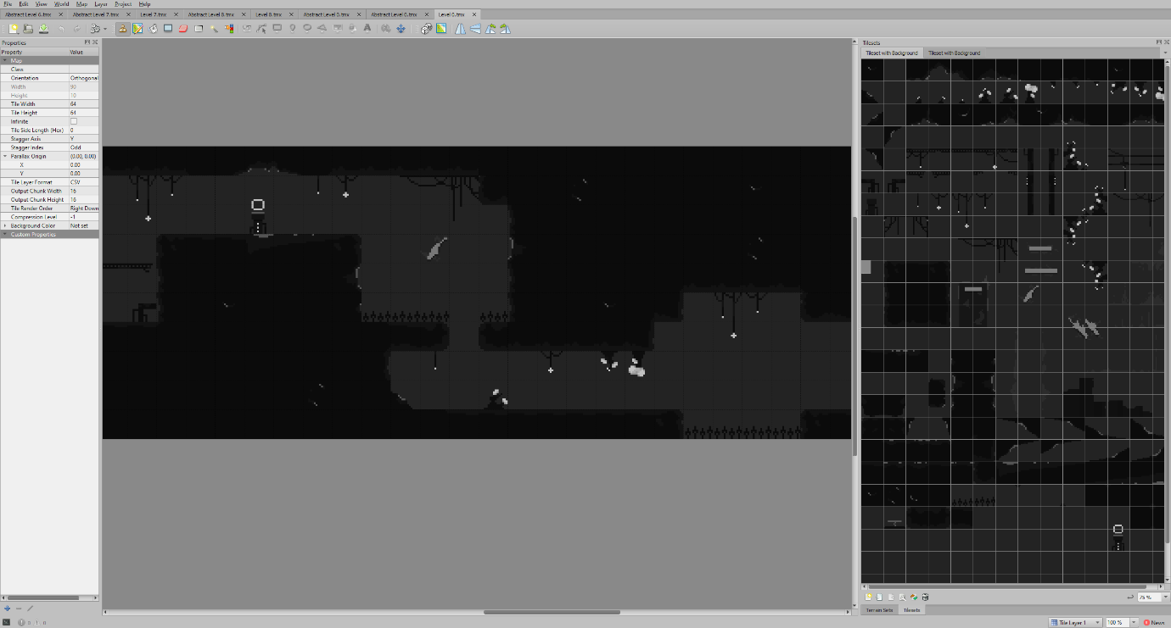

The code used to create a level was then dependent on the values in the csv file. These values were assigned based on the tile set – so the top left tile in the palate above would have the value ‘1’ if exported. The abstract level file exported looks as followed:

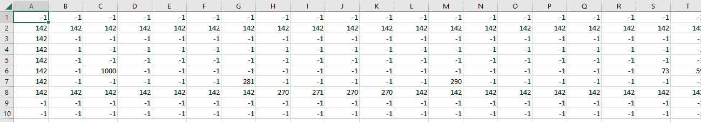

Even though it looks complicated, it can be broken down into the different numbers representing different tiles, which can then be easily created.

The below code shows the new level setup function, as well as the import functions I made to get the file handling to work between the csv and a 2D array.

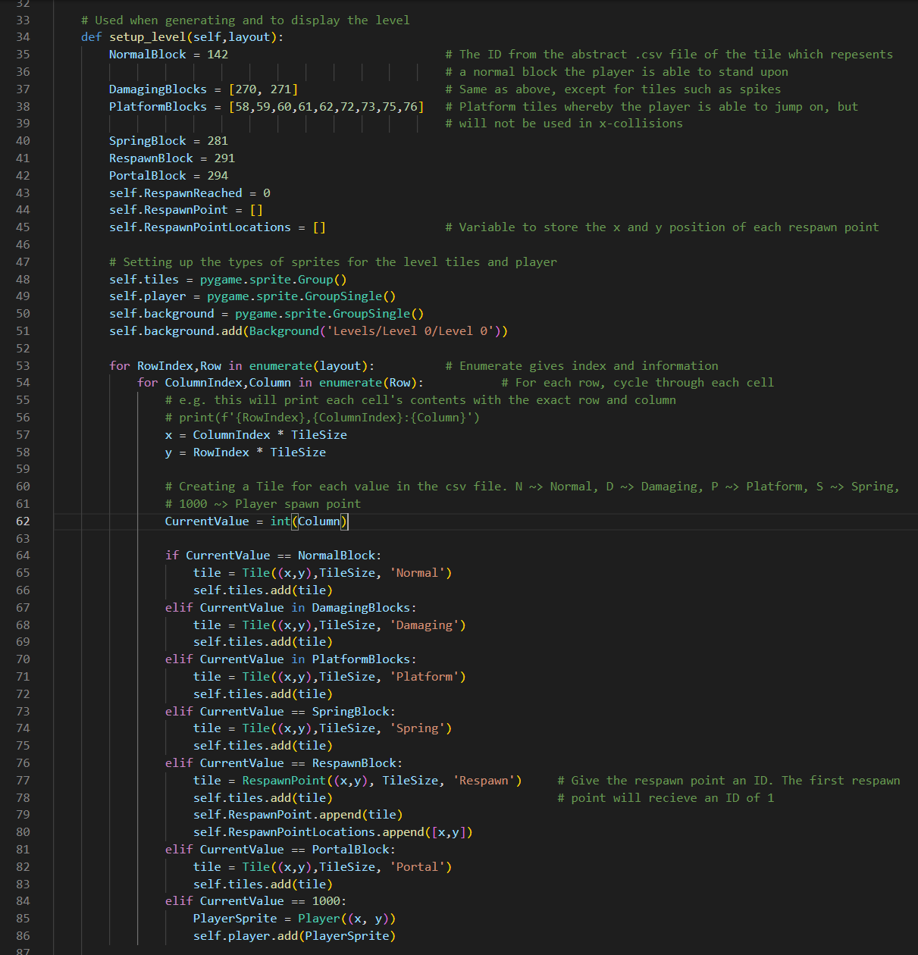

**Problem 2 – Scrolling Vertically**

One aspiration for my game, something that I looked up to in all the games that I analysed, was this feeling of a never ending world, a feeling that the world revolved around the player. This idea of not just scrolling left and right, but also up and down was something that I anticipated adding all along, so why not now?

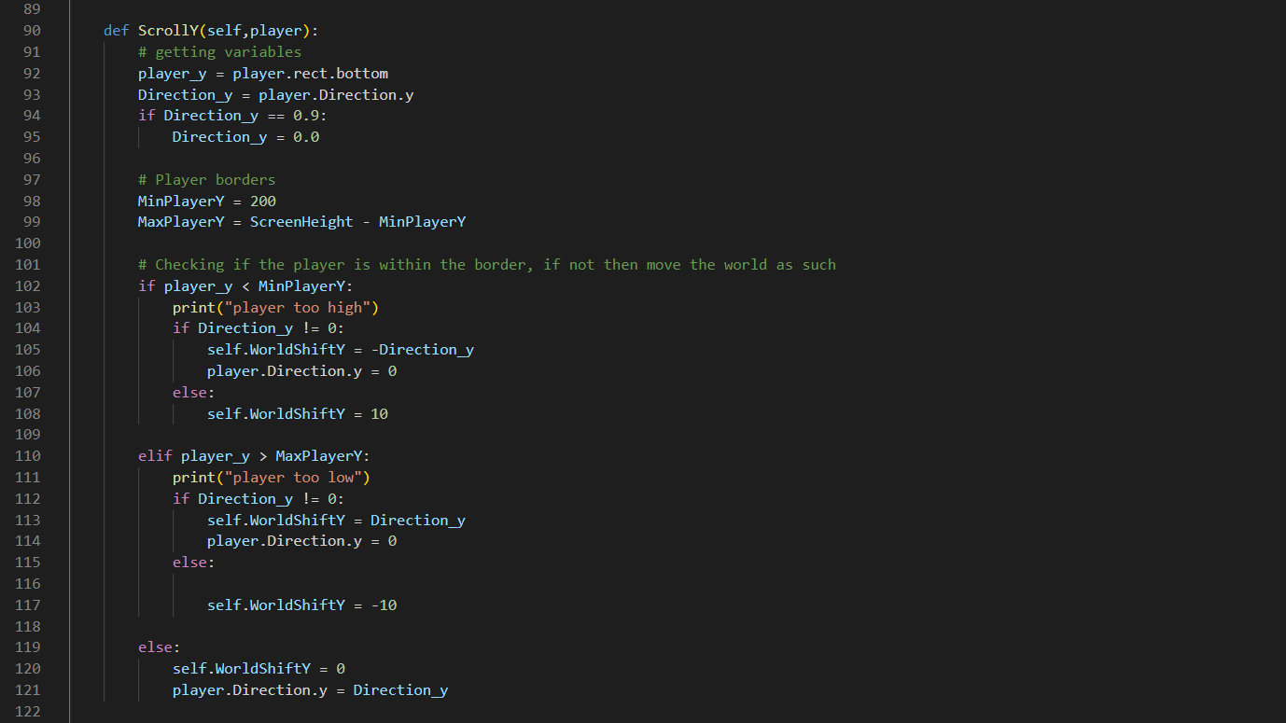When starting to approach this problem, I thought it would be extremely similar to the x-direction, where the player would move left, hit a boundary and the world would set the player’s speed to nought, and have the world move instead. Hence, I started trying to implement the solution for this, see below:

|  |  |  |
| --- | --- | --- |
| **Input/ Event** | **Expected Output** | **Actual Output** |
| The game is started | Screen scrolls down to the player | * Screen scrolls down to the player |
| Screen scrolling vertically and player colliding with tiles | Screen scrolls down and collides with tiles correctly | * Player lags through the tile on the right and falls off the level |

Similar to the Scroll X routine, this was then called every frame. My first simple problem was collision detection. Because I draw my world from the top left, the player must momentarily wait for the screen to drop down to the normal position between the boarders; the problem occurred when I tried to move the player left or right when this happened. Immediate glitching into blocks occurred when this happened, to which I believe the problem to be my gravity. The gravity drags the player downwards into blocks, and if they are inside a block the collision detection should place them back on top so that the frame never displays them falling into the block at all. As the player is an independent object to the world it meant each time the world moved down by a pixel, the player would accelerate downwards to it, which seemed to work out fine when standing still. As mentioned earlier, when moving left and right, the player would overlap on the tiles to such a degree it would push them onto the other side of the wall, causing them to lag through it. This was only the first error with this method however, if the player was to wait until the world moved down, they would then move to the right to do a jump. When jumping, the player hits the top boundary and tells the world to shift in that direction – what then transpires is the world moving downwards and the player becomes ‘stuck’ on the ceiling.

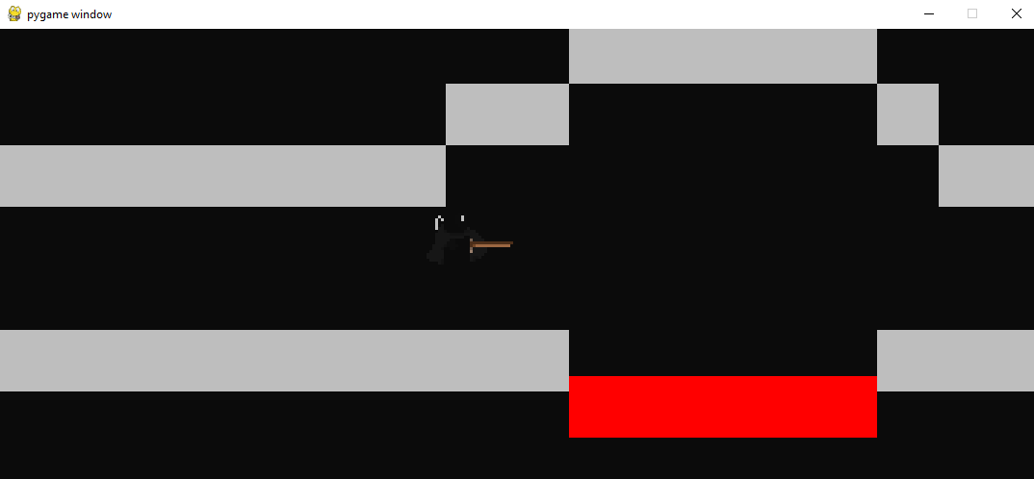

When attempting to solve this problem, the first thing I looked at was the player’s speed when hitting a boundary. My logic was to stop the player in their tracks, record the initial speed value of their jump, then add gravity to it to simulate what the player would be doing. I have called this value the ‘virtual speed’ as it is not the actual speed of the player, rather only what we predicted it to be based on their initial speed. Once the player reaches the arc of their jump (when the virtual speed decreases to, or below 0), we set the player’s speed to the virtual speed and the level carries on as normal (but higher up).

The improved code for this function can be seen on the next page.

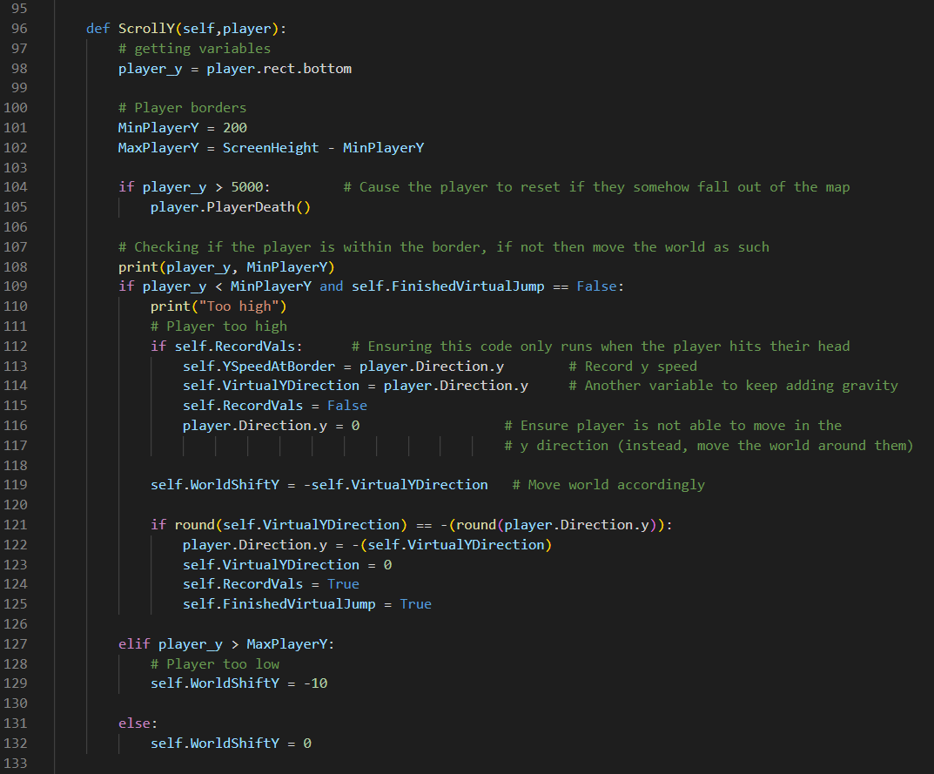

What I found with this function is a problem I am still unsure about. The problem occurs again when the player hits this boundary, and the world is shifted in the y-direction. For the most part it seemed to work, however some odd collision detection was occurring when the player stood still after moving through the level:

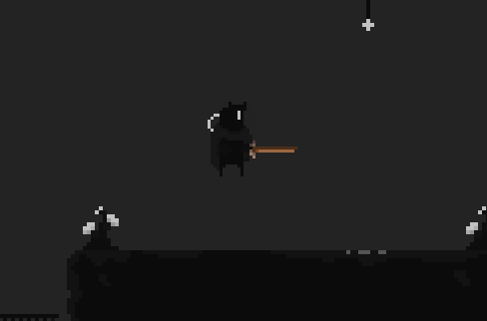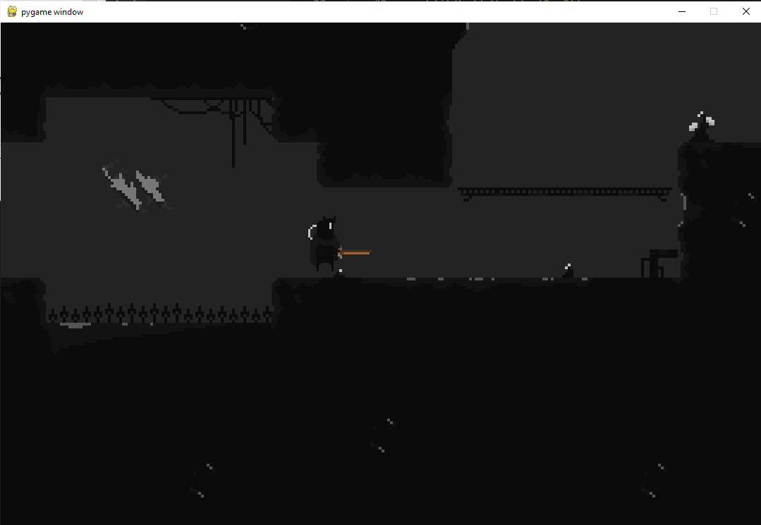

What I believe to be happening is the world’s background to be out of sync with the tile map. Whether the problem was with an integer error, a rounding error or something else I could not figure it out; and before looking further into it I noticed it got worse. Hence, I tried to reform the function by changing the following:

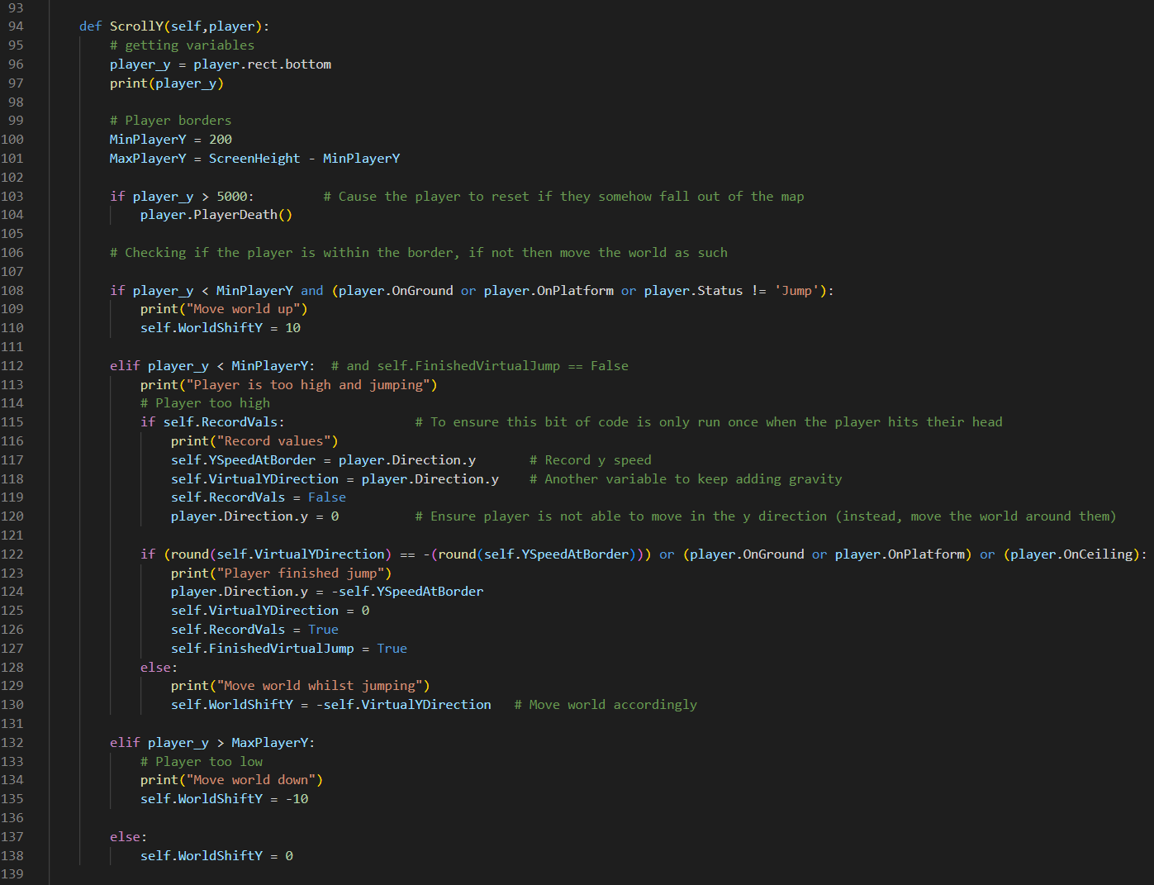

As you can see this problem required a lot of print statements to try and identify what was out of place, and specifically what parts were causing it to fail. Once again, I was still unsure about what the problem was. What I tried to accomplish with this program was to still have the world scroll in the y-direction upon hitting a barrier, but only release the player when they were falling, not at the arc of their jump. This is easier to visualise, so please look at the next screenshots for an example of a jump.

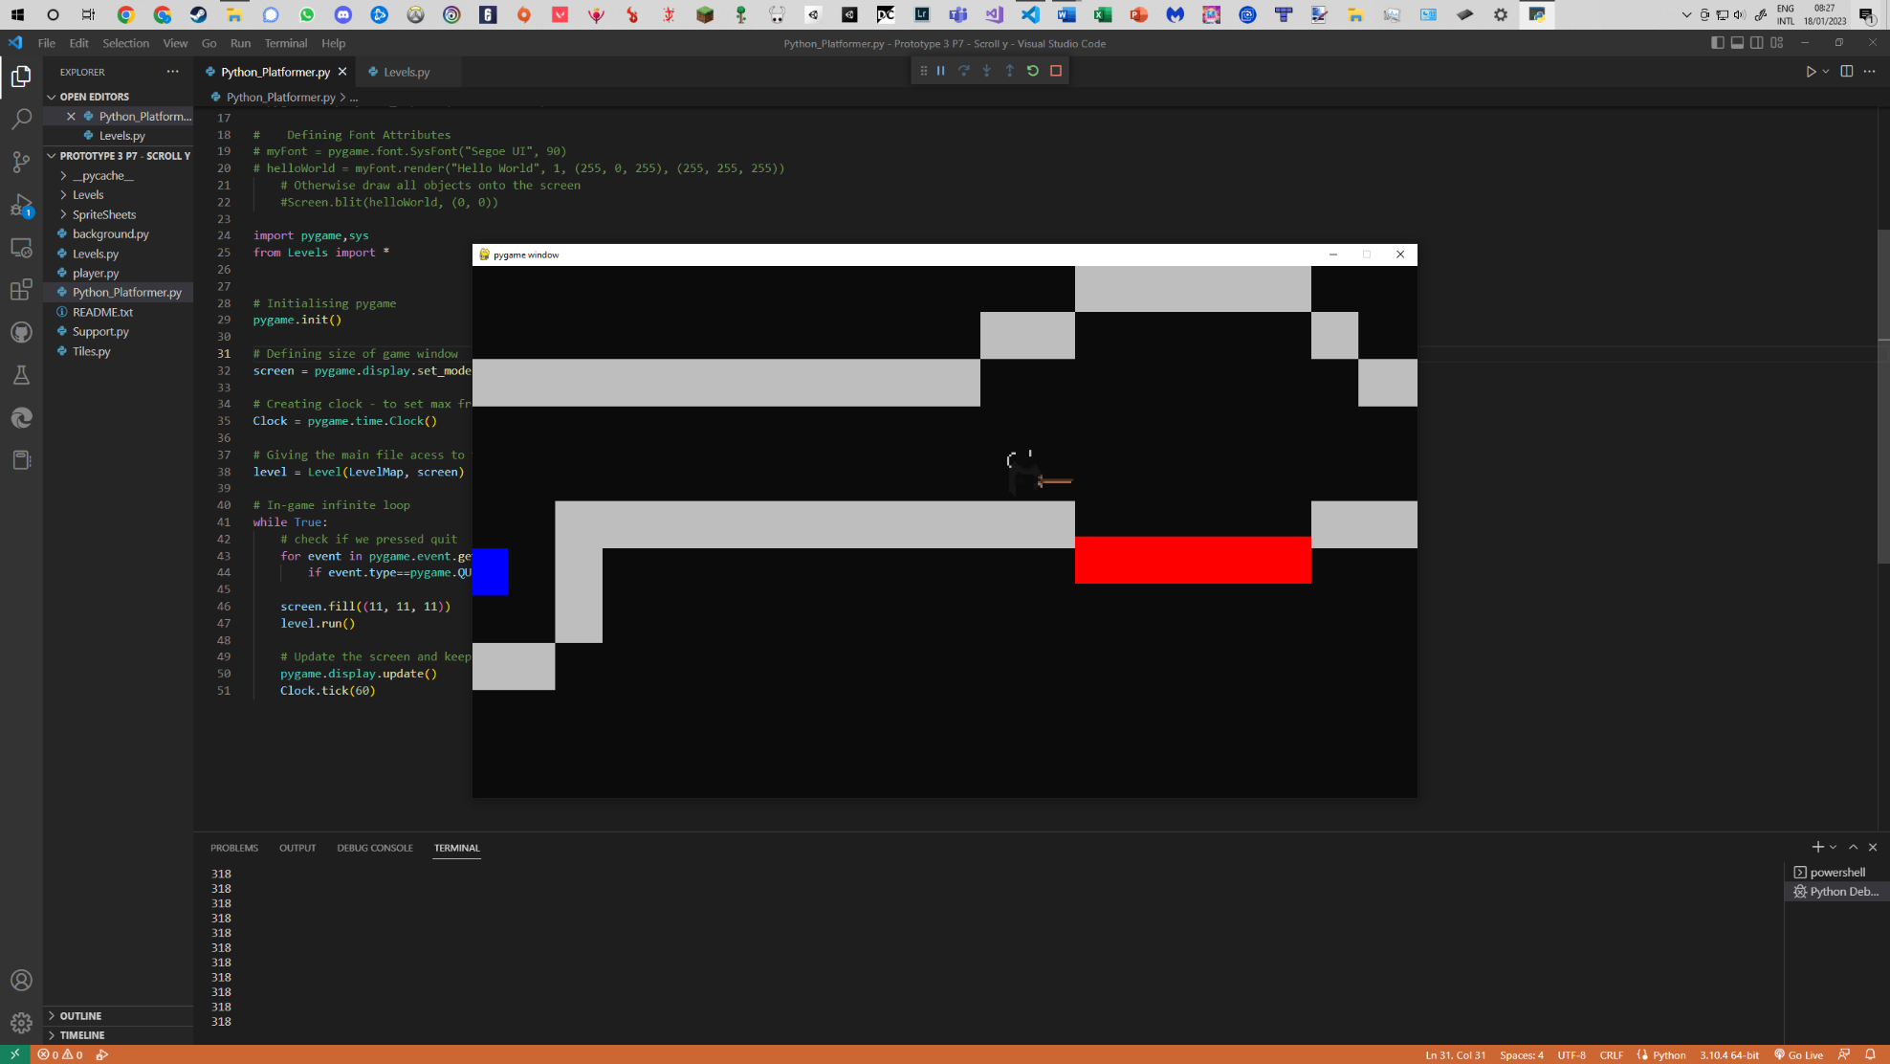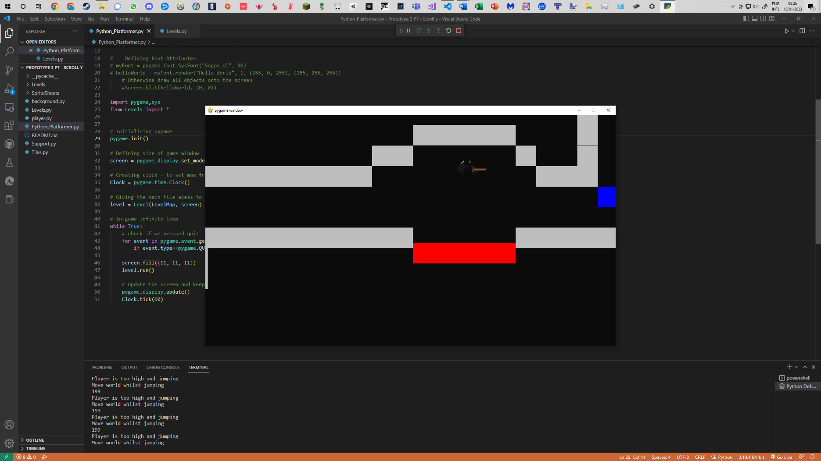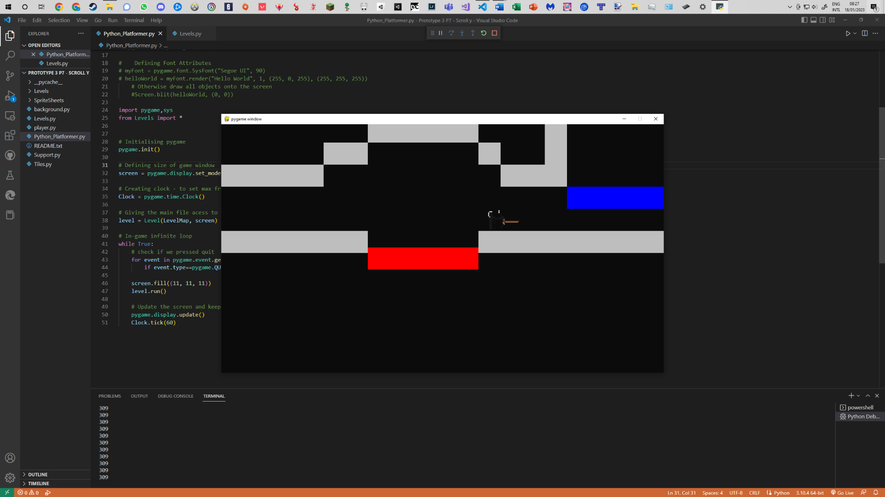

Although only slight, you can see that the black strip running along the top of the middle image. Here, the player has hit the boundary and is kept at that specific y co-ordinate on the screen whilst performing this virtual jump of left through the use of moving the level up and down. The difference between this and the last method is that the world does not stop shifting until the player reaches the top of their jump, but follows them back down (seen in the last screenshot where there is not black bar). Another major difference is the amount of checks that are now done when this happens. However, this new algorithm did not fair well at all when performing jumps and landing on a ledge whilst still on the boarder, not to mention the collision detection was still not working – and a new problem emerged.

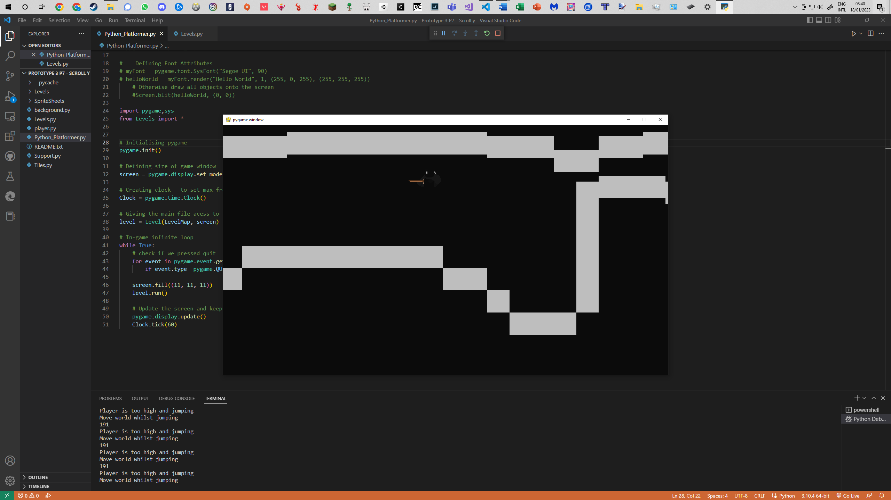

Something completely unexpected, the tiles are all moving at different rates. What the screenshot shows is the ceiling not as blocked tiles, but squashed into one another. I had never encountered this until now, was it another rounding error? Was it something that was affected by the errors in collision detection? After all these piled up, I came to a conclusion.

To conclude this problem, I believed it would be a lot simpler to backtrack to my last working version and not implement scrolling vertically. I do not take this lightly as a lot of time was invested into making this work, however it was consuming too much time and producing more errors than it was fixing. As my level design will be later on in the development process it wasn’t at any loss other than the time put into trying to make this work.

**Problem 3 – Respawn points**

Before finishing up with the prototype I wanted respawn points in my game, furthering the goal of my project. The current method of respawning my player (from the start position) involved a couple simple steps:

1. Record the starting co-ordinates of the player…………………………………….
2. Keep track of how far away the player is from the original spawn point
3. Check for player death…………………………………………………………………………
4. Check for the death animation of the player to be over………………………
5. Move the world back by the amount travelled in step 2……………………..
6. Place the player at the co-ordinates in step 1……………………………………..

The main difference between the spawn point and respawn points is that the respawn points need to be stored in some sort of sorted list, moving from left to right, and there needs to be more variables to track the distances travelled. Some extra code needs to be added to sort through this list, as well as basic collision detection etc. However, thinking abstractly, what needs to happen is for steps 1 and 2 to be changed into the following:

1. Record value of co-ordinates when colliding with a respawn block
2. Keep track of distance from respawn point………………………………….

I will now run through all these different steps and where they can be found in my code. We need to run through these individually as the code is now sprinkled throughout my program, and go as followed:

* **Placing + sorting:** Before any of the steps, we need to create a new sprite group and sort them in terms of their x co-ordinates so that we can assign the first respawn the player encounters to the ID of 1 (this is under the level setup function)

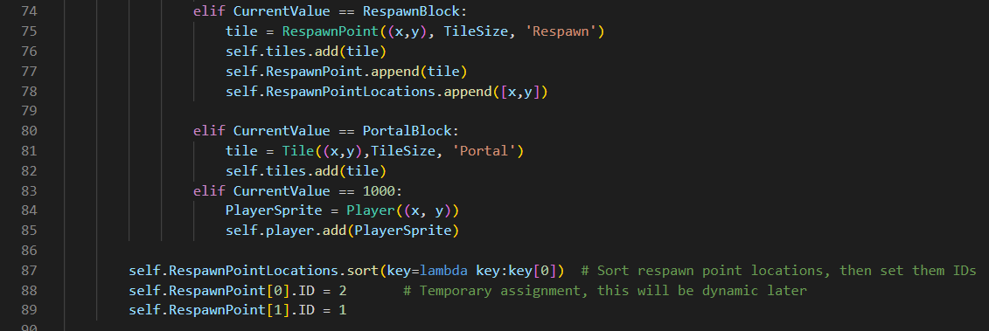

1. **Recording co-ordinates (+collisions):** When colliding with the new respawn point we assign the tuple of x and y co-ordinates under ‘player.RespawnPoint’. Also, as the respawn points are created under the ‘tile’ class we need to ensure they are not treated as normal tiles in terms of collisions as well, however using elif here indirectly does this.

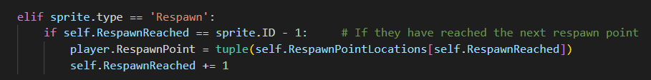

1. **Keeping track of the distance:** Simply, adding on the distance travelled. This is called in the run function, hence every frame of the game

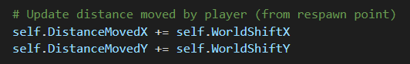

1. **Checking for player death:** Adding on code to the existing respawn function to reset the world based on last checkpoint’s co-ordinates.
2. **Checking for death animation to be over:** Involves checking the length of player.animation (a float that is used as a frame index)
3. **Move world back to respawn point:** Involves creating a reset level function
4. **Move player to respawn point:** Setting the player’s rectangle to the co-ordinates of when they were recorded when they initially touched the respawn point

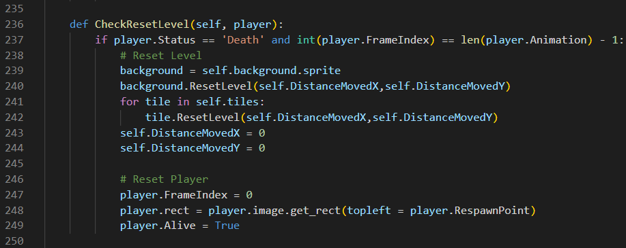

Reset function in ‘Tile’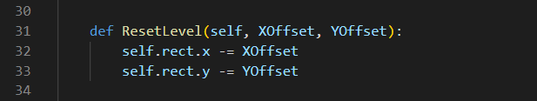 (exactly the same to that as seen in background)

|  |  |  |
| --- | --- | --- |
| **Input/ Event** | **Expected Output** | **Actual Output** |
| Player hits first respawn point and dies | Player respawns at first respawn point | * Player respawns at first respawn point |
| Player hits second respawn point and dies | Player respawns at second respawn point | * Player dissapears |

The code was fully functional for the first respawn point, but the problem was in the second respawn point. Upon reaching the second respawn point, then dying the world shifted back to the beginning. A simple fix: resetting the values to 0 when hitting the new respawn point in step 1.

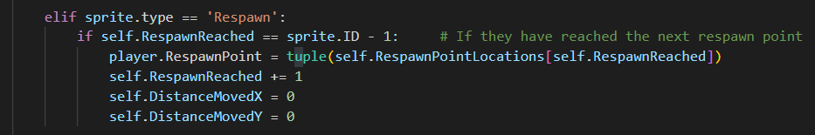

However, the player seems to just disappear now – this can be seen below:

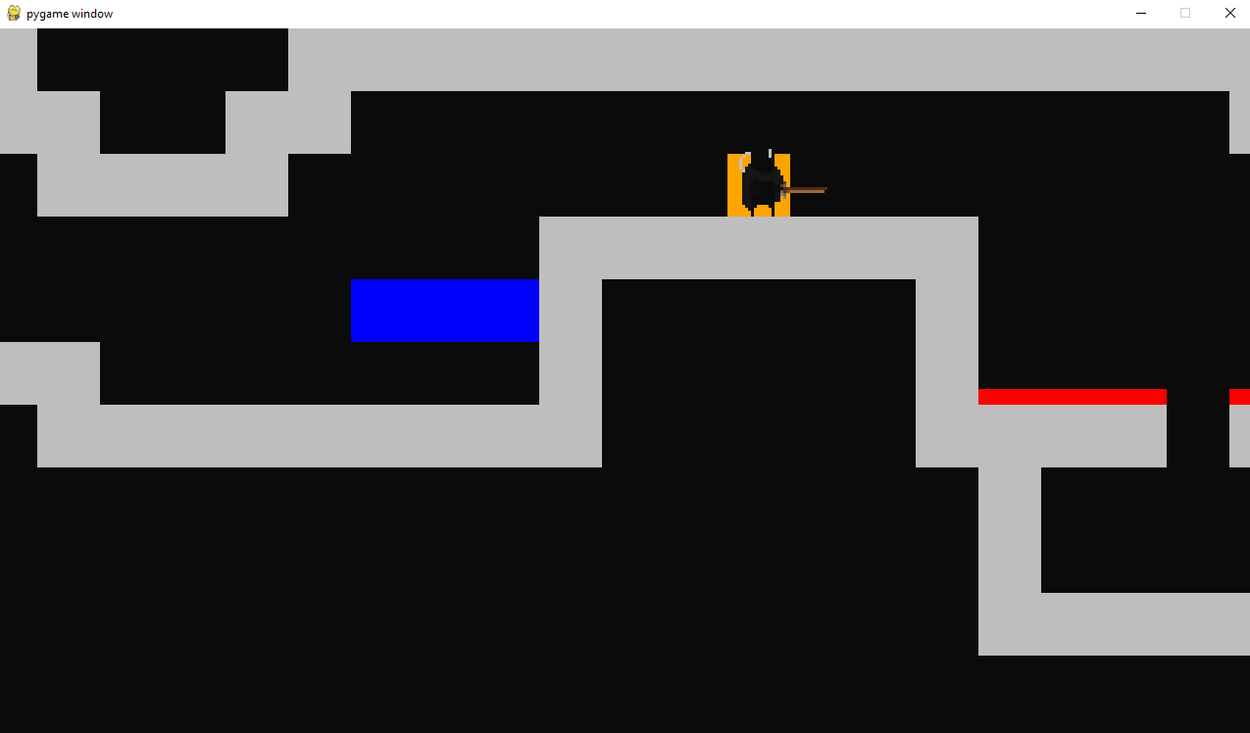

Player’s death

Player reaching respawn point

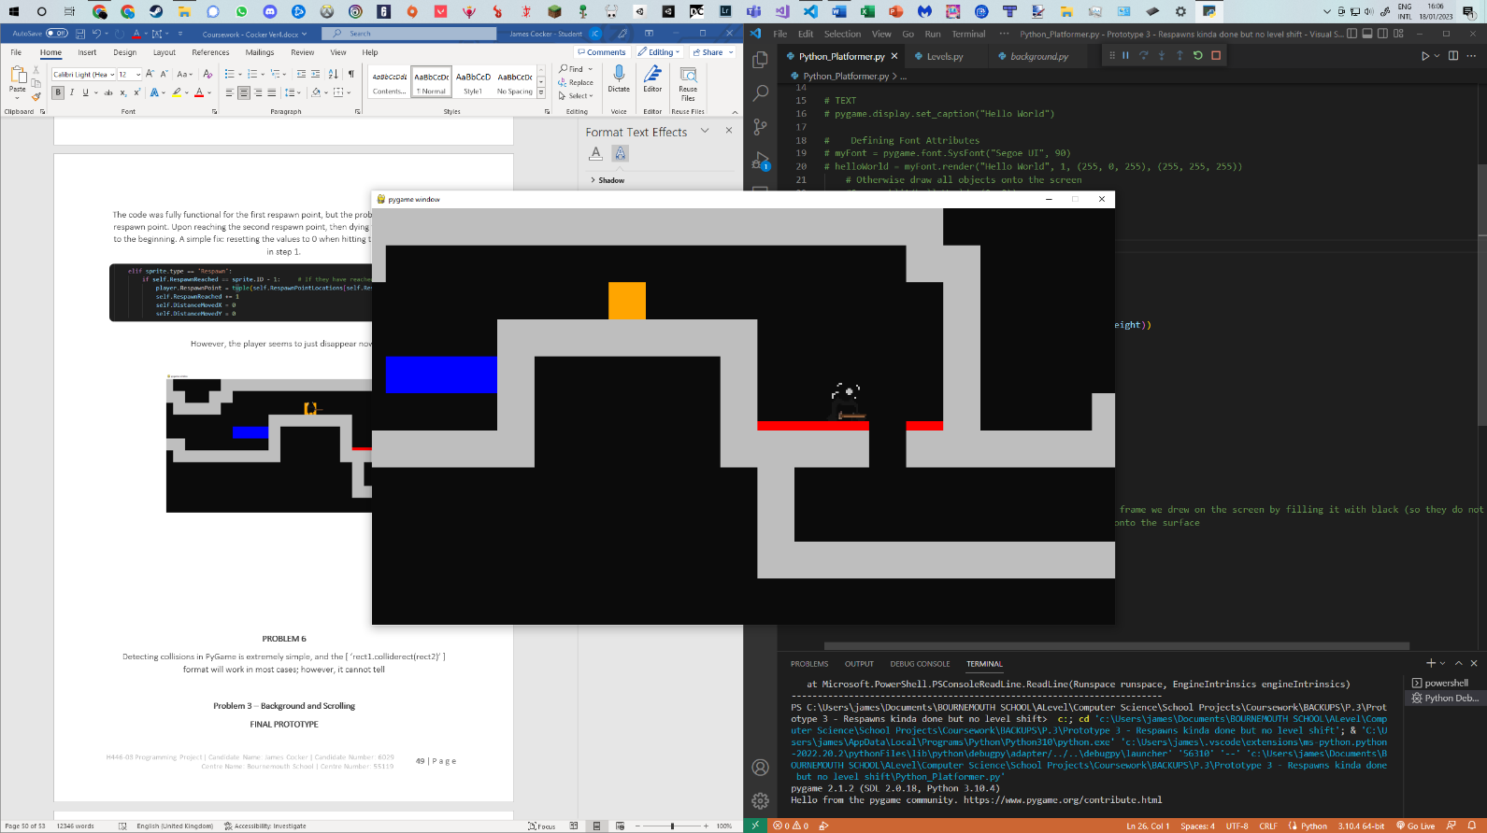

Player disappearing, and world not resetting

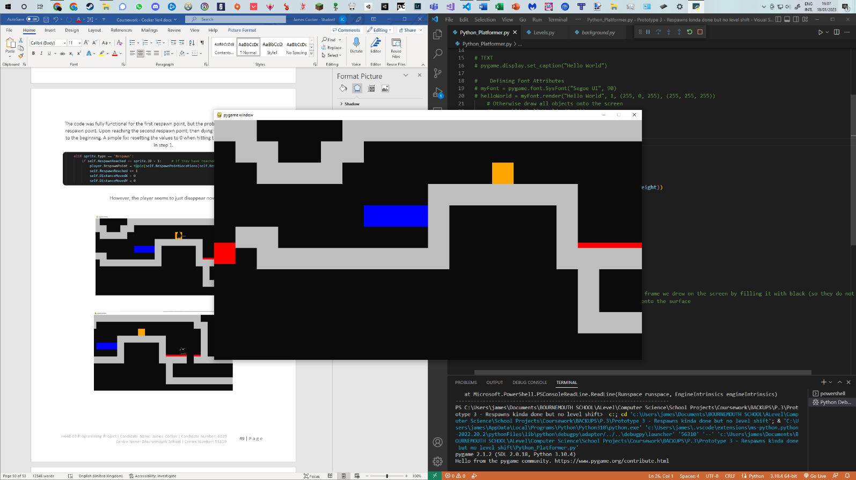

These are the improvements I made:

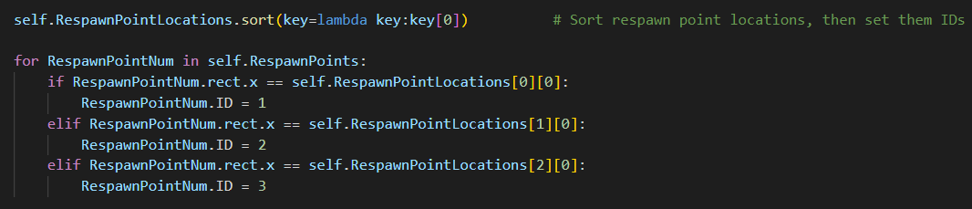

Firstly, sorting the sorting of respawn points. I switched from sorting it manually, to looping through the list and setting the ID’s more dynamically – this might have been confusing the computer which respawn point it was.

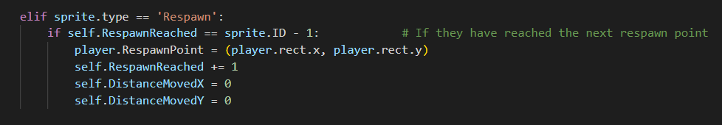

Secondly, I changed the respawn point of the player from the list of values where the respawn points were created, to the co-ordinates of the player when they physically interacted with the respawn point. I believe this solved the issue of my player disappearing as the player is physically taller than the 64x64 blocks. This means putting them in the top left of that point would put their legs inside the tile below them, causing them to lag through the floor; hence the problem was solved and respawn points were now working.

**Validation**

As no more player controls were added, and only logic to my game was the new addition, no extra validation is needed.

**Testing**

|  |  |  |
| --- | --- | --- |
| **Input/ Event** | **Expected Output** | **Actual Output** |
| Player collides with spring tile | Player’s jump speed set to -20, and cannot jump mid air | * Player’s jump speed set to -20, and cannot jump mid air |
| Player Collides with spike tile | Death animation is playing correctly, and the player is not able to move whilst this is happening | * Death animation is playing correctly, and the player is not able to move whilst this is happening |
| Player Death (including falling off the map) | Player to be respawned at last respawn point without lagging through any tiles | * Player to be respawned at last respawn point without lagging through any tiles |
| Player interacting with platform tile | Player should be able to jump up through, but not fall back into a platform | * Player should be able to jump up through, but not fall back into a platform |
| Player collides with portal tile | Next level is loaded, and player is placed at the respawn point set for that level | * Next level is loaded, and player is placed at the respawn point set for that level |

**Review**

Features implemented successfully:

* Block types (normal blocks, platforms, spikes, springs) using inheritance
* Respawn points

Features implemented unsuccessfully:

* Scrolling vertically

What I wanted to add in this prototype was the world for the player to interact with. In the screenshots on the title page, you can see the player performing the same actions, but with the tiles visible on the right-hand side. Red represents spikes, blue represents platforms, orange as respawn points and yellow as springs. The right side of tiles is an abstracted version, only what the computer needs, whereas the left side is what I wanted the world to look like.

After being able to create the world for my player, able to be easily altered when testing with lots of different objects to interact with, I came away from this prototype feeling extremely happy. Not being able to scroll vertically is a disappointment, as it will mean the world won’t be a massive open world map, but instead a side scroller – however I am glad that I attempted it. Overall, this prototype was a success – but if I had more time on the game, making it able to scroll vertically would be one of my first steps.

# **Prototype 4 – Animated Objects, UI, Blinding Spider**

Main File

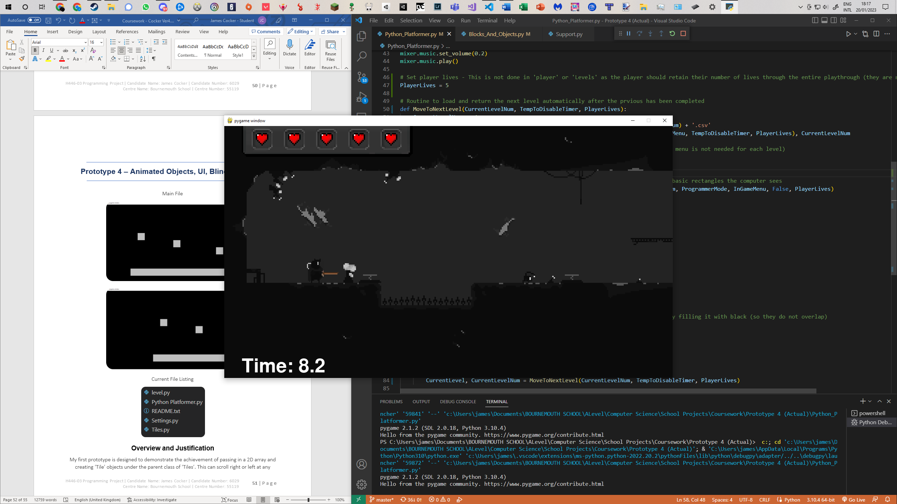

Current File Listing

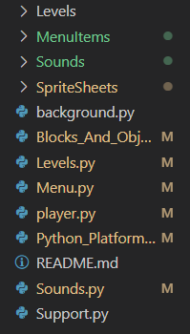

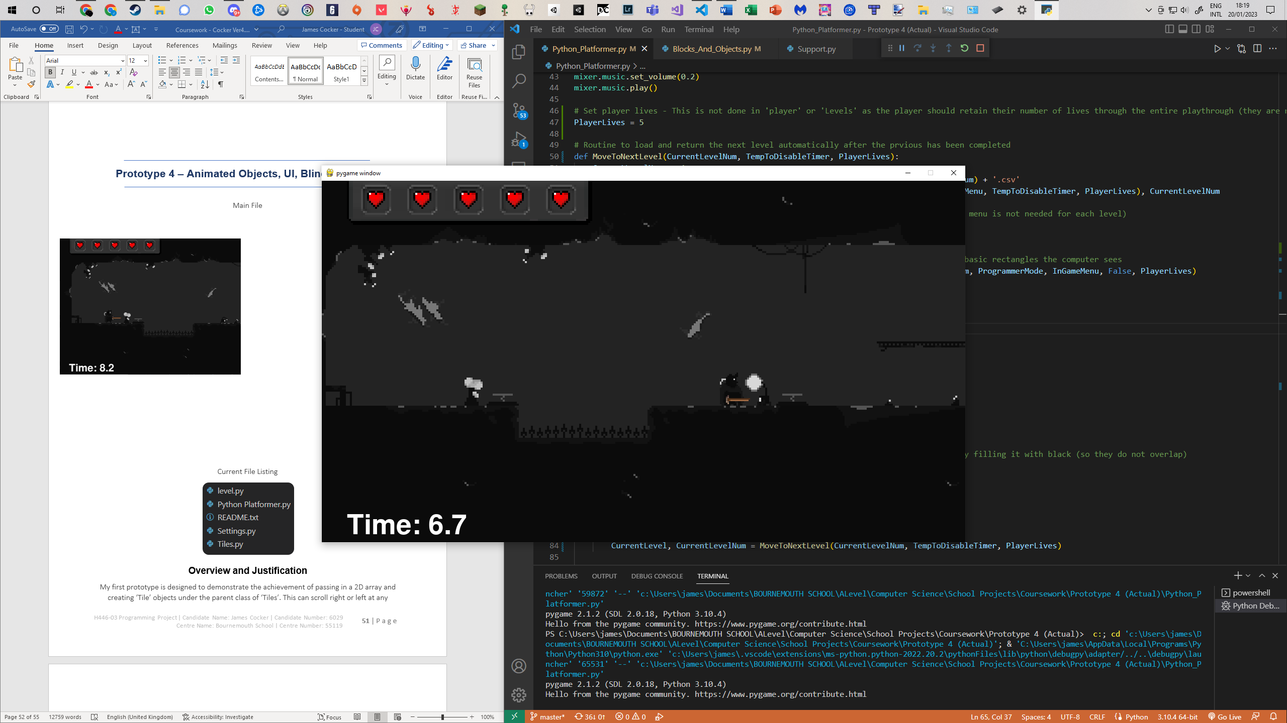

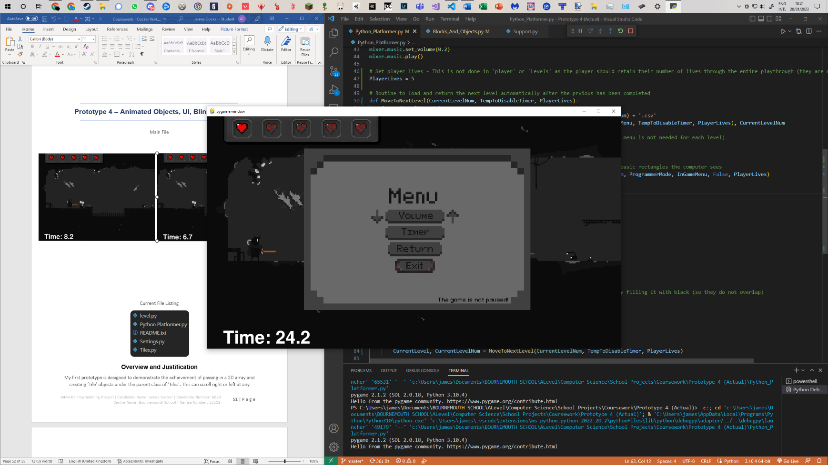

**Overview and Justification**

The next stage in my game was to add animation to objects that the player could interact with, such as the respawn point performing a save animation when the player collides with it. Along with this, I also decided to lump in a few other major changes such as enemies, music, and user interface features such as an in game menu.

**Problems**

**Problem 1 – In-Game Menu**

What I wanted out of the menu I was creating was for it to do the requirements I set out before creating the prototypes: Toggle and alter the volume, toggle the timer, have a return button (to take back to level selection menu which will be done in the next prototype) and exit.

In terms of programming, the first thing I focused on was creating a surface, or a background image for the buttons to be placed on top of - then for this to be layered on top of the screen. I started in a new file, ‘Menu.py’ and created a short indefinite loop for this menu to run.

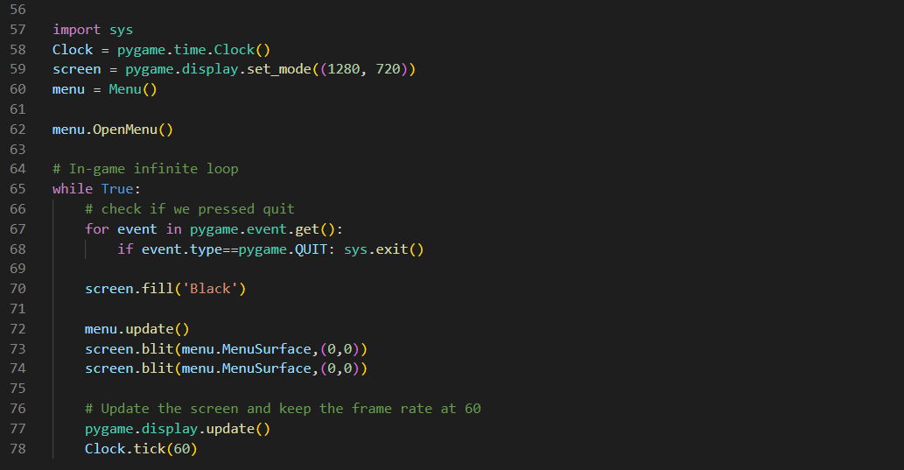

The first attempt of writing the code for the Menu was rather successful, going as followed:

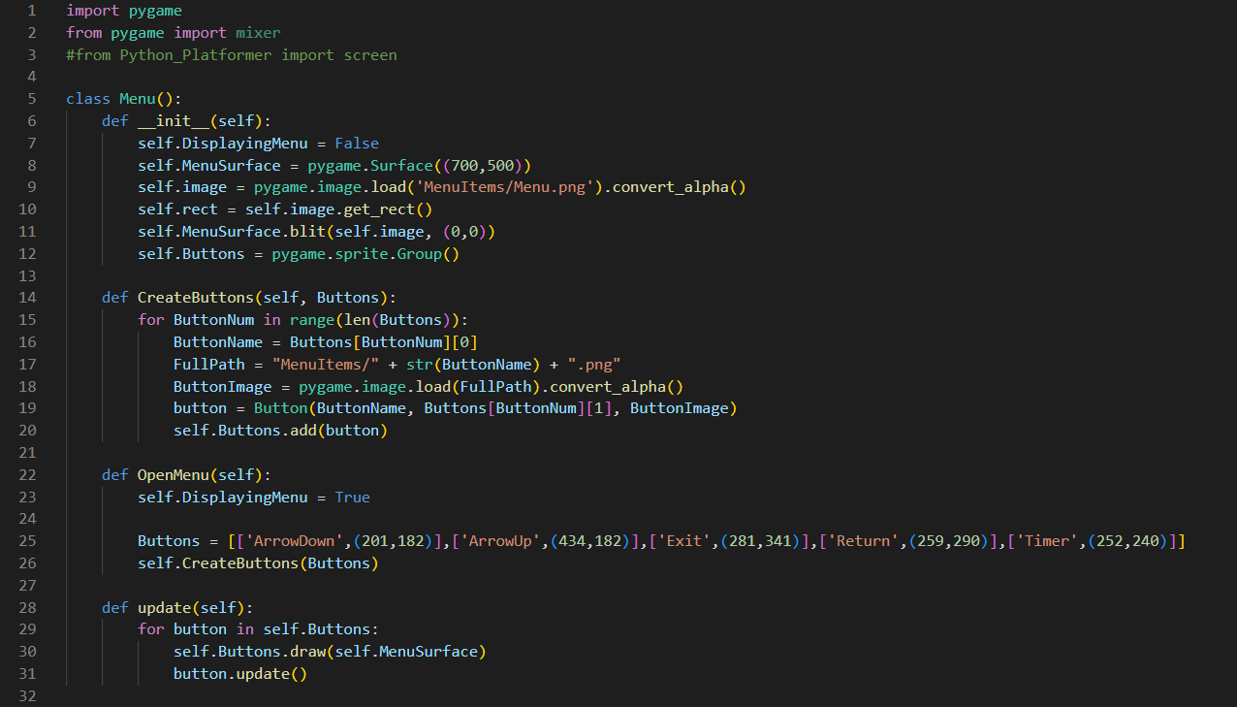

This then led to me creating the button class:

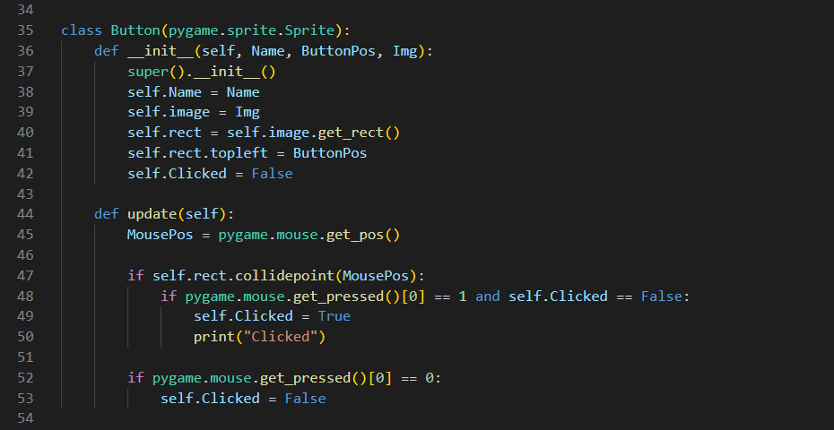

And in fact, for the very backbone of the program, it was functioning within this internal loop. On a side note, creating the buttons and actual menu image was all done in Paint.net – using pixel art in a similar art style to the package I bought for the sprites and background of my game. The screenshots below show what the menu looked like:

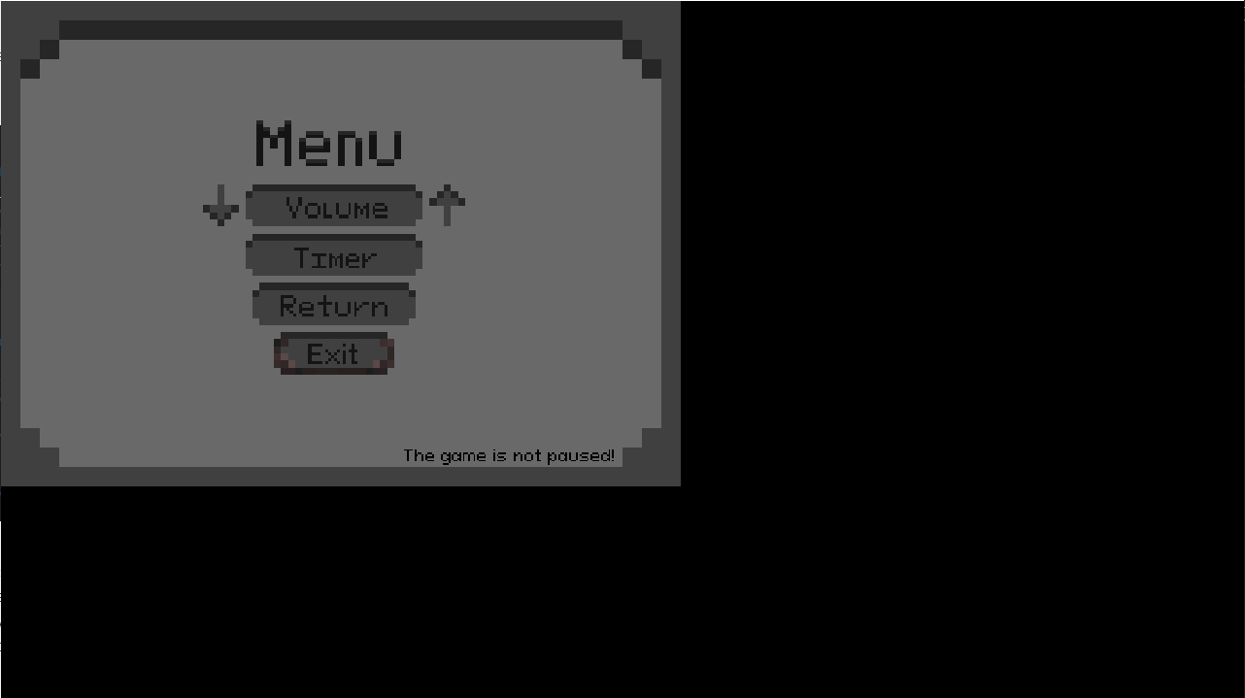

As can be seen, the menu is correctly displaying in the top left of the screen, which is where the menu surface is layering on top of. Also, if you caught it, I wanted the button class to print “clicked” in the terminal once it had been supposedly clicked – and it beautifully worked first time, no slight adjustments, truly a wonderful feeling. However, none of this was problem I encountered, I simply wanted to show you my code whilst it was this simple and so that you could understand how it works in its most abstract form.

Making the buttons more specialised, the ‘update’ function then evolved to:

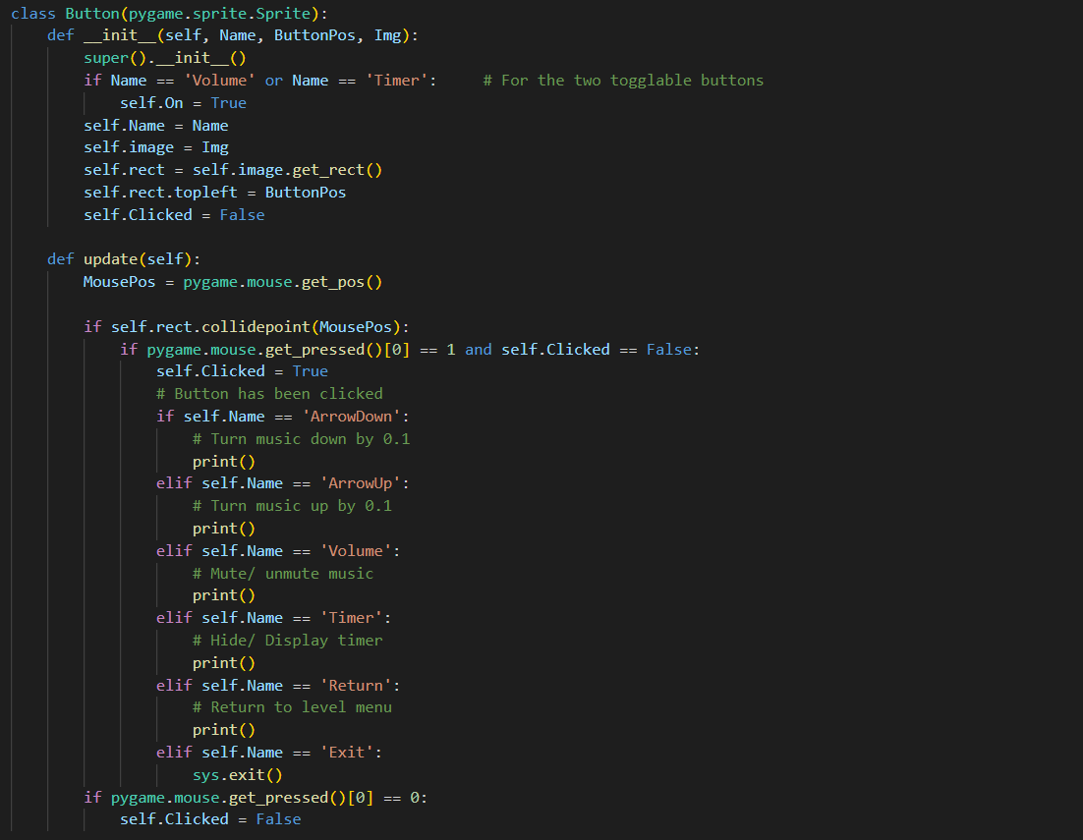

Another short thing I added was to make the menu class more generalised, adding the button creation as an input to the ‘OpenMenu’ function:



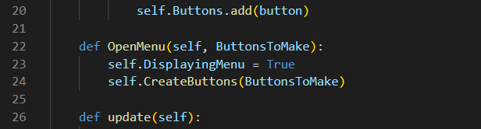

The problem I encountered was when I attempted to fill out each of these functions, specifically the volume buttons. What was happening is that I needed to change the volume of the program, but I was unable to change this volume after toggling the volume to 0, then back on. Not only this, but I needed to have a way of storing the value of the volume when I closed the menu and opened it again, as a new menu was created each time the user pressed esc. See this code below:

The button’s update function:

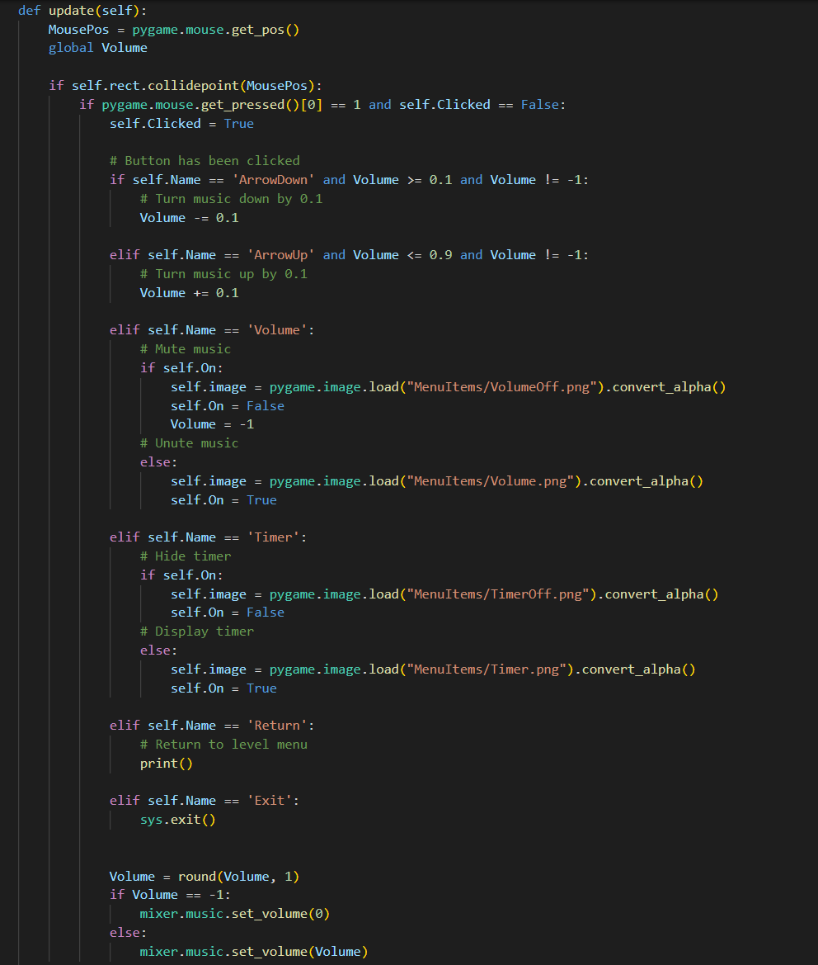

The Menu’s creation upon the user pressing the escape key:



|  |  |  |
| --- | --- | --- |
| **Input/ Event** | **Expected Output** | **Actual Output** |
| Player presses escape | The menu opens on the correct settings | * The menu will open with the default settings each time, so the incorrect volume image will display. E.g. the player mutes the game, closes then reopens the menu and the volume image will display that the volume is not muted |
| Player toggles the volume key | The volume toggles on and off the previous value | * The volume toggles off, but cannot toggle back on |

To fix this problem, I created another global value under ‘RecordedVolume’ and set the menu to only be created once (when the code was initially ran). This fixed the images being on the default settings, as the ‘self.On’ attribute will now be correct for each time the menu is overlayed – meaning the correct images are shown over the buttons. Recording the volume under the variable ‘RecordedVolume’ will mean that the volume can now be toggled on and off correctly.

See the fixed instantiation code for the menu:

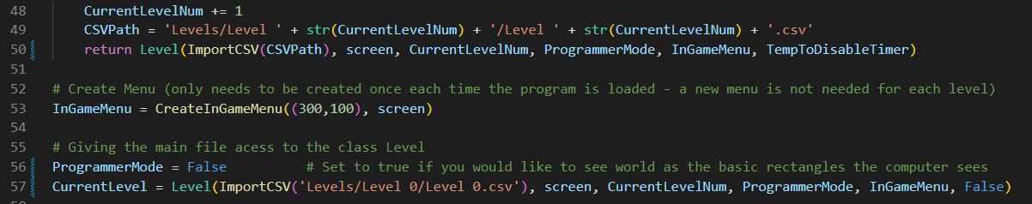

Here, the menu is being created within the master ‘PythonPlatformer.py’ file, and displayed when the user presses escape with the code:

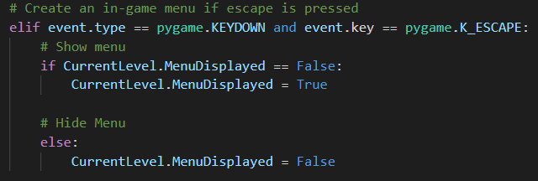

See the fixed volume recording in the button’s update function:

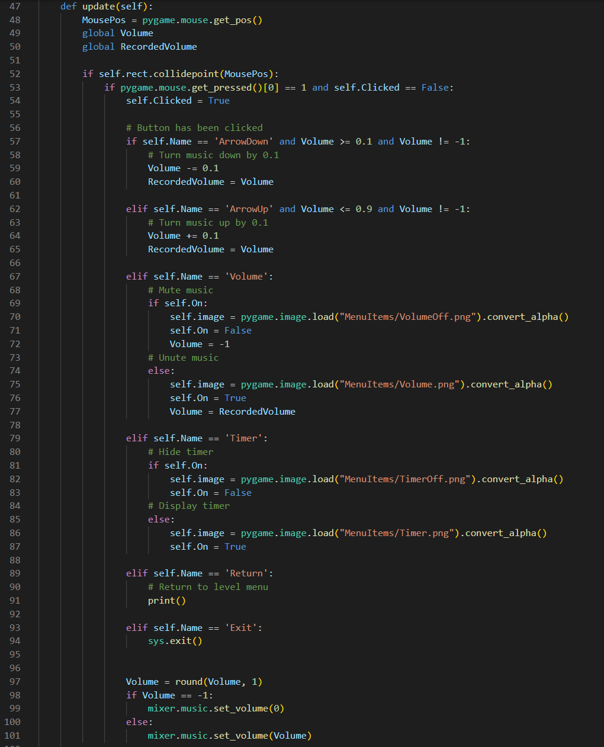

|  |  |  |
| --- | --- | --- |
| **Input/ Event** | **Expected Output** | **Actual Output** |
| Player presses escape | The menu opens on the correct settings | * The menu opens on the correct settings |
| Player toggles the volume key | The volume toggles on and off the previous value | * The volume toggles on and off the previous value |

**Problem 3 – Blinding Spider**

When creating enemies, my original plan was to have 3 enemies, all inheriting from the same class. Creating the master ‘Enemy’ class went as followed:

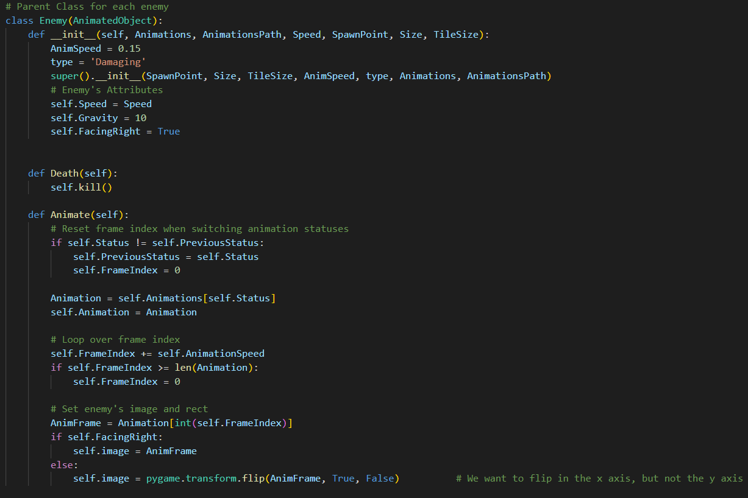

The blinding spider class:

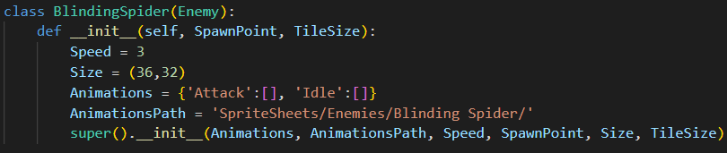

Hence the blinding spider inherits from the enemy class, which inherits from the animated object class, which inherits from the tile class. As the enemy class worked similarly to the player, with its movement and gravity etc this was done with minimal problems, and the enemy in-game looks like this:

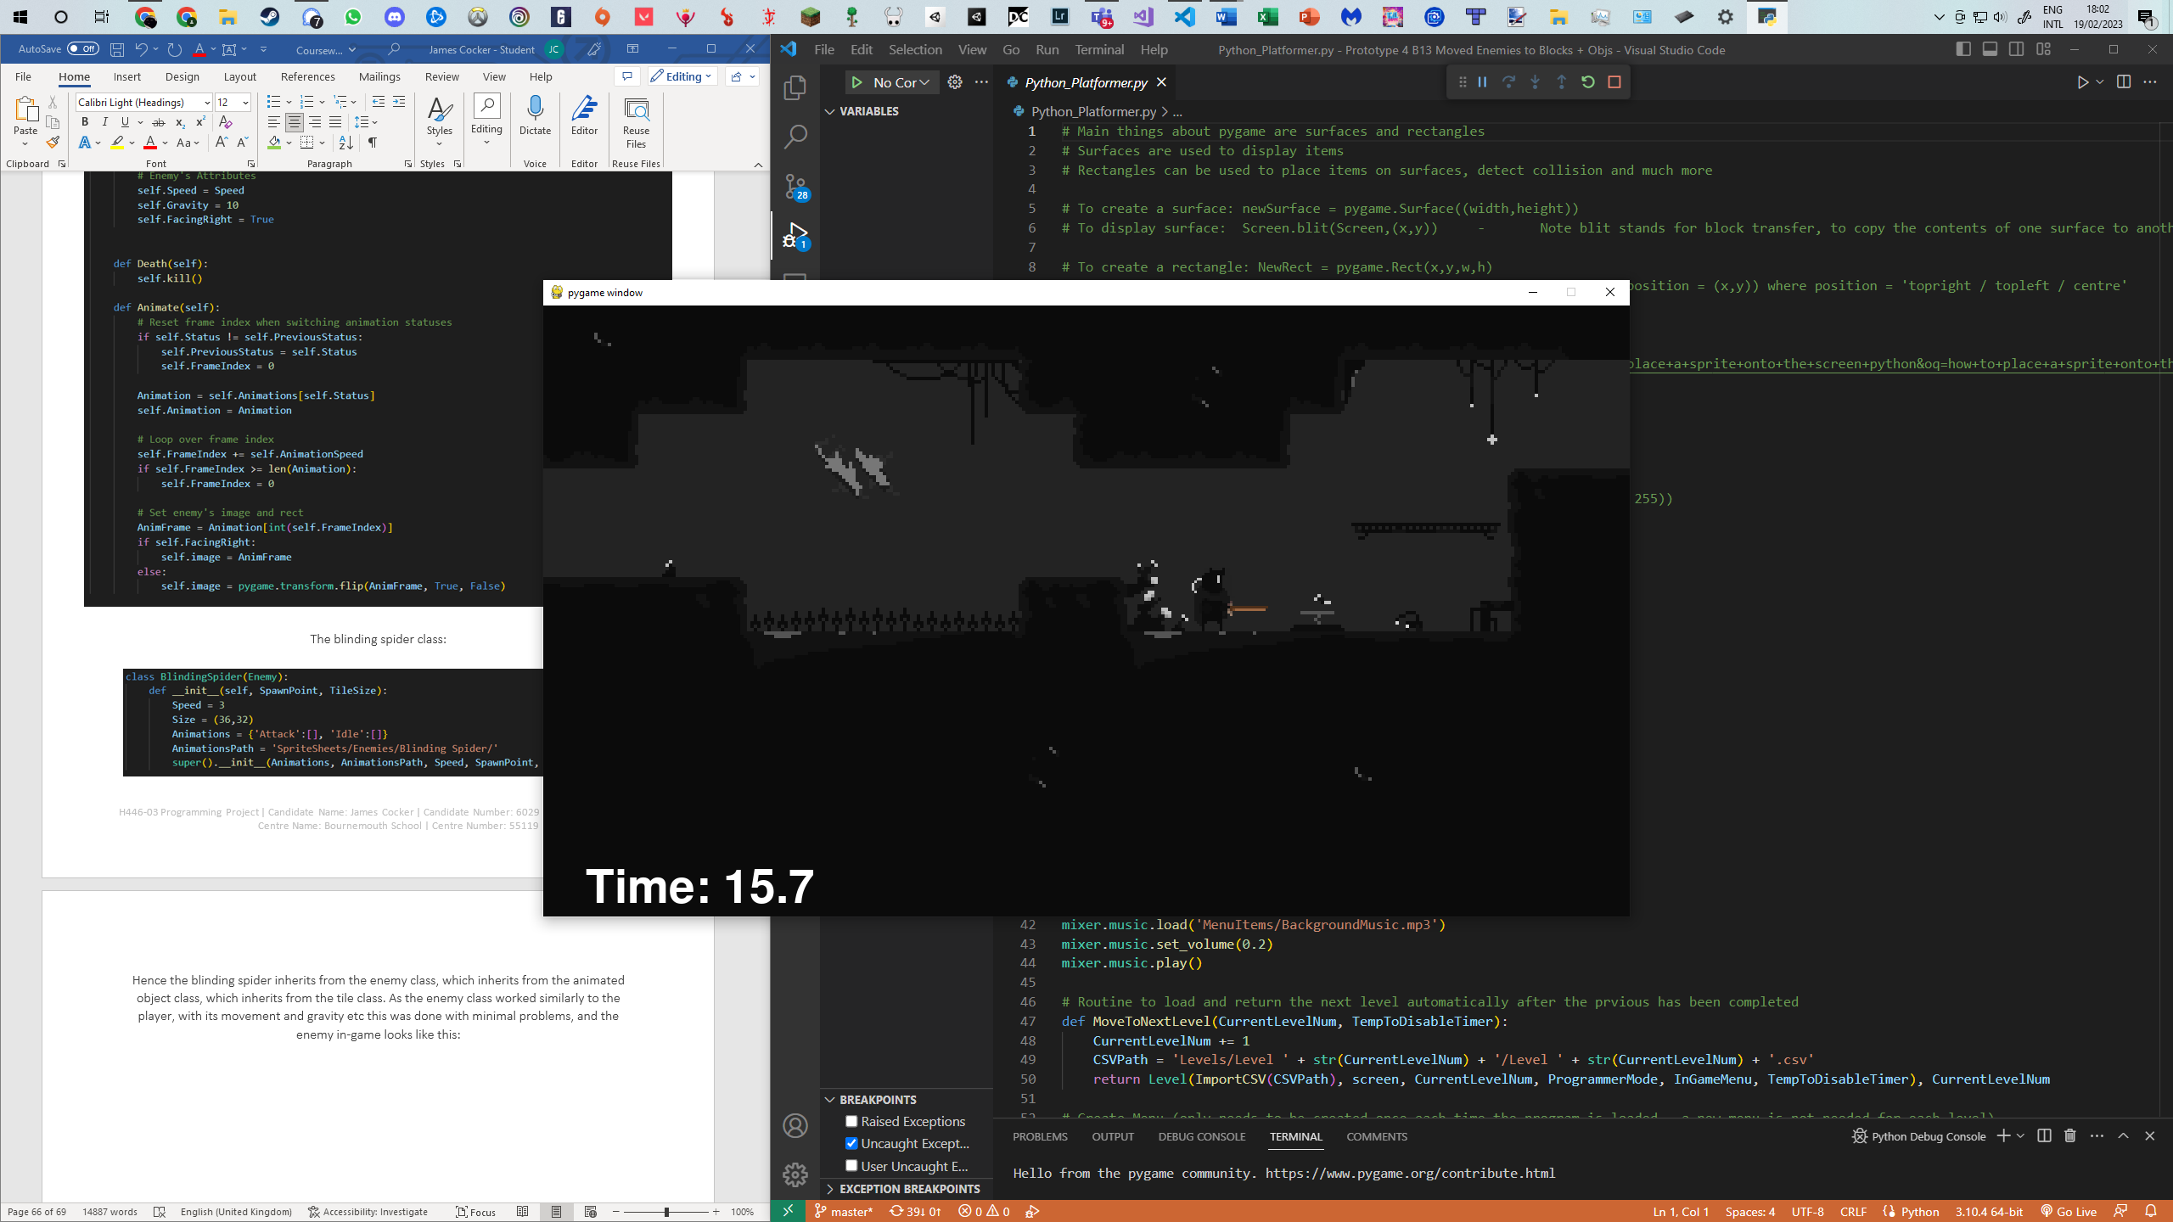

The first problem with this was adding in the collision detection and creating new attack animations for the spider. The code for this can be seen as:

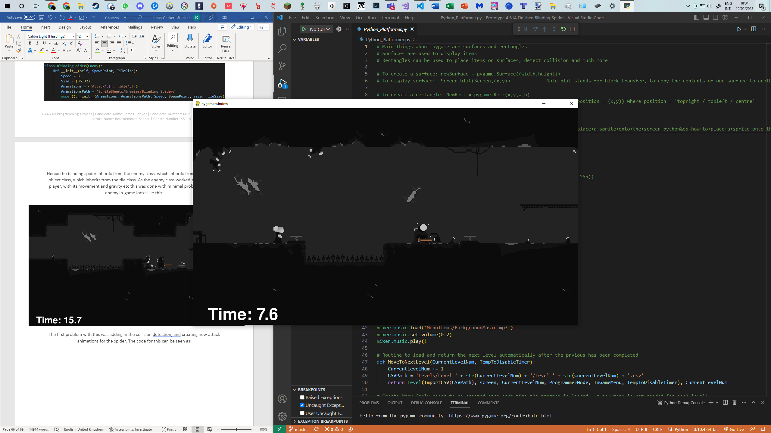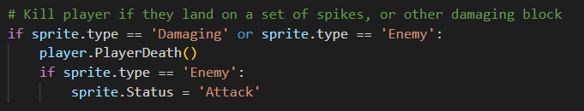

The collision detection is done within the Y_CollisionCheck in Levels.py with the other objects such as springs and respawn points – and as such it didn’t cause many issues. The main problem I had with the enemies is efficiency. For each frame that was running, the player, along with the enemies were having gravity applied, with their own collision detection for walls and each other, etc. The O(n²) function of checking each tile against each of these objects causes issues as it scales up, see the test table:

|  |  |  |
| --- | --- | --- |
| **Number of enemies** | **Expected Output** | **Actual Output** |
| 1 - 3 | Smooth running speed | * Smooth running speed |
| 4 - 6 | Smooth running speed | * Program beings to lag |
| 7+ | Smooth running speed | * Program is unplayable |

This was a problem unlike those I had encountered before, a problem with my code’s efficiency. When I first encountered the lagging I believed it might have been my computer at the time, but after testing it with and without enemies, it became quite obvious what the problem was. After some digging, I found that the background was also quite inefficient, as it seemed I could have up to 10 enemies without any noticeable lag in my game, as long as the background image wasn’t being overlaid, however this was not able to be changed as my game needs that for it to look like it is. The only option from there was to make my enemies more efficient.

My solution to this problem was to remove the gravity from my enemies and just have them detect collisions along the horizontal axis. This meant if I placed enemies in the air they would appear to walk through it, however this does not matter if I place them on the floor to begin with.

The code for my enemies then became:

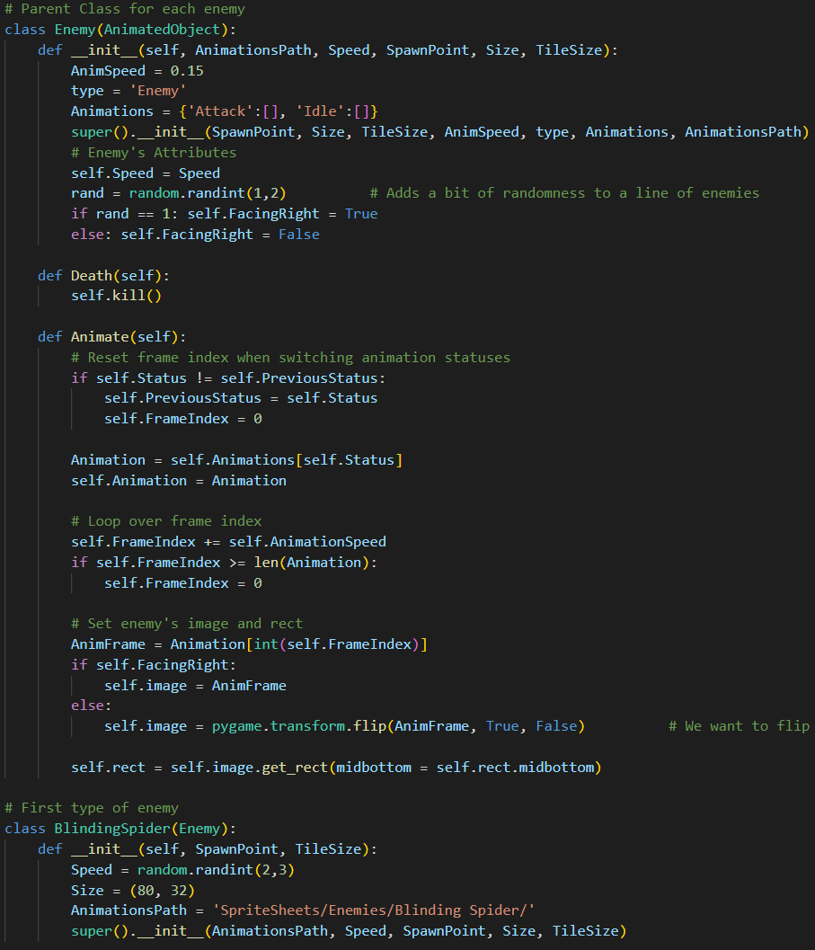



This was an important step to me as it was the first time I began to think about the impact of my code’s efficiency, and how I could optimise it for lower performance computers – however with the enemies now fully functioning, I could have a lot more within one level.

|  |  |  |
| --- | --- | --- |
| **Number of enemies** | **Expected Output** | **Actual Output** |
| 1 - 3 | Smooth running speed | * Smooth running speed |
| 4 - 6 | Smooth running speed | * Smooth running speed |
| 7 - 29 | Smooth running speed | * Smooth running speed |
| 30 - 99 | Smooth running speed | * Program begins to lag |
| 100+ | Smooth running speed | * Program is unplayable |

**Validation**

There is still no further validation required as only the game logic has been updated in this prototype. The only input required from the player is still the arrow keys, with the new exception of the escape key. This however does not need to be validated as the program is only checking for the escape key, hence the user cannot crash the program.

**Testing**

|  |  |  |
| --- | --- | --- |
| **Input/ Event** | **Expected Output** | **Actual Output** |
| Escape pressed | Menu is toggled on and off with the correct buttons saved in the correct position. For example, when the menu is closed and the music has been toggled off, the next time the menu is opened the button still displays the music as muted. | * Menu is toggled on and off with the correct buttons saved in the correct position |
| Interacting with menu buttons, including volume keys | The buttons all funtion as expected, for example the exit key closing the program. | * The buttons all funtion as expected |
| Collision with an enemy | The player runs its death animation, whilst the enemy simulataneously runs it’s attack animation. The player is then reset to respawn point and the enemy continues from the point it left off. | * The player runs its death animation, whilst the enemy simulataneously runs it’s attack animation. The player is then reset to respawn point and the enemy continues from the point it left off. |
| Player interacting with animated objects | The animated objects all function as expected. For example, the respawn point runs it’s respawn animation when the player collides with it. | * The animated objects all function as expected. |

**Review**

Features implemented successfully:

* Music + sounds
* In-game menu
* Animated objects
* The blinding sprider enemy

Features implemented unsuccessfully:

* None

In this prototype I achieved what I believe to be the most impactful changes to bringing the project closer to something that resembles a game. From animating all the objects, such as the respawn points, to adding a UI, enemies, and music my game now feels like it is coming to life. In a little more detail, animated objects all inherit from the tile class, so that as the player moves along the world, they are all kept in sync – however with the added methods of being able to have states and animate through a set of imported images. This ‘AnimatedObject’ class is then inherited from by sub classes of enemies, portals, respawn points, etc. Among the animated objects is the golden gear, the player can collect one golden gear per level and the plan is to add it to a save screen where the player can view their level completion times in the next prototype. In the bottom left of the screenshots above you will be able to see the new timer, counting the number of seconds that have from when the level started – and will stop when the player reaches the portal. This timer will be able to be toggled in the new menu, along with the volume which can also be turned up and down. For the UI, I have created my own menu and button classes. The menu and timer are new features of the overall user interface, along with the pixel art I created to display the player’s remaining lives. Last but not least, music and sounds were things that were quite quick and simple to implement but was truly the one factor that distinctly made this project come to life as a playable game.

# **Prototype 5 – Level design, Level Selection Menus, Scoring System, Wheel Bot, Player Abilities**

Main File

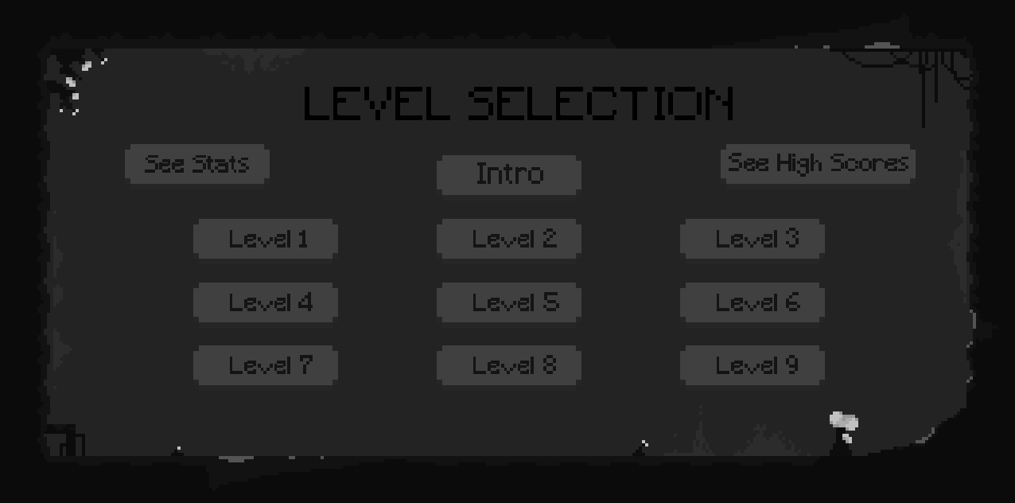

Current File Listing

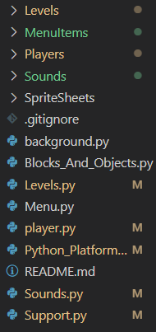

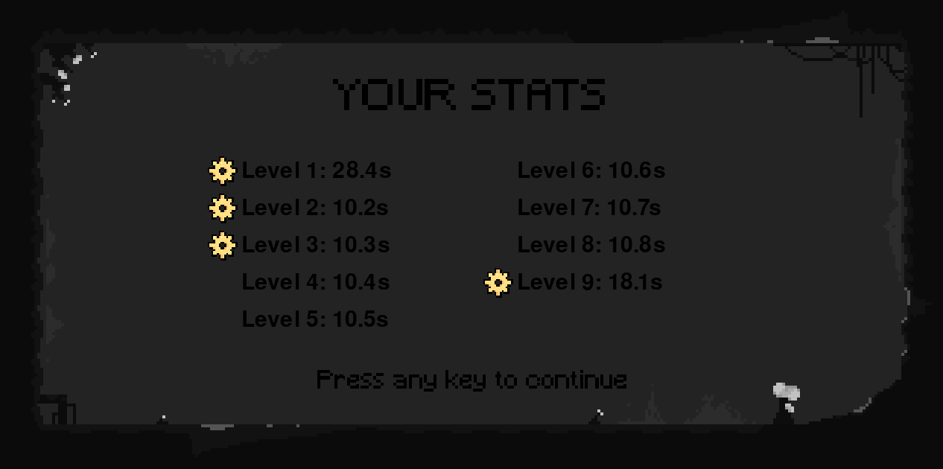

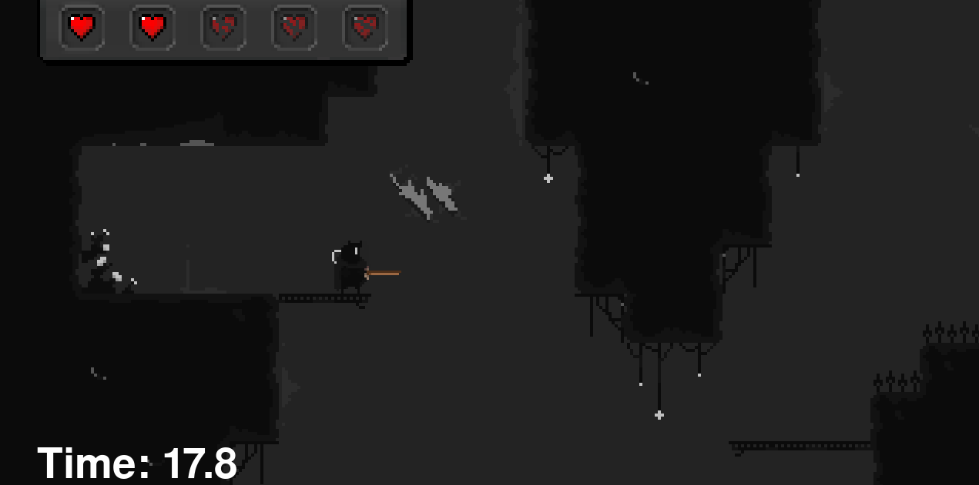

**Overview and Justification**

For my final prototype my main objective was to complete the level design. This was to be 9 full playable levels, each becoming increasingly more challenging with a golden gear available as a collectable. My other plans were all put in place to make the game come together, such as a menu for each of my menus, a login screen, a stats screen, a new enemy and more.

The main objective, designing my levels, needed to be done once all the logic for my game was out the way, hence this came last. This also meant I created the player’s special abilities before working on the level design, as it was the only logic that was needed. The new enemy will be similar to the blinding spider in the sense that it bounces off walls and collides with the player to kill it, so the code for my blinding spider can be easily reused – hence I chose to add this whilst doing my levels. This is required to scale up the difficulty and keep my game interesting as the player traverses the levels. The scoring systems will be added after the levels are completed so that the level completion time for each level can easily be tested and not have to be added manually. I am adding this as it is a requirement set out by my specification.

**Problems**

**Problem 1 – Player Abilities**

I decided to add two new abilities to my game. The reasoning behind this is that as there are 9 levels in total, it would make sense that these get broken down into sets of 3, then a fun new ability is added to the player’s skillset. What I decided to add was a double jump and a dash. As the double jump was a simple flag situation, of testing whether the player was on the ground and had already double jumped, this did not cause me too much grief. The dash on the other hand was different.

What I wanted the dash to be is the player double pressing the arrow key in the direction they wanted to dash, and to then give them a ‘boost’. By boost I mean setting their velocity quite high, and then decelerating them back down to normal speed, almost like a horizontal jump with gravity applied.

Along with a few other checks, this is what my code looked like when the player pressed the right arrow key:

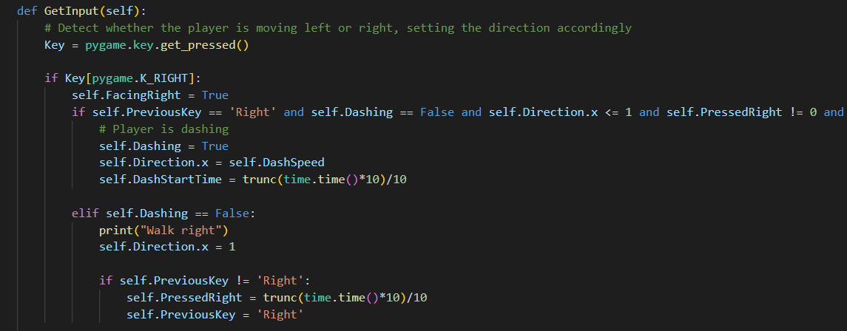

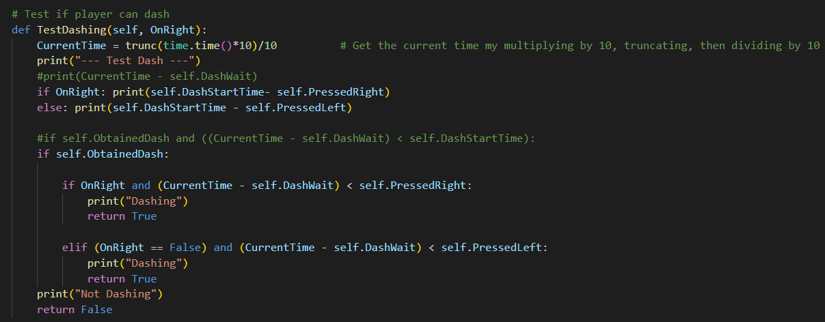

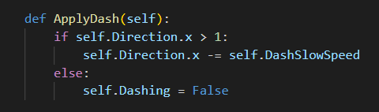

|  |  |  |
| --- | --- | --- |
| **Input/ Event** | **Expected Output** | **Actual Output** |
| Player doubles presses right arrow | Player dashes to the right | * Player dashes multiple times to the right |
| Player holds right arrow key | Player walks to the right | Player dashes multiple times to the right |
| Player presses shift key facing left | Player dashes to the left | * Player dashes multiple times to the left |
| Player holds left arrow key | Player walks to the left | Player dashes multiple times to the left |

These three functions made my dash. To shortly explain, I wanted the double tap of the arrow key to be under a set time. If these conditions were true, then it was to perform a dash in that direction with the ApplyDash() function. This code was filled with errors and caused my player to dash/ jump when they help down an arrow key. This was because the functions were based off of the arrow key recording the time and testing it against the next key press. However the right arrow key was recorded and then ‘pressed’ immediately after when it was held down. This was because the function did not take into account that the arrow key was on pygame’s ‘GetPressed()’ function, not a ‘Keydown’ function. Because of this, and I didn’t want to remove and recreate my code for moving left or right (requiring me to rejig most of my movement code) I decided to have the dash be tested when the user presses the shift key instead. Ironing out these mistakes brought me to the fixed function:

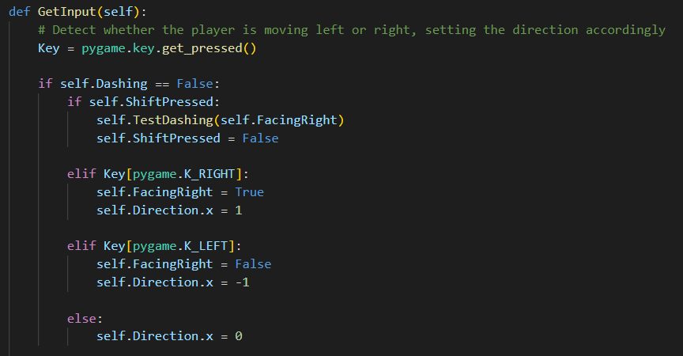

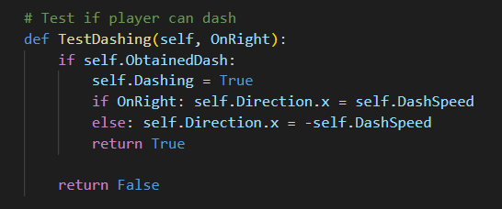

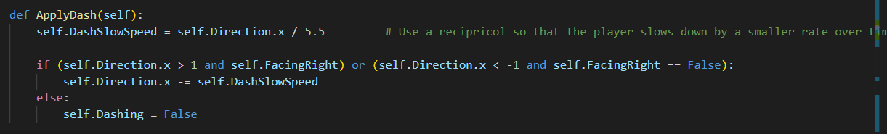

The ‘ApplyDash()’ procedure now uses a reciprocal to create a new value for the amount the player should slow down, as it reduces over time, causing a deceleration-like motion.

|  |  |  |
| --- | --- | --- |
| **Input/ Event** | **Expected Output** | **Actual Output** |
| Player presses shift key facing right | Player dashes to the right | * Player dashes to the right |
| Player holds right arrow key | Player walks to the right | * Player walks to the right |
| Player presses shift key facing left | Player dashes to the left | * Player dashes to the left |
| Player holds left arrow key | Player walks to the left | * Player walks to the left |

**Problem 2 – Menus**

I wanted my game at this stage to have a start menu, a level selection menu and normal in-game menu. I assumed this would be rather straight forward as my menu class was rather generalised, taking in only the button names and their positions upon creation. The button images and importing them were all taken care of with this menu function:

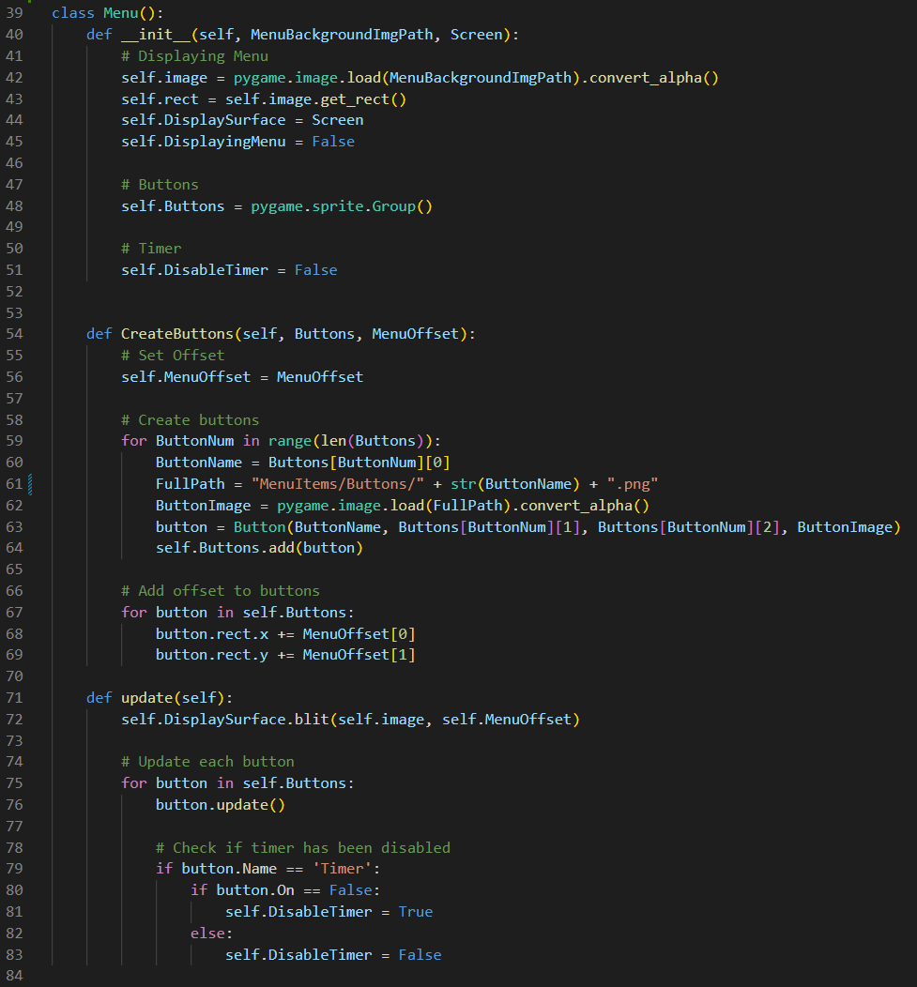

My initial thoughts on creating the starting menu was to have two buttons, under ‘Start’ and ‘Load Game’ which would be in a while loop until the user clicks one or the other. My first attempt at the creation of this, with just the start button, was simply:

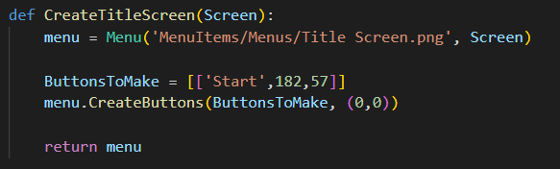

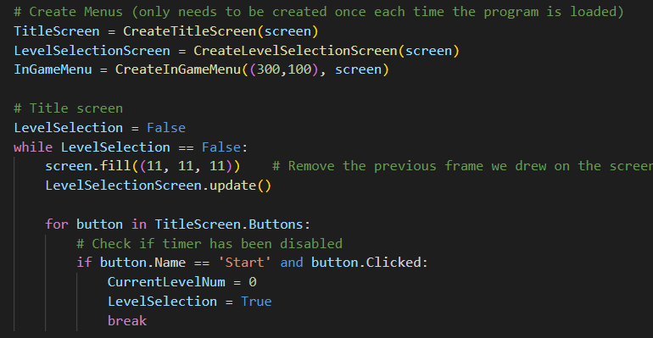

After selecting ‘Start’ the while loop would be broken, and the code should fall back into the normal game loop. The level selection menu will be activated if the user presses the corresponding button, but for now I just wanted to get the simple level selection working.

|  |  |  |
| --- | --- | --- |
| **Input/ Event** | **Expected Output** | **Actual Output** |
| Code is run | Title menu appears and presents user with ‘Start’ and ‘Exit’ buttons | * A black screen is presented |
| User selects ‘Start’ | The normal game loop is started | * Buttons cannot be seen |

The problem was that there was just a black screen presented, with no menus or buttons showing. The problem here was the menu not running it’s corresponding update function, so the code became:

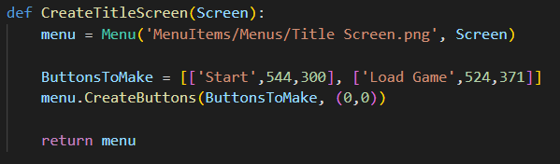

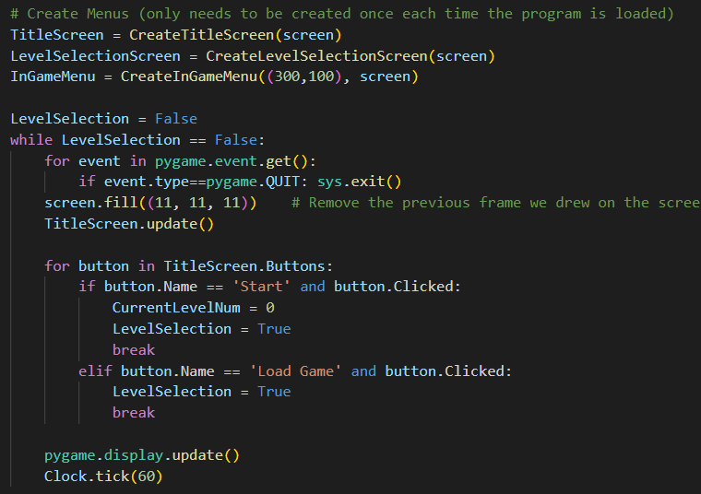

The next problem was creating the level selection screen, and waiting until the user pressed a level to then load that corresponding level:

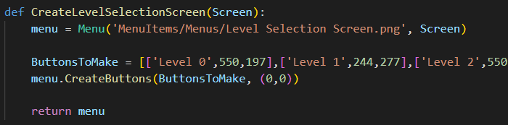

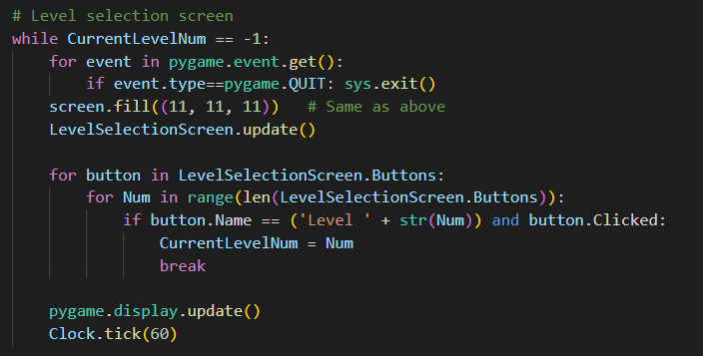

|  |  |  |
| --- | --- | --- |
| **Input/ Event** | **Expected Output** | **Actual Output** |
| Code is run | Title menu appears and presents user with ‘Start’ and ‘Exit’ buttons | * Title menu appears and presents user with ‘Start’ and ‘Exit’ buttons |
| User selects ‘Start’ | The normal game loop is started | * The normal game loop is started |

The main problem I encounter when attempting to create buttons in specific places, like with all my menus, is getting the positions correct. The only way to do this was to use paint.net to draw out an example menu and use a recently tool to find what position the top left of the button was in relation to the menu, not the screen. This is because the menu surface is overlaid on the screen, hence no offset needs to be added to the buttons if the menu is smaller than the screen (like the in-game menu). Here is an example of using Paint.net to do this:

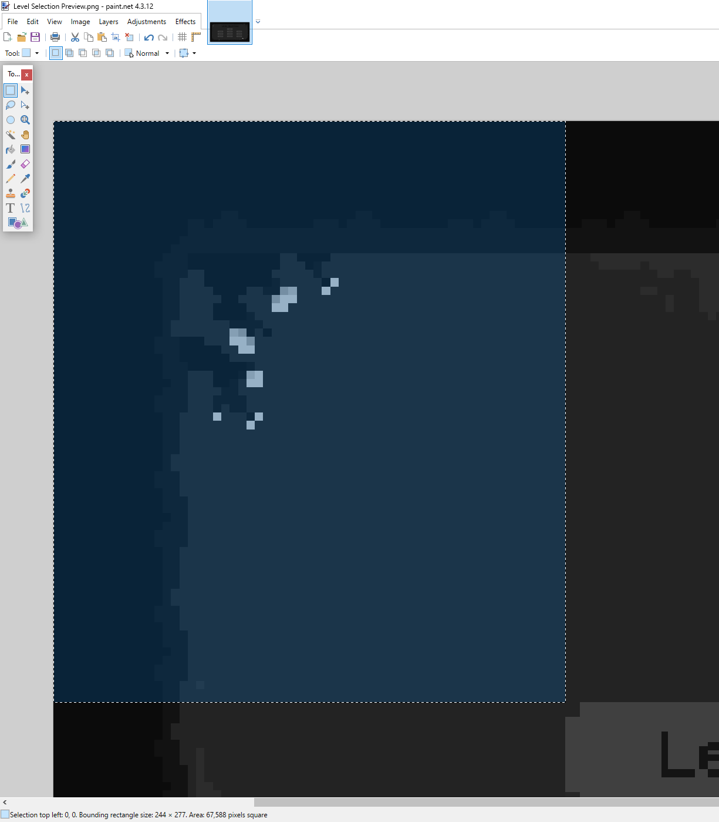

**Problem 3 – File handling**

When navigating the level selection menu, I also wanted the user to be able to choose between viewing their own scores and viewing the scores of everyone else who played the game on that computer under a different name. This involved the user giving text input for their name so that they could ‘login’ or ‘create a new account’ with just their first name - see the validation section for more on the text input validation. Once this was working I could assign the player to a name, with a set of times for each level and a bool of whether they got the golden gear. This needed to be stored in a separate file so that the data was not lost, requiring file handling for calculating the scores and displaying the correct information.

Creating the name screen function went as followed:

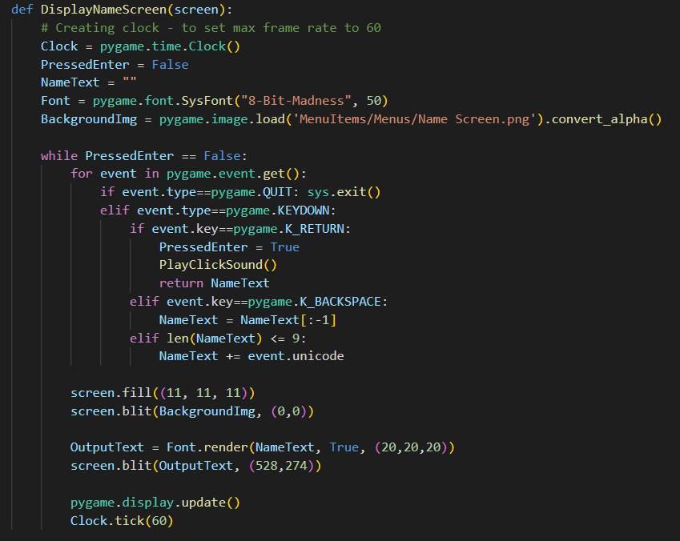

The function is called before anything else in the program with:

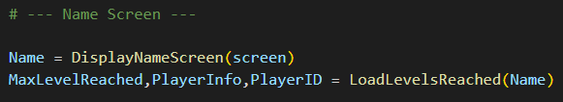

The next job is to then find them in the file and get the number of the furthest level they visited (so that if they pressed start or level selection the program will know which level to jump them to, or how many levels to give them the selection of). The handling of a new player was also contained in this function:

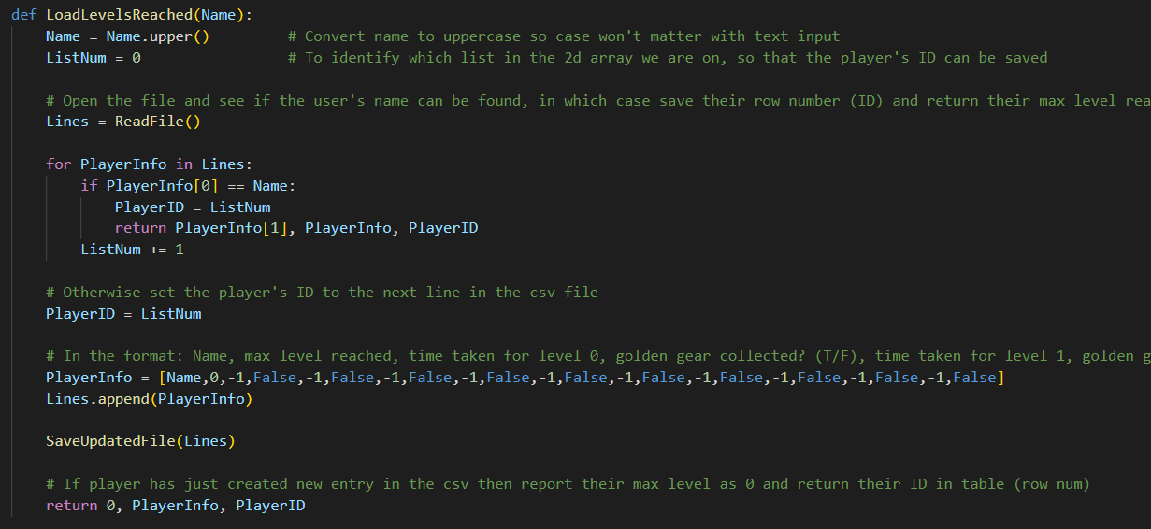

This then leads on to the saving of the file:

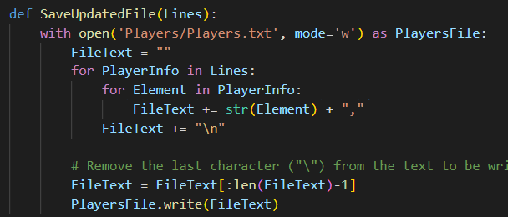

|  |  |  |
| --- | --- | --- |
| **Input/ Event** | **Expected Output** | **Actual Output** |
| New player enters their name | A new entry to the text file is made, and saved | * A new entry to the text file is made, and saved |
| New player attempts to access their stats | Game displays stats | * Code crashes due to integer error |

The saving of this file is where things began to become peculiar. The data for new players was being read in incorrectly, and saved incorrectly. This was solved by taking off the last comma off the file. It took a lot of digging within all the new files to find the one small mistake that produced the integer error, however it was because the last entry into the text file was empty due to the leading comma. The ‘SaveUpdatedFile’ procedure became:

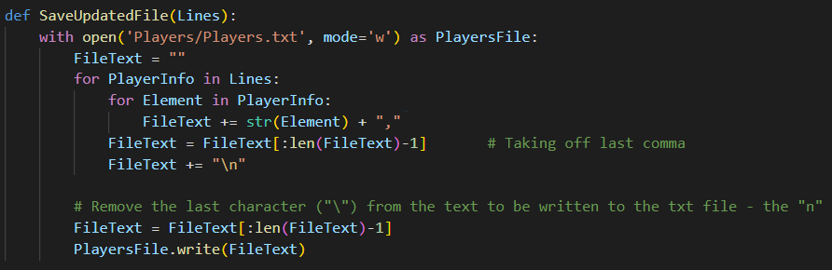

|  |  |  |
| --- | --- | --- |
| **Input/ Event** | **Expected Output** | **Actual Output** |
| New player enters their name | A new entry to the text file is made, and saved | * A new entry to the text file is made, and saved |
| New player attempts to access their stats | Game displays stats | * Game displays stats |

**Validation**

The text input the player gives when entering their name is something that needs validation. To ensure the code does not crash after an incorrect value is inputted to the text box I am ensuring it is under the length of 9, saving it as a string (meaning numbers will be taken as an input, but not crash the code) then capitalising it. This means the name input is not case sensitive, nor will it crash due to odd Unicode characters being inputted.

|  |  |  |
| --- | --- | --- |
| **Name Input** | **Expected Output** | **Actual Output** |
| ‘James’ | Code saves under name ‘JAMES’ and does not crash at any point | * Code saves under name ‘JAMES’ and does not crash at any point |
| ‘James 889’ | Code saves under name ‘JAMES 889’ and does not crash at any point | * Code saves under name ‘JAMES 889’ and does not crash at any point |
| ‘=-‘/.;[]-2’ | Code saves under name ‘=-‘/.;[]-2’and does not crash at any point | * Code saves under name ‘=-‘/.;[]-2’and does not crash at any point |

**Testing**

|  |  |  |
| --- | --- | --- |
| **Input/ Event** | **Expected Output** | **Actual Output** |
| Player navigates title page menu | Menu should not crash and all buttons should function correctly | * Menu should not crash and all buttons should function correctly |
| Player enters name in name menu | No matter the input, the name should be saved into a text file if a new player, otherwise load previous data | * No matter the input, the name is saved into a text file if a new player, otherwise loads previous data |
| Player navigates level selection menu | Menu should not crash and all buttons should function correctly | * Menu should not crash and all buttons should function correctly |
| Player exits the game | Player data should be saved onto text file correctly | * Player data should be saved onto text file correctly |
| Player collides with the new enemy | Player is placed at their respawn point and enemy continues as normal after animation | * Player is placed at their respawn point and enemy continues as normal after animation |

**Review**

Features implemented successfully:

* Level design
* Level selection menus
* Scoring system with file handling
* Wheel bot enemy
* Player abilities, including a double jump and dash

Features implemented unsuccessfully:

* Levels being under different pixel art
* Levels including a merchant and weapon system

This prototype by far had the newest features. One that most stood out to me was the menus, as the program has been written in an object-oriented way, it allowed me to create new menus extremely quickly, even with completely different backgrounds, buttons and button positions. Building up my menu system, including the title screen, level selection and scoring system menus is something I am particularly proud of. Overall however, the most time consuming and best additions was the levels themselves. From creating different types of jumping to trying to think of puzzles that would incorporate multiple special abilities and have that all be player tested was something extremely difficult, and I am glad to have overcome that barrier.

# **Code Listing**

Final file listing

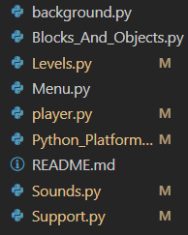

**Background.py**

1. **import** pygame
3. **class** Background(pygame.sprite.Sprite): *# Used to create a template for the background image, inherit from the parent class 'Sprite'*
4. **def** __init__(self,FullPath): *# position, tile size*
5. **super().__init__() *# Run the initialisation routine of pygame's parent class***
6. self.image = pygame.image.load(FullPath + '.png')
7. self.rect = self.image.get_rect(topleft = (0,0))
9. **def** ResetLevel(self, XOffset):
10. **self.rect.x -= XOffset**
12. *# Will scroll through the level, shifting each tile to the left or right*
13. **def** update(self, XShift):
14. self.rect.x += XShift

**Blocks_And_Objects.py**

1. **import** pygame, random
2. **from** Support **import** ImportFolder
4. *# The parent class for each class in this file*
5. **class Tile(pygame.sprite.Sprite): *# Used to create a template for each tile, inherit from the parent class 'Sprite'***
6. **def** __init__(self,pos,size,TileSize,type): *# position, tile size*
7. super().__init__() *# Run the initialisation routine of pygame's parent class*
8. self.type = type *# Set type of tile*
10. **self.image = pygame.Surface((size[0],size[1])) *# Create a surface with the dimesnions of the given tile size, where size is a tuple with [0] being its x dimension size***
11. self.rect = self.image.get_rect(midbottom = (pos[0]+(size[0]/2), pos[1]+(TileSize))) *# Give the rectangle for the surface the same dimensions as the image, where pos is a tuple for the top left*
12. *# of the image. I have chosen to force this into being the 'midbottom' as when the class is inherited from*
13. *# animated objects, not all objects are the same height and width (e.g spring).*
14. *# If deciding to draw the abstract level, the different blocks are colour coded as such*
15. **if type == 'Normal':**
16. self.image.fill('Gray')
17. **elif** type == 'Damaging':
18. self.image.fill('Red')
19. **elif** type == 'Platform':
20. **self.image.fill('Blue')**

23. *# Will reset level upon player death*
24. **def** ResetLevel(self, XOffset):
25. **self.rect.x -= XOffset**
27. *# Will scroll through the level, shifting each tile to the left or right*
28. **def** update(self,XShift):
29. self.rect.x += XShift
31. *# Parent class for 'enemy' and the other objects such as 'respawn point'*
32. **class** AnimatedObject(Tile):
33. **def** __init__(self,pos,size,TileSize,AnimSpeed,type,Animations,FullPath): *# position, tile size*
34. super().__init__(pos,size,TileSize,type) *# Run the initialisation routine of pygame's parent class*
36. self.Animations = Animations *# Set arrays for each animation state*
37. self.ImportAssets(FullPath)
38. self.Status = 'Idle'
39. self.PreviousStatus = 'Idle'
40. **self.FrameIndex = 0**
41. self.AnimationSpeed = AnimSpeed
42. self.image = self.Animations['Idle'][self.FrameIndex] *# Fill the surface with the animation frame 'idle'*
43. self.rect = self.image.get_rect(midbottom = self.rect.midbottom) *# Give the rectangle for the surface the same dimensions as the image*
45. **def ImportAssets(self, Path):**
46. *# Add each image to the arrays for later use*
47. **for** Animation **in** self.Animations.keys():
48. FullPath = Path + Animation
49. self.Animations[Animation] = ImportFolder(FullPath)
51. **def** update(self, XShift): *# Override tile's update method as we must animate the object as well*
52. *# Shifting the respawn point, and animating it*
53. self.rect.x += XShift
55. **self.Animate() *# Each class has unique animation routines, hence no need to define it and for it to be overriden in each instance of the class***

58. *# --- Enemies ---*
60. ***# Parent Class for each enemy***
61. **class** Enemy(AnimatedObject):
62. **def** __init__(self, AnimationsPath, Speed, SpawnPoint, Size, TileSize):
63. AnimSpeed = 0.15
64. type = 'Enemy'
65. **Animations = {'Attack':[], 'Idle':[]}**
66. super().__init__(SpawnPoint, Size, TileSize, AnimSpeed, type, Animations, AnimationsPath)
67. *# Enemy's Attributes*
68. self.Speed = Speed
69. rand = random.randint(1,2) *# Adds a bit of randomness to a line of enemies*
70. **if rand == 1: self.FacingRight = True**
71. **else**: self.FacingRight = False
73. **def** Death(self):
74. self.kill()
76. **def** Animate(self):
77. *# Reset frame index when switching animation statuses*
78. **if** self.Status != self.PreviousStatus:
79. self.PreviousStatus = self.Status
80. **self.FrameIndex = 0**
82. Animation = self.Animations[self.Status]
83. self.Animation = Animation
85. ***# Loop over frame index***
86. self.FrameIndex += self.AnimationSpeed
87. **if** self.FrameIndex >= len(Animation):
88. self.FrameIndex = 0
90. ***# Set enemy's image and rect***
91. AnimFrame = Animation[int(self.FrameIndex)]
92. **if** self.FacingRight:
93. self.image = AnimFrame
94. **else**:
95. **self.image = pygame.transform.flip(AnimFrame, True, False) *# We want to flip in the x axis, but not the y axis***
97. self.rect = self.image.get_rect(midbottom = self.rect.midbottom)
99. *# First type of enemy*
100. **class BlindingSpider(Enemy):**
101. **def** __init__(self, SpawnPoint, TileSize):
102. Speed = random.randint(2,3)
103. Size = (80, 32)
104. AnimationsPath = 'SpriteSheets/Enemies/Blinding Spider/'
105. **super().__init__(AnimationsPath, Speed, SpawnPoint, Size, TileSize)**
107. *# Second type of enemy*
108. **class** FlowerEnemy(Enemy):
109. **def** __init__(self, SpawnPoint, TileSize):
110. **Speed = 0.7**
111. Size =()*####################*
112. AnimationsPath = 'SpriteSheets/Enemies/Flower Enemy/'
113. super().__init__(AnimationsPath, Speed, SpawnPoint, Size, TileSize)
115. ***# Third type of enemy***
116. **class** WheelBot(Enemy):
117. **def** __init__(self, SpawnPoint, TileSize):
118. Speed = random.randint(4,5)
119. Size = (43,26)
120. **AnimationsPath = 'SpriteSheets/Enemies/Wheel Bot/'**
121. super().__init__(AnimationsPath, Speed, SpawnPoint, Size, TileSize)

124. *# --- Collectable Items ---*
126. *# Parent class for each item*
127. **class** CollectableItem(AnimatedObject):
128. **def** __init__(self, pos, size, TileSize, type, ToMove, Path):
129. Animations = {'Idle':[]}
130. **super().__init__(pos, size, TileSize, 0, type, Animations, Path) *# Run the initialisation routine of Animated object (and hence tile)***
132. *# Set attributes*
133. InitialYPos = self.rect.y
134. self.UpperBound = InitialYPos
135. **self.LowerBound = InitialYPos + ToMove**
136. self.MoveUp = False
138. **def** Animate(self):
140. ***# Object floats up and down, so shift y pos up to a certain point, then back down***
141. self.rect = self.image.get_rect(center = self.rect.center) *# Give the rectangle for the surface the same dimensions as the image*
143. YPos = self.rect.y
145. **if self.MoveUp:**
146. self.rect.y -= 1
147. **if** YPos < self.UpperBound:
148. self.MoveUp = False
149. **else**:
150. **self.rect.y += 1**
151. **if** YPos > self.LowerBound:
152. self.MoveUp = True
154. *# Golden Gear*
155. **class GoldenGear(CollectableItem):**
156. **def** __init__(self, pos, size, TileSize, type, ToMove):
157. Path = 'SpriteSheets/AnimatedObjects/Golden Gear/'
158. super().__init__(pos, size, TileSize, type, ToMove, Path) *# Run the initialisation routine of Animated object (and hence tile)*
160. ***# Double Jump***
161. **class** DoubleJump(CollectableItem):
162. **def** __init__(self, pos, size, TileSize, type, ToMove):
163. Path = 'SpriteSheets/AnimatedObjects/Double Jump/'
164. super().__init__(pos, size, TileSize, type, ToMove, Path) *# Run the initialisation routine of Animated object (and hence tile)*
166. *# Dash*
167. **class** Dash(CollectableItem):
168. **def** __init__(self, pos, size, TileSize, type, ToMove):
169. Path = 'SpriteSheets/AnimatedObjects/Dash/'
170. **super().__init__(pos, size, TileSize, type, ToMove, Path) *# Run the initialisation routine of Animated object (and hence tile)***


174. *# --- General Animated Objects ---*
176. *# Portal*
177. **class** Portal(AnimatedObject):
178. **def** __init__(self, pos, size, TileSize, type):
179. Animations = {'Idle':[], 'Warp':[]}
180. **Path = 'SpriteSheets/AnimatedObjects/Portal/'**
181. AnimSpeed = 0.15
182. super().__init__(pos, size, TileSize, AnimSpeed, type, Animations, Path) *# Run the initialisation routine of Animated object (and hence tile)*
184. **def** Animate(self): *# Creating the animate function to be used inside the parent class*
185. **Animation = self.Animations[self.Status]**
186. self.Animation = Animation
188. *# Loop over frame index*
189. self.FrameIndex += self.AnimationSpeed
190. **if self.FrameIndex >= len(Animation):**
191. self.FrameIndex = 0
193. *# Set image and rect of the respawn point*
194. self.image = Animation[int(self.FrameIndex)]
195. **self.rect = self.image.get_rect(midbottom = self.rect.midbottom)**
197. *# Respawn point*
198. **class** RespawnPoint(AnimatedObject):
199. **def** __init__(self, pos, size, TileSize, type):
200. **Animations = {'Idle':[], 'Saving':[], 'Startup':[]}**
201. Path = 'SpriteSheets/AnimatedObjects/Save/'
202. AnimSpeed = 0.15
203. super().__init__(pos, size, TileSize, AnimSpeed, type, Animations, Path) *# Run the initialisation routine of Animated object (and hence tile)*
204. *# Set attributes of respawn point*
205. **self.ID = 0 *# Where ID is the number of the respawn point***
206. self.Saving = False
208. **def** Animate(self):
209. *# If we have swapped to a new status, set animation speed (back) to default and frame index to 0*
210. **if self.Status != self.PreviousStatus:**
211. self.PreviousStatus = self.Status
212. self.FrameIndex = 0
214. Animation = self.Animations[self.Status]
215. **self.Animation = Animation**
217. *# Loop over frame index*
218. self.FrameIndex += self.AnimationSpeed
219. **if** int(self.FrameIndex) == len(self.Animation) - 1:
220. **if self.Status == 'Saving':**
221. self.Status = 'Idle'
222. self.FrameIndex = 0
224. *# Set image and rect of the respawn point*
225. **self.image = Animation[int(self.FrameIndex)]**
226. self.rect = self.image.get_rect(midbottom = self.rect.midbottom)
228. *# Spring*
229. **class** Spring(AnimatedObject):
230. **def __init__(self, pos, size, TileSize, type):**
231. Animations = {'Idle':[], 'Bounce':[]}
232. Path = 'SpriteSheets/AnimatedObjects/Spring/'
233. AnimSpeed = 0.3
234. super().__init__(pos, size, TileSize, AnimSpeed, type, Animations, Path) *# Run the initialisation routine of Animated object (and hence tile)*
236. **def** Animate(self):
237. Animation = self.Animations[self.Status]
239. *# Add onto frame index*
240. **self.FrameIndex += self.AnimationSpeed**
242. *# Set image and rect of spring*
243. self.image = Animation[int(self.FrameIndex)]
244. self.rect = self.image.get_rect(midtop = self.rect.midtop)
246. **if** int(self.FrameIndex) == len(Animation) - 1:
247. self.FrameIndex = 0
248. self.Status = 'Idle'
249. self.Animation = self.Animations[self.Status]
250. **self.image = self.Animation[self.FrameIndex]**

**Levels.py**

1. **import** pygame, time
2. **from** Blocks_And_Objects **import** *
3. **from** player **import** Player
4. **from** Menu **import** *
5. **from Sounds import \***
6. **from** background **import** Background
8. *# Set constants*
9. ScreenWidth = 1280
10. **ScreenHeight = 640**
11. TileSize = 64
13. *# Creating the call that will be used for each level*
14. **class** Level:
15. ***# Creating an initialisation routine***
16. **def** __init__(self, level_data, surface, CurrentLevelNum, ProgrammerMode, InGameMenu, ToDisableTimer, PlayerLivesAndAbilities):
17. *# Set attributes*
18. self.TimerFont = pygame.font.SysFont("8-Bit-Madness", 80)
19. self.display_surface = surface
20. **self.CurrentLevelNum = CurrentLevelNum**
21. self.ProgrammerMode = ProgrammerMode
22. self.LostAllLives = False
23. self.Scrolling = False
25. ***# Health Bar***
26. PlayerLivesAndAbilities[0] = 5 *# Reset Health*
27. self.PlayerLives = PlayerLivesAndAbilities[0]
28. self.HealthBarImg = pygame.image.load('MenuItems/Health Bar/' + str(self.PlayerLives) + '.png').convert_alpha()
30. ***# Player Abilities***
31. self.SpacePressed = False *# Used to get the keydown for space, when user presses double jump*
32. self.ShiftPressed = False *# Used to get the keydown for shift, when user wants to dash*
33. self.PlayerLivesAndAbilities = PlayerLivesAndAbilities *# An array in the form [ No. of lives (between 1 and 5), double jump collected?, dash collected? ]*
35. ***# Setup Level***
36. self.setup_level(level_data)
38. *# Resetting level*
39. self.DistanceMovedX = 0 *# Used to keep track of how far the tileset and background will need to move should the player die*
40. **self.DistanceMovedY = 0**
41. self.WorldShiftX = 0
42. self.CurrentX = 0
44. *# Menu*
45. **self.InGameMenu = InGameMenu**
46. self.MenuDisplayed = False
47. self.CollectedGoldenGear = False
48. self.SavedGoldenGear = False *# If saved is true, it means the user has collected the golden gear and hit a check point*
49. self.GoldenGearImg = pygame.image.load('MenuItems/Golden Gear.png').convert_alpha()
51. *# Timer*
52. self.ToDisableTimer = ToDisableTimer
53. self.LevelStartTime = time.time()
55. ***# To tell if player has chosen to exit the level***
56. self.SaveAndExit = False
58. *# Indicates whether the player has beaten the level (hit the portal)*
59. self.FinishedLevel = False

62. *# Used when generating and to display the level*
63. **def** setup_level(self,layout):
64. NormalBlock = 142 *# The ID from the abstract .csv file of the tile which repesents a normal block the player is able to stand upon*
65. **DamagingBlocks = [270, 271] *# Same as above, except for tiles such as spikes***
66. PlatformBlocks = [58,59,60,61,62,72,73,75,76] *# Platform tiles whereby the player is able to jump on, but will not be used in x-collisions*
67. SpringBlock = 281 *# Ect...*
68. RespawnBlock = 305
69. PortalBlock = 322
70. **BlindingSpiderEnemy = 290**
71. WheelBotEnemy = 303
72. InvisibleEnemyWall = 286
73. goldengear = 307
74. PlayerSpawn = 285
75. **doublejump = 287**
76. dash = 288
78. self.RespawnReached = 0
79. self.RespawnPointLocations = [] *# Variable to store the x and y position of each respawn point*
81. *# Setting up the types of sprites for the level tiles and player*
82. self.tiles = pygame.sprite.Group()
83. self.enemies = pygame.sprite.Group()
84. self.springs = pygame.sprite.Group()
85. **self.player = pygame.sprite.GroupSingle()**
86. self.RespawnPoints = pygame.sprite.Group()
87. self.AnimatedObjects = pygame.sprite.Group()
88. self.background = pygame.sprite.GroupSingle()
89. self.GoldenGearObj = pygame.sprite.GroupSingle()
91. Path = 'Levels/Level ' + str(self.CurrentLevelNum) + '/Level ' + str(self.CurrentLevelNum)
92. self.background.add(Background(Path))
94. **for** RowIndex,Row **in** enumerate(layout): *# Enumerate gives index and information*
95. **for ColumnIndex,Column in enumerate(Row): *# For each row, cycle through each cell***
96. *# e.g. this will print each cell's contents with the exact row and column*
97. *# print(f'{RowIndex},{ColumnIndex}:{Column}')*
98. x = ColumnIndex * TileSize
99. y = RowIndex * TileSize
101. *# Creating a Tile for each value in the csv file. N ~> Normal, D ~> Damaging, P ~> Platform, S ~> Spring, 1000 ~> Player spawn point*
102. CurrentValue = int(Column)
104. **if** CurrentValue == NormalBlock:
105. **tile = Tile((x,y),(TileSize,TileSize), TileSize, 'Normal')**
106. self.tiles.add(tile)
107. **elif** CurrentValue == InvisibleEnemyWall:
108. tile = Tile((x,y),(TileSize,TileSize), TileSize, 'EnemyWall')
109. self.tiles.add(tile)
110. **elif CurrentValue in DamagingBlocks:**
111. tile = Tile((x,y),(TileSize,16), TileSize, 'Damaging')
112. self.tiles.add(tile)
113. **elif** CurrentValue **in** PlatformBlocks:
114. tile = Tile((x,y),(TileSize,TileSize), TileSize, 'Platform')
115. **self.tiles.add(tile)**
116. **elif** CurrentValue == SpringBlock:
117. tile = Spring((x,y), (64,32), TileSize, 'Spring')
118. self.tiles.add(tile)
119. self.springs.add(tile)
120. **self.AnimatedObjects.add(tile)**
121. **elif** CurrentValue == RespawnBlock:
122. tile = RespawnPoint((x,y), (64,76), TileSize, 'Respawn') *# Each respawn point will recieve an ID. The first respawn point will recieve an ID of 1*
123. self.tiles.add(tile)
124. self.RespawnPoints.add(tile)
125. **self.RespawnPointLocations.append([x,y])**
126. self.AnimatedObjects.add(tile)
127. **elif** CurrentValue == PortalBlock:
128. tile = Portal((x,y),(112,12), TileSize, 'Portal')
129. self.portal = tile
130. **self.tiles.add(tile)**
131. self.AnimatedObjects.add(tile)
132. **elif** CurrentValue == BlindingSpiderEnemy:
133. enemy = BlindingSpider((x,y), TileSize)
134. self.enemies.add(enemy)
135. **self.tiles.add(enemy)**
136. **elif** CurrentValue == WheelBotEnemy:
137. enemy = WheelBot((x,y), TileSize)
138. self.enemies.add(enemy)
139. self.tiles.add(enemy)
140. **elif CurrentValue == goldengear:**
141. tile = GoldenGear((x,y), (48,48), TileSize, 'GoldenGear', 30)
142. self.GoldenGear = tile
143. self.tiles.add(tile)
144. self.GoldenGearObj.add(tile)
145. **elif CurrentValue == doublejump:**
146. tile = DoubleJump((x,y), (64,58), TileSize, 'DoubleJump', 30)
147. self.tiles.add(tile)
148. self.AnimatedObjects.add(tile)
149. **elif** CurrentValue == dash:
150. **tile = Dash((x,y), (46,38), TileSize, 'Dash', 30)**
151. self.tiles.add(tile)
152. self.AnimatedObjects.add(tile)
153. **elif** CurrentValue == PlayerSpawn:
154. PlayerSprite = Player((x, y), self.PlayerLivesAndAbilities[1], self.PlayerLivesAndAbilities[2])
155. **self.player.add(PlayerSprite)**

158. self.RespawnPointLocations.sort(key=**lambda** key:key[0]) *# Sort respawn point locations by their x value, then set them IDs. This is because the player will always move through the level left to right,*
159. *# so the first respawn point will always be the leftmost one*
161. *# Allows for a max of 5 respawn points (not flexible, but a for or while loop is unessesary)*
163. **for** RespawnPointNum **in** self.RespawnPoints:
164. **if** RespawnPointNum.rect.x == self.RespawnPointLocations[0][0]:
165. **RespawnPointNum.ID = 1**
166. **elif** RespawnPointNum.rect.x == self.RespawnPointLocations[1][0]:
167. RespawnPointNum.ID = 2
168. **elif** RespawnPointNum.rect.x == self.RespawnPointLocations[2][0]:
169. RespawnPointNum.ID = 3
170. **elif RespawnPointNum.rect.x == self.RespawnPointLocations[3][0]:**
171. RespawnPointNum.ID = 4
172. **elif** RespawnPointNum.rect.x == self.RespawnPointLocations[4][0]:
173. RespawnPointNum.ID = 5
175. ***# A scrolling routine to take the player and see if they are at the preset border. If they are then set***
176. *# the player's speed to 0 and set the entire world to move accordingly at the inverted player speed*
177. **def** ScrollX(self, player):
178. *# getting variables*
179. player_x = player.rect.centerx *# If you get a 'nonetype' error here, it will mean the csv doesnt have a player spawn point*
180. **Direction_x = player.Direction.x**
181. new_player_x = player_x + Direction_x
183. *# Player borders*
184. MinPlayerX = 450
185. **MaxPlayerX = ScreenWidth - MinPlayerX**
187. *# Checking if the player is within the border, if not then move the world as such*
188. **if** player.Status != 'Death':
189. **if** player.Dashing:
190. **if (new_player_x < MinPlayerX) or (new_player_x > MaxPlayerX):**
191. self.WorldShiftX = -round(Direction_x) * 7
192. player.PlayerSpeed = 0
194. **else**:
195. **if new_player_x < MinPlayerX and Direction_x < 0:**
196. self.WorldShiftX = player.NormalSpeed
197. player.PlayerSpeed = 0
199. **elif** new_player_x > MaxPlayerX **and** Direction_x > 0:
200. **self.WorldShiftX = -(player.NormalSpeed)**
201. player.PlayerSpeed = 0
203. **else**:
204. self.WorldShiftX = 0
205. **player.PlayerSpeed = player.NormalSpeed**
206. **else**:
207. self.WorldShiftX = 0
208. player.PlayerSpeed = 0
210. ***# Move the level if they are still not within bounds***
211. **if** Direction_x == 0:
212. **if** player_x < MinPlayerX - 20:
213. self.WorldShiftX += 2
214. player.rect.x += 2
215. **elif player_x > MaxPlayerX + 20:**
216. self.WorldShiftX -= 2
217. player.rect.x -= 2
219. **def** X_CollisionCheck(self, player):
220. ***# Apply player's horizontal movement if the world is not scrolling***
221. player.rect.centerx += player.Direction.x * player.PlayerSpeed
223. *# Apply enemies horizontal movement*
224. **for** Enemy **in** self.enemies:
225. **if Enemy.Status != 'Attack':**
226. **if** Enemy.FacingRight: Enemy.rect.x += Enemy.Speed
227. **else**: Enemy.rect.x += -Enemy.Speed
228. **else**:
229. **if** (int(Enemy.FrameIndex) == len(Enemy.Animation) - 1): *# Enemy has finished attack animation*
230. **Enemy.Status = 'Idle'**
232. *# Now check for collision*
233. **for** sprite **in** self.tiles.sprites():
234. *# Player x collision*
235. **if sprite.type == 'Normal' and sprite.rect.colliderect(player.rect): *# Do not check for x collisions with platforms or spikes, just normal blocks***
236. **if** player.Direction.x < 0:
237. player.rect.left = sprite.rect.right + 5
238. player.OnLeft = True
239. self.CurrentX = player.rect.left
240. **elif player.Direction.x > 0:**
241. player.rect.right = sprite.rect.left - 5
242. player.OnRight = True
243. self.CurrentX = player.rect.right
244. **else**:
245. **if player.FacingRight:**
246. player.rect.right = sprite.rect.left - 5
247. self.CurrentX = player.rect.right
248. **else**:
249. player.rect.left = sprite.rect.right + 5
250. **self.CurrentX = player.rect.left**
251. *# Enemy x collision*
252. **if** sprite.type == 'Normal' **or** sprite.type == 'EnemyWall':
253. **for** Enemy **in** self.enemies:
254. **if** sprite.rect.colliderect(Enemy.rect):
255. **if Enemy.FacingRight:**
256. Enemy.rect.right = sprite.rect.left
257. **else**:
258. Enemy.rect.left = sprite.rect.right
259. Enemy.FacingRight = **not** Enemy.FacingRight *# Use not operator to invert boolean*
261. *# Resetting 'on left' and 'on right' attributes when player stops or moves in opposite direction*
262. **if** player.OnLeft **and** (player.rect.left < self.CurrentX **or** player.Direction.x >= 0):
263. player.OnLeft = False
264. **if** player.OnRight **and** (player.rect.left > self.CurrentX **or** player.Direction.x <= 0):
265. **player.OnRight = False**
267. **def** Y_CollisionCheck(self, player):
268. *# Apply vertical movement*
269. player.ApplyGravity()
271. *# Kill player if too far down in level*
272. **if** player.rect.y > ScreenHeight + 20:
273. player.PlayerDeath()
275. ***# Now check for collision***
276. **for** sprite **in** self.tiles.sprites():
277. **if** sprite.rect.colliderect(player.rect):
278. *# GENERAL PLAYER COLLISION CHECKS:*
280. ***# Player has beaten the level and should be put onto the next***
281. **if** sprite.type == 'Portal' **and** sprite.Status != 'Warp':
282. sprite.Status = 'Warp'
283. sprite.FrameIndex = 0
285. ***# Kill player if they land on a set of spikes, or other damaging block***
286. **if** sprite.type == 'Damaging' **or** sprite.type == 'Enemy':
287. player.PlayerDeath()
288. **if** sprite.type == 'Enemy':
289. **if** sprite.Status != 'Attack': BlindingSpiderAttackSound() *# As to only play the sound once*
290. **sprite.Status = 'Attack'**
292. *# Bounce player if they hit a spring*
293. **if** sprite.type == 'Spring':
294. PlaySpringSound()
295. **sprite.Status = 'Bounce'**
296. player.IsJumping = True
297. player.OnGround = False
298. **if** player.ObtainedDoubleJump: player.DoubleJump = True
299. player.rect.bottom = sprite.rect.top
300. **player.Jump(-20)**
302. *# If they hit a respawn point, check they have not already done so, then set their new spawn point to here*
303. **elif** sprite.type == 'Respawn':
304. **if** self.RespawnReached == sprite.ID - 1: *# If they have reached the next respawn point*
305. **PlayRespawnSound()**
306. player.RespawnPoint = player.rect.topleft
307. **if** self.CollectedGoldenGear:
308. self.SavedGoldenGear = True
309. self.RespawnReached += 1
310. **self.DistanceMovedX = 0**
311. self.DistanceMovedY = 0
312. sprite.Status = 'Saving'
313. sprite.FrameIndex = 0
315. **elif sprite.type == 'GoldenGear':**
316. **if** self.CollectedGoldenGear == False:
317. PlayGoldenGearCollection()
318. self.CollectedGoldenGear = True
320. **elif sprite.type == 'DoubleJump':**
321. PlayGoldenGearCollection()
322. self.PlayerLivesAndAbilities[1] = True *# An array in the form [ No. of lives (between 1 and 5), double jump collected?, dash collected? ]*
323. player.ObtainedDoubleJump = True
324. sprite.kill()
326. **elif** sprite.type == 'Dash':
327. PlayGoldenGearCollection()
328. self.PlayerLivesAndAbilities[2] = True *# An array in the form [ No. of lives (between 1 and 5), double jump collected?, dash collected? ]*
329. player.ObtainedDash = True
330. **sprite.kill()**

333. *# PLAYER Y COLLISION CHECKS:*
335. ***# If it is none of the above, and it is not a platform then keep them on top of the tile***
336. **elif** player.Direction.y > 0 **and** (sprite.type == 'Normal' **or** sprite.type == 'Damaging'):
337. player.rect.bottom = sprite.rect.top
338. player.Direction.y = 0
339. player.IsJumping = False
340. **player.OnGround = True**
341. *# If the player hits their head, then reset direction and set on ceiling to true*
342. **elif** player.Direction.y < 0 **and** sprite.type == 'Normal':
343. player.rect.top = sprite.rect.bottom
344. player.Direction.y = 0
345. **player.OnCeiling = True**
347. *# If the block is a platform then ensure player is physically above it before applying y collision checks*
348. **if** sprite.type == 'Platform' **and** (player.rect.bottom <= (sprite.rect.top + 10) **or** player.Direction.y > 10 **and** player.rect.bottom <= (sprite.rect.bottom - 20)) **and** player.Direction.y > 0:
349. player.rect.bottom = sprite.rect.top
350. **player.Direction.y = 0**
351. player.IsJumping = False
352. player.OnGround = True
353. player.OnPlatform = True
355. ***# Setting player's ground, platform and ceiling attributes***
356. **if** player.OnGround **and** player.Direction.y < 0 **or** player.Direction.y > 1:
357. player.OnGround = False
358. player.OnPlatform = False
359. **if** player.OnCeiling **and** player.Direction.y > 0:
360. **player.OnCeiling = False**
362. *# 'Direction' will be 0 (or 0.9) when the player is standing still.*
363. *# When the player jumps, their direction will be max negative (-17) and arc to 0 as they reach the peak of their jump.*
364. *# On their decent, their direction will accelerate (due to gravity) in the positive direction.*
365. ***# The reason 10 has been chosen is so that the player may have some leaniency when falling off a block and attempting to jump (so that they may fall a little whithout it counting as falling)***
366. *# This, in my opinion, helps with playability and smoothness of the game*
367. **if** player.Direction.y >= 10:
368. player.IsFalling = True
369. **else**:
370. **player.IsFalling = False**
372. **def** ChangePlayerLives(self, Amount):
373. **if** self.PlayerLives > 0 **and** Amount < 0:
374. self.PlayerLives -= 1
375. **if self.SavedGoldenGear == False:**
376. self.CollectedGoldenGear = False
377. PlayerDamagedSound()
378. **if** self.PlayerLives == 0:
379. self.LostAllLives = True
380. **elif self.PlayerLives < 5 and Amount > 0:**
381. self.PlayerLives += 1
382. self.PlayerLivesAndAbilities[0] += Amount
383. self.HealthBarImg = pygame.image.load('MenuItems/Health Bar/' + str(self.PlayerLives) + '.png').convert_alpha()
385. **def CheckResetLevel(self, player):**
386. *# Check for the player to have died, and finished their death animation before resetting level and player*
387. **if** player.Status == 'Death' **and** (int(player.FrameIndex) == len(player.Animation) - 1):
388. player.SpacePressed = False *# So that the player does not bounce after being respawned*
389. player.ShiftPressed = False *# So that the player does not dash after being respawned*
391. player.FrameIndex = len(player.Animation) - 1 *# Keep the player at the last frame of death so this loop will continue*
393. *# Reset Level*
394. background = self.background.sprite
395. **background.ResetLevel(self.DistanceMovedX)**
396. **for** tile **in** self.tiles:
397. tile.ResetLevel(self.DistanceMovedX)
399. *# Reset distance moved by player (when hitting the barrier)*
400. **self.DistanceMovedX = 0**
402. *# Reset Player if they havent hit a respawn point*
403. **if** self.RespawnReached == 0:
404. self.ChangePlayerLives(-1)
405. **player.Direction.y = 0**
406. player.FrameIndex = 0
407. player.rect = player.image.get_rect(topleft = player.SpawnPoint)
408. player.Alive = True
409. **else**:
410. ***# Start the startup animation of the respawn point***
411. **for** RespawnPointNum **in** self.RespawnPoints:
412. **if** RespawnPointNum.ID == self.RespawnReached **and** RespawnPointNum.Status != 'Startup':
413. RespawnPointNum.Status = 'Startup'
414. RespawnPointNum.FrameIndex = 0
415. **break**
417. *# Reset Player*
418. **if** RespawnPointNum.Status == 'Startup' **and** (int(RespawnPointNum.FrameIndex) == len(RespawnPointNum.Animation) - 2):
419. self.ChangePlayerLives(-1)
420. **RespawnPointNum.Status = 'Idle'**
421. player.Direction.y = 0
422. player.FrameIndex = 0
423. player.rect = player.image.get_rect(topleft = (player.RespawnPoint[0] + 30, player.RespawnPoint[1] - 10))
424. player.Alive = True
426. **def** UpdateTimer(self, DisableTimer):
427. *# Update timer by subtracting current time from level start time*
428. self.ElapsedTime = str(round(time.time() - self.LevelStartTime,1))
430. ***# If they havent disabled the timer, then display it in the bottom left***
431. **if** DisableTimer == False:
432. TimerText = self.TimerFont.render("Time: " + self.ElapsedTime, True, (255,255,255))
433. self.display_surface.blit(TimerText, (50,ScreenHeight-60))
435. **def run(self):**
436. *# --- Drawing and Updating Screen ---*
438. *# Calling the scrolling through level function*
439. self.tiles.update(self.WorldShiftX)
441. *# If the user is in "Programmer mode" then display the 'tiles'*
442. **if** self.ProgrammerMode:
443. *# Tiles*
444. self.tiles.draw(self.display_surface)
445. **else:**
446. *# Background*
447. self.background.update(self.WorldShiftX)
448. self.background.draw(self.display_surface)

451. *# --- Check for End of Game ---*
453. *# Check portal's status*
454. **if** self.portal.Status == 'Warp': *# The only time the warp animation is played is when the player has reached the portal*
455. **if (int(self.portal.FrameIndex) == len(self.portal.Animation) - 1):**
456. self.FinishedLevel = True

459. *# --- Updating Level Objects ---*
461. *# - General Animated Objects -*
462. self.AnimatedObjects.draw(self.display_surface)
464. *# - Enemies -*
465. **for Enemy in self.enemies: *# We are not adding enemies to self.animated objects because we want them to render on top of objects such as springs and portals***
466. self.display_surface.blit(Enemy.image, (Enemy.rect.x, Enemy.rect.y))
468. *# Check that the portal isnt warping before changing the player or scrolling the world*
469. **if** self.portal.Status != 'Warp':
470. ***# Get player***
471. player = self.player.sprite
472. *# - World Shifting -*
474. *# Update distance moved by player (for respawn point)*
475. **self.DistanceMovedX += self.WorldShiftX**
477. *# Scroll level*
478. self.ScrollX(player)

481. *# - Player -*
482. **if** self.SpacePressed:
483. player.SpacePressed = True
484. self.SpacePressed = False
485. **if self.ShiftPressed:**
486. player.ShiftPressed = True
487. self.ShiftPressed = False
489. *# Update player and check for level reset*
490. **self.player.update()**
491. self.CheckResetLevel(player)
493. PlayerWidth = player.rect.width *# Storing the temporary value of the width so the player can be checked for collisions with the correct rect,*
494. player.rect.width = 25 *# then it can be put back for when the next animation slide is placed on the rect*
495. **self.portal.rect.h = 12**
496. self.portal.rect.y += 156 *# Similar with portal, except shift it up and down*
498. self.X_CollisionCheck(player) *# Check collisions for the x and y directions of the player. This must be done separately so that we know wether*
499. self.Y_CollisionCheck(player) *# the player needs to be 'pushed' in the x or y direction of a block*
501. *# Draw player*
502. **if** player.FacingRight:
503. self.display_surface.blit(player.image, (player.rect.x - 24, player.rect.y))
504. **else**:
505. **self.display_surface.blit(player.image, (player.rect.x - 50, player.rect.y))**
507. player.rect.width = PlayerWidth *# Restore player's rect for the image processing*
508. self.portal.rect.y -= 156 *# Restore portal's rect*
509. self.portal.rect.h = 164
510. **else:**
511. self.WorldShiftX = 0 *# Stop shifting world if warping*

514. *# --- Other ---*
516. *# Display menu*
517. **if** self.MenuDisplayed:
518. self.InGameMenu.update()
519. self.ToDisableTimer = self.InGameMenu.DisableTimer
520. **for Button in self.InGameMenu.Buttons:**
521. **if** Button.Name == 'Exit' **and** Button.Clicked:
522. self.SaveAndExit = True
524. *# Updating timer*
525. **self.UpdateTimer(self.ToDisableTimer)**
527. *# Display health bar*
528. self.display_surface.blit(self.HealthBarImg, (50, 0))
530. ***# Display golden gear in bottom right if collected, otherwise display it on the screen -> this means that in programmer mode, the golden gear will not 'disapear' when collected***
531. **if** self.CollectedGoldenGear:
532. self.display_surface.blit(self.GoldenGearImg, (ScreenWidth - 100, ScreenHeight - 100))
533. **else**:
534. self.GoldenGearObj.draw(self.display_surface)

**Menu.py**

1. **import** pygame, sys
2. **from** pygame **import** mixer
3. **from** Sounds **import** *
4. **from** Support **import** *
6. **global** Volume
7. **global** RecordedVolume
8. Volume = 0.2
9. RecordedVolume = Volume

12. **def** CreateInGameMenu(MenuOffset, Screen):
13. menu = Menu('MenuItems/Menus/Menu.png', Screen, "In-Game Menu")
15. **ButtonsToMake = [['ArrowDown',201,182],['ArrowUp',434,182],['Volume',252,189],['Timer',252,240],['Return',259,290],['Exit',281,341]]**
16. menu.CreateButtons(ButtonsToMake, MenuOffset)
18. **return** menu

21. **def** CreateTitleScreen(Screen):
22. menu = Menu('MenuItems/Menus/Title Screen.png', Screen, "Title Screen")
24. ButtonsToMake = [['Start',544,300], ['Load Game',524,371]]
25. **menu.CreateButtons(ButtonsToMake, (0,0))**
27. **return** menu

30. **def CreateLevelSelectionScreen(Screen):**
31. menu = Menu('MenuItems/Menus/Level Selection Screen.png', Screen, "Level Selection Screen")
33. **return** menu

36. **def** CreateButtonsForLevelSelectionScreen(MaxLevelReached, LevelSelectionScreen):
37. **for** button **in** LevelSelectionScreen.Buttons:
38. button.kill()
40. **ButtonsToMake = [['Level 0',550,197],['Level 1',244,277],['Level 2',550,277],['Level 3',856,277],['Level 4',244,357],['Level 5',550,357],['Level 6',856,357],['Level 7',244,436],['Level 8',550,436],['Level 9',856,436],['See Stats',158,183],['See High Scores',907,183],]**
42. *# Loop through each button and set it to the 'off' image if the user is unable to press it*
43. Counter = 0
44. **for** Button **in** ButtonsToMake:
45. **if Counter > MaxLevelReached and Counter <= 9:**
46. Button[0] += " Off"
47. Counter += 1
49. LevelSelectionScreen.CreateButtons(ButtonsToMake, (0,0))

52. **class** Menu():
53. **def** __init__(self, MenuBackgroundImgPath, Screen, MenuType):
54. *# Displaying Menu*
55. **self.image = pygame.image.load(MenuBackgroundImgPath).convert_alpha()**
56. self.rect = self.image.get_rect()
57. self.DisplaySurface = Screen
58. self.DisplayingMenu = False
59. self.MenuType = MenuType
60. **self.Return = False *# Indicates if player has pressed 'Return' in the in-game menu***
62. *# Buttons*
63. self.Buttons = pygame.sprite.Group()
64. self.MouseDown = False
66. *# Setup for specific menus*
67. **if** MenuType == "In-Game Menu":
68. self.DisableTimer = False
69. **elif** MenuType == "Level Selection Screen":
70. **self.MaxLevelReached = 0**

73. **def** CreateButtons(self, Buttons, MenuOffset):
74. *# Set Offset*
75. **self.MenuOffset = MenuOffset**
77. *# Create buttons*
78. **for** ButtonNum **in** range(len(Buttons)):
79. ButtonName = Buttons[ButtonNum][0]
80. **FullPath = "MenuItems/Buttons/" + str(ButtonName) + ".png"**
81. ButtonImage = pygame.image.load(FullPath).convert_alpha()
82. button = Button(ButtonName, Buttons[ButtonNum][1], Buttons[ButtonNum][2], ButtonImage)
83. self.Buttons.add(button)
85. **if self.MenuType == "In-Game Menu":**
86. *# Add offset to buttons*
87. **for** button **in** self.Buttons:
88. button.rect.x += MenuOffset[0]
89. button.rect.y += MenuOffset[1]
91. **def** update(self):
92. *# Refresh images*
93. self.DisplaySurface.blit(self.image, self.MenuOffset)
94. self.Buttons.draw(self.DisplaySurface)
96. *# Call buttons' update routine when the user clicks the mouse*
97. **if** self.MouseDown:
98. *# Update each button*
99. **for** button **in** self.Buttons:
100. **button.update()**
102. *# Check if timer has been disabled*
103. **if** button.Name == 'Timer':
104. **if** button.On == False:
105. **self.DisableTimer = True**
106. **else**:
107. self.DisableTimer = False
109. **elif** button.Name == 'Return' **and** button.Clicked:
110. **self.Return = True**
111. button.Clicked = False
113. *# Reset mouse down*
114. self.MouseDown = False

117. **class** Button(pygame.sprite.Sprite):
118. **def** __init__(self, Name, ButtonPosX, ButtonPosY, Img):
119. super().__init__()
120. ***# Give the timer and volume buttons an 'off' and 'on' to check for later***
121. **if** Name == 'Timer' **or** Name == 'Volume': *# For the two togglable buttons*
122. self.On = True
124. *# Set attributes*
125. **self.Name = Name**
126. self.image = Img
127. self.rect = self.image.get_rect()
128. self.rect.topleft = (ButtonPosX, ButtonPosY)
129. self.Clicked = False
131. **def** update(self):
132. *# Get mouse pos*
133. MousePos = pygame.mouse.get_pos()
135. ***# Check if the mouse is colliding with the button. No need to check whether the mouse is being clicked as the update function is only run when this happens***
136. **if** self.rect.collidepoint(MousePos):
137. *# Play click sound for anything other the vol up and down buttons (as the user will typically press these multiple times within a short interval)*
138. **if** self.Name != 'ArrowDown' **and** self.Name != 'ArrowUp':
139. PlayClickSound()
141. *# Get volume and recorded volume*
142. **global** Volume
143. **global** RecordedVolume
145. ***# Set each button the attribute 'clicked'***
146. self.Clicked = True
148. *# --- Buttons for in-game menu ---*
150. ***# Button has been clicked***
151. **if** self.Name == 'ArrowDown' **and** Volume >= 0.1 **and** Volume != -1:
152. *# Turn music down by 0.1*
153. Volume -= 0.1
154. RecordedVolume = Volume
155. **VolumeClickSound()**
157. **elif** self.Name == 'ArrowUp' **and** Volume <= 0.9 **and** Volume != -1:
158. *# Turn music up by 0.1*
159. Volume += 0.1
160. **RecordedVolume = Volume**
161. VolumeClickSound()
163. **elif** self.Name == 'Volume':
164. *# Mute music*
165. **if self.On:**
166. self.image = pygame.image.load("MenuItems/Buttons/VolumeOff.png").convert_alpha()
167. self.On = False
168. Volume = -1
169. *# Unute music*
170. **else:**
171. self.image = pygame.image.load("MenuItems/Buttons/Volume.png").convert_alpha()
172. self.On = True
173. Volume = RecordedVolume
175. **elif self.Name == 'Timer':**
176. *# Hide timer*
177. **if** self.On:
178. self.image = pygame.image.load("MenuItems/Buttons/TimerOff.png").convert_alpha()
179. self.On = False
181. *# Display timer*
182. **else**:
183. self.image = pygame.image.load("MenuItems/Buttons/Timer.png").convert_alpha()
184. self.On = True
186. *# Ensure the volume is a float to 1 d.p*
187. Volume = round(Volume, 1)
188. *# Check if volume has been set to off*
189. **if** Volume == -1:
190. **mixer.music.set_volume(0)**
191. *# Otherwise set volume to new volume*
192. **else**:
193. mixer.music.set_volume(Volume)
195. ***# To check if the user has stopped clicking***
196. **if** pygame.mouse.get_pressed()[0] == 0:
197. self.Clicked = False

**player.py**

1. **import** pygame, time
2. **from** math **import** trunc
3. **from** pygame **import** K_SPACE
4. **from** Support **import** ImportFolder
5. **from Sounds import \***

8. **class** Player(pygame.sprite.Sprite):
9. **def** __init__(self, SpawnPoint, ObtainedDoubleJump, ObtainedDash):
10. **super().__init__()**
11. self.ImportAssets()
12. self.SpawnPoint = SpawnPoint
13. self.RespawnPoint = SpawnPoint
14. self.FrameIndex = 0 *# Used to pick one of the animation frames*
15. **self.AnimationSpeed = 0.15 *# How fast image will update***
16. self.image = self.Animations['Idle'][self.FrameIndex] *# Fill the player surface with the animation frame 'idle'*
17. self.rect = self.image.get_rect(topleft = SpawnPoint) *# Give the rectangle for the surface the same dimensions as the image*
19. *# Player Movement*
20. **self.Direction = pygame.math.Vector2(0,0)**
22. self.SpacePressed = False
23. self.ShiftPressed = False
25. **self.PlayerSpeed = 8**
26. self.NormalSpeed = self.PlayerSpeed
27. self.JumpSpeed = -17
28. self.Gravity = 0.9
29. *#self.DashCooldown = 0.4 # Time between being able to dash is 0.4s*
30. **self.DashSpeed = 5**
32. self.OnPlatform = False
33. self.IsJumping = False
34. self.IsFalling = False
35. **self.Dashing = False**
36. self.Alive = True
38. *# Player Abilities*
39. self.ObtainedDoubleJump = ObtainedDoubleJump
40. **self.DoubleJump = ObtainedDoubleJump**
41. self.ObtainedDash = ObtainedDash
42. self.Dash = ObtainedDash
43. self.DashStartTime = 0
45. ***# Player Status***
46. self.Status = 'Idle'
47. self.PreviousStatus = 'Idle'
48. self.FacingRight = True
50. ***# Player collisions***
51. self.OnCeiling = False
52. self.OnGround = False
53. self.OnRight = False
54. self.OnLeft = False
56. **def** ImportAssets(self):
57. *# Set arrays for each animation state*
58. self.Animations = {'Idle':[], 'Run':[], 'Jump':[], 'Dash':[], 'Death':[], 'Fall':[]}
60. ***# Add each image to the arrays for later use***
61. **for** Animation **in** self.Animations.keys():
62. FullPath = 'SpriteSheets/PlayerAnimation/' + Animation
63. self.Animations[Animation] = ImportFolder(FullPath)
65. **def Animate(self):**
66. *# If we have swapped to a new status, set animation speed (back) to default and frame index to 0*
67. **if** self.Status != self.PreviousStatus:
68. self.PreviousStatus = self.Status
69. self.AnimationSpeed = 0.15
70. **self.FrameIndex = 0**
72. Animation = self.Animations[self.Status]
73. self.Animation = Animation
75. ***# Loop over frame index***
76. self.FrameIndex += self.AnimationSpeed
77. **if** self.FrameIndex >= len(Animation):
78. self.FrameIndex = 0
80. ***# Flipping player***
81. AnimFrame = Animation[int(self.FrameIndex)]
82. **if** self.FacingRight:
83. self.image = AnimFrame
84. **else**:
85. **self.image = pygame.transform.flip(AnimFrame, True, False) *# We want to flip in the x axis, but not the y axis***
87. *# Set the rectangle of the player when touching the floor (and hitting walls)*
88. **if** self.OnGround:
89. **if** self.ObtainedDoubleJump **and** self.DoubleJump == False:
90. **self.DoubleJump = True**
92. **if** self.OnRight:
93. self.rect = self.image.get_rect(bottomright = self.rect.bottomright)
94. **elif** self.OnLeft:
95. **self.rect = self.image.get_rect(bottomleft = self.rect.bottomleft)**
96. **else**:
97. self.rect = self.image.get_rect(midbottom = self.rect.midbottom)
99. *# Set the rectangle of the player when hitting the ceiling (and hitting walls)*
100. **elif self.OnCeiling and self.OnRight:**
101. self.rect = self.image.get_rect(topright = self.rect.topright)
102. **elif** self.OnCeiling **and** self.OnLeft:
103. self.rect = self.image.get_rect(topleft = self.rect.topleft)
104. **elif** self.OnCeiling:
105. **self.rect = self.image.get_rect(midtop = self.rect.midtop)**
107. **def** GetInput(self):
108. *# Detect whether the player is moving left or right, setting the direction accordingly*
109. Key = pygame.key.get_pressed()
111. **if** self.Dashing == False:
112. **if** self.ShiftPressed:
113. self.AnimationSpeed = 0.25
114. self.TestDashing(self.FacingRight)
115. **self.ShiftPressed = False**
117. **elif** Key[pygame.K_RIGHT]:
118. self.FacingRight = True
119. self.Direction.x = 1
121. **elif** Key[pygame.K_LEFT]:
122. self.FacingRight = False
123. self.Direction.x = -1
125. **else:**
126. self.Direction.x = 0
128. *# Test if player is jumping*
129. **if** self.SpacePressed:
130. **self.SpacePressed = False**
131. *# See if player is attempting a normal jump*
132. **if** self.IsJumping == False **and** self.IsFalling == False:
133. PlayerJumpSound()
134. self.IsJumping = True
135. **self.Jump(self.JumpSpeed)**
136. *# See if player is attempting a double jump*
137. **elif** self.DoubleJump **and** self.OnGround == False:
138. self.DoubleJump = False
139. PlayerJumpSound()
140. **self.IsJumping = True**
141. self.Jump(self.JumpSpeed + 5) *# Get player to run the jump routine again but with a reduced value*
143. *# Test if player can dash*
144. **def** TestDashing(self, OnRight):
145. ***#CurrentTime = trunc(time.time()*10)/10 # Get the current time my multiplying by 10, truncating, then dividing by 10 in order to get a truncated 1 d.p value***
147. **if** self.ObtainedDash: *# and CurrentTime - self.DashStartTime <= self.DashCooldown*
148. self.Dashing = True
149. **if** OnRight: self.Direction.x = self.DashSpeed
150. **else: self.Direction.x = -self.DashSpeed**
151. **return** True
153. **return** False
155. **def GetStatus(self):**
156. *# Override all statuses if the player has died*
157. **if** self.Alive == False:
158. self.Status = 'Death'
159. **else**:
160. ***# Detect player status animation state from direction***
161. **if** self.Direction.y < 0:
162. self.Status = 'Jump'
163. self.AnimationSpeed = 0.2
164. **elif** self.Direction.y > self.Gravity:
165. **self.Status = 'Fall'**
166. **else**:
167. *# Player is running or idling*
168. **if** self.Direction.x != 0 **and** self.Status != 'Jump':
169. self.Status = 'Run'
170. **elif self.OnGround:**
171. self.Status = 'Idle'
173. **if** self.Dashing:
174. self.Status = 'Dash'
175. **self.ApplyDash()**
177. **def** ApplyDash(self):
178. self.DashSlowSpeed = round(self.Direction.x / 14, 3) *# Use a recipricol so that the player slows down by a smaller rate over time, instead of a sudden (or linear) stop. Round to 3d.p.*
180. **if (self.Direction.x > 1 and self.FacingRight) or (self.Direction.x < -1 and self.FacingRight == False):**
181. self.Direction.x -= self.DashSlowSpeed
182. **else**:
183. self.Dashing = False
185. **def ApplyGravity(self):**
186. *# Add gravity onto the player*
187. self.Direction.y += self.Gravity
188. self.rect.y += self.Direction.y
190. **def PlayerDeath(self):**
191. *# Set player death*
192. self.Direction.x = 0
193. self.Alive = False
194. self.Status = 'Death'
196. **def** Jump(self, JumpSpeed):
197. *# Add jump speed onto the y direction (this will decrease over time due to gravity)*
198. self.Direction.y = JumpSpeed
200. **def update(self):**
201. *# Update the player's inputs, status and animation*
202. **if** self.Alive:
203. self.GetInput()
204. self.GetStatus()
205. ***# if self.Dashing:***
206. *# self.Status = 'Dash'*
207. *# self.ApplyDash()*
208. self.Animate()

**Python_Platformer.py**

1. **import** pygame, sys
2. **from** Levels **import** *
3. **from** Support **import** *
4. **from** pygame **import** mixer
6. *# Initialising pygame*
7. pygame.init()
9. *# Defining size of game window*
10. **screen = pygame.display.set_mode((ScreenWidth, ScreenHeight))**
12. *# Creating clock - to set max frame rate to 60*
13. Clock = pygame.time.Clock()
15. ***# Set Level Variables***
16. GameWon = False
17. StartedGame = False
18. CurrentLevelNum = -1
19. NumberOfLastLevel = 9
20. **ProgrammerMode = False *# Set to true if you would like to see world as the basic rectangles the computer sees***
22. *# Player background game music*
23. mixer.music.load('MenuItems/BackgroundMusic.mp3')
24. mixer.music.set_volume(0.2)
25. **mixer.music.play()**
27. *# Set player lives and abilities - This is not done in 'player' or 'Levels' as the player should retain their abilities through the entire playthrough*
28. *# This is in the format [ No. of lives (between 1 and 5), double jump collected?, dash collected? ]*
29. *#PlayerLivesAndAbilities = [5, True, True]*
31. *# Routine to load and return the next level automatically after the prvious has been completed*
32. **def** MoveToNextLevel(CurrentLevelNum, PlayerLivesAndAbilities, MaxLevelReached):
33. *# Increase max level num if they are progressing through the game (to prevent incrementing by one when player is replaying old levels)*
34. CurrentLevelNum += 1
35. **if MaxLevelReached <= CurrentLevelNum:**
36. MaxLevelReached = CurrentLevelNum
37. TempToDisableTimer = CurrentLevel.ToDisableTimer
38. CSVPath = 'Levels/Level ' + str(CurrentLevelNum) + '/Level ' + str(CurrentLevelNum) + '.csv'
39. **return** Level(ImportCSV(CSVPath), screen, CurrentLevelNum, ProgrammerMode, InGameMenu, TempToDisableTimer, PlayerLivesAndAbilities), CurrentLevelNum, MaxLevelReached

42. *# --- Name Screen ---*
44. Name = DisplayNameScreen(screen)
45. **MaxLevelReached,PlayerInfo,PlayerID,PlayerLivesAndAbilities = LoadLevelsReached(Name)**
47. *# Create Menus (only needs to be created once each time the program is loaded)*
48. TitleScreen = CreateTitleScreen(screen)
49. LevelSelectionScreen = CreateLevelSelectionScreen(screen)
50. **InGameMenu = CreateInGameMenu((300,100), screen)**

53. *# --- Title Screen ---*
55. **while StartedGame == False:**
56. **for** event **in** pygame.event.get():
57. **if** event.type==pygame.QUIT: sys.exit()
58. **elif** event.type==pygame.MOUSEBUTTONDOWN:
59. TitleScreen.MouseDown = True
61. screen.fill((11, 11, 11)) *# Remove the previous frame we drew on the screen by filling it with black (so they do not overlap)*
62. TitleScreen.update()
64. *# Loop through each button in title screen and check for 'start' or 'load game'*
65. **for button in TitleScreen.Buttons:**
66. **if** button.Name == 'Start' **and** button.Clicked:
67. CurrentLevelNum = MaxLevelReached
68. StartedGame = True
69. **break**
70. **elif button.Name == 'Load Game' and button.Clicked:**
71. StartedGame = True
72. **break**
74. pygame.display.update()
75. **Clock.tick(60)**

78. *# The indefinite loop when the player has selected 'start' or 'load game'*
79. **while** True:
81. *# --- Level selection screen ---*
83. *# Give this its own routine so that when user 'returns' back to level selection screen, their max level reached (and hence the buttons available to them) have updated*
84. CreateButtonsForLevelSelectionScreen(int(MaxLevelReached), LevelSelectionScreen)
86. **while** CurrentLevelNum == -1:
87. **for** event **in** pygame.event.get():
88. **if** event.type==pygame.QUIT:
89. SaveScores(MaxLevelReached, PlayerID, PlayerInfo)
90. **sys.exit()**
91. **elif** event.type==pygame.MOUSEBUTTONDOWN:
92. LevelSelectionScreen.MouseDown = True
94. screen.fill((11, 11, 11))
95. **LevelSelectionScreen.update()**
97. *# Check for button presses on level selection or stats/ high score screens*
98. **for** button **in** LevelSelectionScreen.Buttons:
99. **if** button.Clicked:
100. **if 'Level' in button.Name and not('Off' in button.Name):**
101. CurrentLevelNum = int(button.Name[-1])
102. **break**
103. **elif** button.Name == 'See Stats':
104. DisplayStatsScreen(MaxLevelReached,PlayerID,PlayerInfo,screen)
105. **elif button.Name == 'See High Scores':**
106. DisplayHighScoreScreen(MaxLevelReached,PlayerID,PlayerInfo,screen)
107. button.Clicked = False
109. pygame.display.update()
110. **Clock.tick(60)**

113. *# Giving the main file acess to the class Level*
114. CSVPath = 'Levels/Level ' + str(CurrentLevelNum) + '/Level ' + str(CurrentLevelNum) + '.csv'
115. **CurrentLevel = Level(ImportCSV(CSVPath), screen, CurrentLevelNum, ProgrammerMode, InGameMenu, False, PlayerLivesAndAbilities)**

118. *# --- In-game loop ---*
120. **while InGameMenu.Return == False:**
121. *# check if we pressed quit*
122. **for** event **in** pygame.event.get():
123. **if** event.type==pygame.QUIT:
124. SaveScores(MaxLevelReached, PlayerID, PlayerInfo)
125. **sys.exit()**
126. **elif** event.type==pygame.MOUSEBUTTONDOWN:
127. InGameMenu.MouseDown = True
128. *# Create an in-game menu if escape is pressed*
129. **elif** event.type == pygame.KEYDOWN:
130. **if event.key == pygame.K_ESCAPE:**
131. *# Show menu*
132. **if** CurrentLevel.MenuDisplayed == False:
133. CurrentLevel.MenuDisplayed = True
134. *# Hide Menu*
135. **else:**
136. CurrentLevel.MenuDisplayed = False
137. **elif** event.key == pygame.K_SPACE:
138. CurrentLevel.SpacePressed = True
139. **elif** event.key == pygame.K_LSHIFT:
140. **CurrentLevel.ShiftPressed = True**
142. screen.fill((11, 11, 11))
144. *# Running the next level when the player completes the first one*
145. **if CurrentLevel.FinishedLevel == False:**
146. CurrentLevel.run()
147. *# Reset Level if all lives are lost*
148. *# if CurrentLevel.LostAllLives:*
149. *# CurrentLevel = Level(ImportCSV(CSVPath), screen, CurrentLevelNum, ProgrammerMode, InGameMenu, False, PlayerLivesAndAbilities)*
150. **else:**
151. **if** int(CurrentLevelNum) != 0:
152. PreviousTime = float(PlayerInfo[(int(CurrentLevelNum)*2)])
154. *# Save level completion time if it has not been filled in (when it = -1.0) or if the player has beaten their prvious score*
155. **if CurrentLevel.ToDisableTimer == False and (float(CurrentLevel.ElapsedTime) < PreviousTime or str(PreviousTime) == "-1.0"):**
156. PlayerInfo[(int(CurrentLevelNum)*2)] = str(CurrentLevel.ElapsedTime)
157. *# Save golden gear separately as long as it is not already true (meaning if the player does one run in a short time without the golden gear, then another and collects the golden gear their saved progress*
158. *# will show them with a short time and still haven collected the golden gear - but this was the desired intent)*
159. **if** str(PlayerInfo[1+(int(CurrentLevelNum)*2)]) == 'False':
160. **PlayerInfo[1+(int(CurrentLevelNum)*2)] = str(CurrentLevel.CollectedGoldenGear)**
162. **if** int(CurrentLevelNum) == NumberOfLastLevel:
163. *# Save scores and return player back to level selection once game is over*
164. SaveScores(MaxLevelReached, PlayerID, PlayerInfo)
165. **InGameMenu.Return = True**
166. **else**:
167. *# Otherwise move to next level*
168. CurrentLevel, CurrentLevelNum, MaxLevelReached = MoveToNextLevel(int(CurrentLevelNum), PlayerLivesAndAbilities, int(MaxLevelReached))
170. ***# Save and exit if the user has chosen to quit the game from pressing 'exit' in the in-game menu***
171. **if** CurrentLevel.SaveAndExit:
172. SaveScores(MaxLevelReached, PlayerID, PlayerInfo)
173. sys.exit()
175. ***# Update the screen and keep the frame rate at 60***
176. pygame.display.update()
177. Clock.tick(60)
179. *# Reset Level num, menu return and buttons*
180. **CurrentLevelNum = -1**
181. InGameMenu.Return = False
182. **for** button **in** LevelSelectionScreen.Buttons:
183. button.Clicked = False

**Sounds.py**

1. **import** pygame
3. *# Playing the 'click' sound when the player clicks on the menu*
4. **def** PlayClickSound():
5. **pygame.mixer.Channel(0).play(pygame.mixer.Sound('Sounds/MenuClick.wav'))**
7. **def** PlayGoldenGearCollection():
8. pygame.mixer.Channel(1).play(pygame.mixer.Sound('Sounds/Golden Gear.wav'))
10. **def PlayerDamagedSound():**
11. pygame.mixer.Channel(2).play(pygame.mixer.Sound('Sounds/Damaged.wav'))
13. **def** VolumeClickSound():
14. pygame.mixer.Channel(3).play(pygame.mixer.Sound('Sounds/VolClick.wav'))
16. **def** PlayerJumpSound():
17. pygame.mixer.Channel(4).play(pygame.mixer.Sound('Sounds/Jump.wav'))
19. **def** BlindingSpiderAttackSound():
20. **pygame.mixer.Channel(5).play(pygame.mixer.Sound('Sounds/Blinding Spider Attack.wav'))**
22. **def** PlaySpringSound():
23. pygame.mixer.Channel(6).play(pygame.mixer.Sound('Sounds/Spring.wav'))
25. **def PlayRespawnSound():**
26. pygame.mixer.Channel(7).play(pygame.mixer.Sound('Sounds/Respawn.wav'))

**Support.py**

1. **from** csv **import** reader
2. **from** os **import** walk
3. **import** pygame, sys
4. **from** Sounds **import** *
6. **def** ImportFolder(Path):
7. SurfaceList = []
8. **for** _,__,ImageFiles **in** walk(Path): *# Underscore to indicate we do not care about looping through these*
9. **for** Image **in** ImageFiles:
10. **FullPath = Path + "/" + str(Image)**
11. ImageSurface = pygame.image.load(FullPath).convert_alpha()
12. SurfaceList.append(ImageSurface)
13. *# Return the list of images for animation*
14. **return** SurfaceList
16. **def** ImportCSV(Path):
17. *# Used to import the level's cvs file into an array*
18. Contents = []
19. **with** open(Path,'r') **as** Map: *# If this errors, it means there is no 'next map' in the next level*
20. **CSVReader = reader(Map,delimiter = ',')**
21. **for** Row **in** CSVReader:
22. Contents.append(Row)
23. **return** Contents
25. **def DisplayNameScreen(screen):**
26. *# Creating clock - to set max frame rate to 60*
27. Clock = pygame.time.Clock()
28. PressedEnter = False
29. NameText = ""
30. **Font = pygame.font.SysFont("8-Bit-Madness", 50)**
31. BackgroundImg = pygame.image.load('MenuItems/Menus/Name Screen.png').convert_alpha()
33. **while** PressedEnter == False:
34. **for** event **in** pygame.event.get():
35. **if event.type==pygame.QUIT: sys.exit()**
36. **elif** event.type==pygame.KEYDOWN:
37. **if** event.key==pygame.K_RETURN:
38. PressedEnter = True
39. PlayClickSound()
40. **return NameText**
41. **elif** event.key==pygame.K_BACKSPACE:
42. NameText = NameText[:-1]
43. **elif** len(NameText) <= 9:
44. NameText += event.unicode
46. screen.fill((11, 11, 11))
47. screen.blit(BackgroundImg, (0,0))
49. OutputText = Font.render(NameText, True, (20,20,20))
50. **screen.blit(OutputText, (528,274))**
52. pygame.display.update()
53. Clock.tick(60)
55. **def ReadFile():**
56. **with** open("Players/Players.txt") **as** PlayersFile:
57. Lines = [line.strip().split(",") **for** line **in** PlayersFile]
59. **return** Lines
61. **def** SaveUpdatedFile(Lines):
62. **with** open('Players/Players.txt', mode='w') **as** PlayersFile:
63. FileText = ""
64. **for** PlayerInfo **in** Lines:
65. **for Element in PlayerInfo:**
66. FileText += str(Element) + ","
67. FileText = FileText[:len(FileText)-1] *# Taking off last comma*
68. FileText += "**\n**"
70. ***# Remove the last character ("\") from the text to be written to the txt file - the "n" was already taken off by the last comma shortening***
71. FileText = FileText[:len(FileText)-1]
72. PlayersFile.write(FileText)
74. **def** LoadLevelsReached(Name):
75. **Name = Name.upper() *# Convert name to uppercase so case won't matter with text input***
76. ListNum = 0 *# To identify which list in the 2d array we are on, so that the player's ID can be saved*
78. *# Open the file and see if the user's name can be found, in which case save their row number (ID) and return their max level reached*
79. Lines = ReadFile()
81. **for** PlayerInfo **in** Lines:
82. **if** PlayerInfo[0] == Name:
83. PlayerID = ListNum
85. **if PlayerInfo[len(PlayerInfo)-2] == '1': DoubleJump = True**
86. **else**: DoubleJump = False
88. **if** PlayerInfo[len(PlayerInfo)-1] == '1': Dash = True
89. **else**: Dash = False
91. PlayerLivesAndAbilities = [5, DoubleJump, Dash]
93. **return** PlayerInfo[1], PlayerInfo, PlayerID, PlayerLivesAndAbilities
94. ListNum += 1
96. *# Otherwise set the player's ID to the next line in the csv file*
97. PlayerID = ListNum
99. *# In the format: Name, max level reached, time taken for level 0, golden gear collected? (T/F), time taken for level 1, golden gear collected? (T/F), ect... and the last two are 'double jump collected?(1/0), dash collected?(1/0)'*
100. **PlayerInfo = [Name,0,-1,False,-1,False,-1,False,-1,False,-1,False,-1,False,-1,False,-1,False,-1,False,-1,False, 0, 0]**
101. Lines.append(PlayerInfo)
103. SaveUpdatedFile(Lines)
105. ***# Creating the new player's lives and abilities to be returned***
106. PlayerLivesAndAbilities = [5,False,False]
108. *# If player has just created new entry in the csv then report their max level as 0 and return their ID in table (row num)*
109. **return** 0, PlayerInfo, PlayerID, PlayerLivesAndAbilities
111. **def** DisplayHighScoreScreen(MaxLevelReached, PlayerID, PlayerInfoToSave, screen):
112. *# Creating a 2D array of all level times, in the form [[Player 1s Level 1 time, P1s Level 2 time, ect..], [P2s Level 1 time, ect...], ect...] --- > Intro level is not stored or displayed in high scores*
113. AllListsOfLevelTimes = []
114. ListOfLevelTimes = []
115. **IndexesOFTimes = [2,4,6,8,10,12,14,16,18,20] *# Statically set list of indexes as it would be hard to loop through dynamically***
116. OutputTextLocations = [(180,220),(180,270),(180,320),(180,370),(180,420),(700,220),(700,270),(700,320),(700,370)] *# Same for text locations*
118. Lines = ReadFile()
119. **for** PlayerInfo **in** Lines:
120. **for LevelNum in range(9): *# Looping through from 0 to 8 (9 times, once for each level)***
121. ListOfLevelTimes.append(PlayerInfo[(IndexesOFTimes[LevelNum])])
122. AllListsOfLevelTimes.append(ListOfLevelTimes)
123. ListOfLevelTimes = []
125. ***# Sort through array of times and put into lists of best times for each level, along with the players name. The lists are in the form [Best time for Level 1, Best time for l2, ect...],[Name of player with best time for Level 1, ect...]***
126. SortedLevelTimes = []
127. SortedPlayerNames = []
128. **for** LevelNum **in** range(9):
129. BestPlayer = ""
130. **LowestTime = 9000.0**
131. **for** PlayerNum **in** range(len(AllListsOfLevelTimes)):
132. CurrentVal = AllListsOfLevelTimes[PlayerNum][LevelNum]
133. **if** CurrentVal != "-1" **and** float(CurrentVal) <= float(LowestTime):
134. LowestTime = CurrentVal
135. **BestPlayer = Lines[PlayerNum][0]**
136. SortedLevelTimes.append(LowestTime)
137. SortedPlayerNames.append(BestPlayer)
139. *# Display background and have the text overlay this*
140. **Background = pygame.image.load('MenuItems/Menus/High Scores Screen.png').convert_alpha()**
141. screen.blit(Background, (0,0))
143. Font = pygame.font.SysFont("8-Bit-Madness", 45)
144. **for** LevelNum **in** range(9):
145. **Text = "Level " + str(LevelNum+1) + ": " + SortedLevelTimes[LevelNum] + "s (" + SortedPlayerNames[LevelNum] + ")"**
146. OutputText = Font.render(Text, True, (0,0,0))
147. screen.blit(OutputText, OutputTextLocations[LevelNum])
148. pygame.display.update()
150. ***# Then pause the screen until the user presses a key***
151. ReturnUponKeyPress(MaxLevelReached, PlayerID, PlayerInfoToSave)
153. **def** DisplayStatsScreen(MaxLevelReached, PlayerID, PlayerInfo, screen):
154. Background = pygame.image.load('MenuItems/Menus/Stats Screen.png').convert_alpha()
155. **GoldenGear = pygame.image.load('MenuItems/Golden Gear Stats.png').convert_alpha()**
156. screen.blit(Background, (0,0))
158. IndexesOFTimes = [2,4,6,8,10,12,14,16,18] *# Statically set list of indexes*
159. OutputTextLocations = [(330,220),(330,270),(330,320),(330,370),(330,420),(700,220),(700,270),(700,320),(700,370)] *# Same for text locations*
161. Font = pygame.font.SysFont("8-Bit-Madness", 45)
162. **for** LevelNum **in** range(9): *# Loops through all 9 levels in the order 0 to 8*
163. **if** PlayerInfo[(IndexesOFTimes[LevelNum])] != -1:
164. **if** str(PlayerInfo[3+(LevelNum*2)]) == 'True':
165. **screen.blit(GoldenGear, (OutputTextLocations[LevelNum][0] - 45, OutputTextLocations[LevelNum][1] - 5))**
167. Text = "Level " + str(LevelNum+1) + ": " + PlayerInfo[(IndexesOFTimes[LevelNum])] + "s"
168. OutputText = Font.render(Text, True, (0,0,0))
169. screen.blit(OutputText, OutputTextLocations[LevelNum])
170. **pygame.display.update()**
172. ReturnUponKeyPress(MaxLevelReached, PlayerID, PlayerInfo)
174. **def** ReturnUponKeyPress(MaxLevelReached, PlayerID, PlayerInfo):
175. **while True:**
176. **for** event **in** pygame.event.get():
177. **if** event.type==pygame.QUIT:
178. SaveScores(MaxLevelReached, PlayerID, PlayerInfo)
179. sys.exit()
180. **elif event.type==pygame.KEYDOWN:**
181. PlayClickSound()
182. **return**
184. **def** SaveScores(MaxLevelReached, PlayerID, PlayerInfo):
185. ***# Open the file and see if the user's name can be found, in which case save their row number (ID) and return their max level reached***
186. Lines = ReadFile()
188. PlayerInfo[1] = MaxLevelReached
189. Lines[PlayerID] = PlayerInfo
191. SaveUpdatedFile(Lines)

**EVALUATION**

# **Post Development Testing**

|  |  |  |  |  |  |
| --- | --- | --- | --- | --- | --- |
| **Aspect to Test** | **Success Criteria** | **Input(s)** | **Expected Output** | **Actual Output** | **Evidence** |
| **Tile Class** | **Criteria 4** | **Normal:** Player death | To move all the tiles by the amount the player has moved since reaching the last checkpoint. | All tiles moved by amount player moved since reaching last checkpoint. |  |
| **Criteria 14** | **Normal:** Player holds the right arrow key until they hit the right boundary, where Xshift = -7 (where 7 represents the player speed) | To shift all the tiles to the left by 7 each frame. | Shifted all the tiles to the left by 7 each frame. |  |
|  | **Criteria 14** | **Extreme:** Player performs a dashing ability whilst on the border of the boundary | To take account of how far the player has travelled each frame, move the world by the negation of that value, and ensure the player does not move past that boundary. | Each frame is moved by the negation of the speed and the player does not move past the boundary. |  |
| **Animated Object Class** | **Criteria 33** | **Normal:** Game is started | Each animated object adds all lists of images for each animation. | Each animated object adds all lists of images for each animation. | (both the portal and player are animating correctly as shown) |
|  | **Criteria 2** | **Extreme:** Player dashes through a respawn point | The respawn point animates and saves the current co-ordinates of the player correctly. | The respawn point animates and saves the current co-ordinates of the player correctly. |  |
|  | **Erroneous:** N/a | | | | |
| **Enemy Class** | **Criteria 34** | **Normal:** Enemy hits a damaging tile | Kill the enemy. | Does not kill enemy |  |
|  | **Criteria 2** | **Extreme:** Enemy collides with player whilst dashing | To kill the player. | Kills the player. |  |
|  | **Criteria 34** | **Erroneous:** Enemy becomes stuck inside a tile/ wall | To kill the sprite. | Forces sprite to the side of the wall it is closest to. | Cannot be shown as enemies are not able to directly spawn inside wall, nor can they walk through into one. |
| **Collectable Item Class** | **Criteria 35** | **Normal:** Game is started | Move the object up and down between two y values. | Item is moved up and down between two y values. |  |
|  | **Criteria 35** | **Normal:** The player contacts the collectable item | The item is removed from the screen, plays a collection sound and the player acquires the item. | The item is removed from the screen, plays a collection sound and the player acquires the item. | The player has jumped across the spikes and collected the golden gear. An image of the gear is now visible in the bottom right as its been collected. |
| **Level Class** | **Criteria 35** | **Normal:** Game is started | To initialise the Level, setting all attributes to default, e.g., setting ‘FinishedLevel’ to false. | Initialises the Level, setting all attributes to default, e.g., setting ‘FinishedLevel’ to false. | Adding some code to print variables upon the start-up:    When code is running: |
|  | **Criteria 35** | **Normal:** Game is started | To loop through each value in the level layout and create the corresponding tile for that predefined value found in the CSV. This routine also arranges the respawn point ID’s. | To loop through each value in the level layout and create the corresponding tile for that predefined value found in the CSV - and arrange the respawn point ID’s. | Code that sorts and sets IDs:    Proof of this within the program: |
|  | **Criteria 33** | **Normal:** Player hits boundary and shifts world. | To scroll the level left and right depending on the players x co-ordinates, setting the Xshift value used by Tile and AnimatedObject update functions. | Scrolls the level left and right depending on the players x co-ordinates, setting the Xshift value used by Tile and Animated  Object update functions. |  |
|  | **Criteria 33** | **Normal:** Player collides with tiles | The collision between the type of tile and player is identified and the corresponding routine is put into motion. | The collision between the type of tile and player is identified and the corresponding routine is put into motion. | **Normal tile** - player is kept from falling:    **Damaging tile** - player killed:    **Platform tile** - player can jump up through and stand on:    **Respawn tile** – saves player’s progress:    **Spring tile** – bounces player: |
|  | **Criteria 14 and 2** | **Normal:** Player dies | To reset the level at the corresponding checkpoint upon player death. | Resets the level at the corresponding checkpoint upon player death. | Here, the player has gotten two checkpoints – but respawns at the latest one. |
|  | **Criteria 22** | **Extreme:** Player toggles the timer on and off repeatedly. | To calculate the time that has elapsed since the level began and render that value onto the screen if the user hasn’t disabled the timer. Retain this value so that it can be rendered once again if the user decides to enable the timer once more. | Calculates and displays the timer for the level. This value is retained so that it can be rendered once again if the user decides to enable the timer once more. |  |
|  | **Erroneous:** N/a | | | | |
| **Menu + Button Classes** | **Criteria 35** | **Normal:** User navigates through the menus/ presses escape and brings up the in-game menu. | For each location in the 2D array of button locations create an instance of the button class. Render these buttons on a surface, along with the menu background, and place onto the screen. | For each location in the 2D array of button locations create an instance of the button class. Render these buttons on a surface, along with the menu background, and place onto the screen. | Each menu containing buttons in my game is displayed above – with all buttons in their correct positions. |
|  | **Criteria 35** | **Extreme:** User clicks an area of the screen where the button from one menu overlaps the button from the next. | The initial button that had been pressed should be the only one registered as clicked. | The initial button that had been pressed should be the only one registered as clicked. | In the title page, the ‘Load Game’ button is directly behind the ‘Level 5’ button when clicked on. Hence, as the game does not go directly from ‘Load Game’ to ‘Level 5’ the mousedown event feature is working correctly. |
|  | **Erroneous:** N/a | | | | |

# **Usability Testing**

To test all aspects of my usability features, the initial expected design is compared to the outcome of the actual design of my finished project, with the colour code: green – met, amber - partially met, red – unmet.

|  |  |  |  |
| --- | --- | --- | --- |
| **Aspect to Test** | **Expected Design** | **Actual Design** | **Evidence** |
| Graphical Menu User Interface | The menus in my game will include simple buttons, which will be used to help navigate around my game. These menus will be made with the pixel art theme in mind. | The menus in my game include simple buttons, which can be used to help navigate around my game. These menus have been made with the pixel art theme in mind. |  |
| Intuitive Controls | The user will use the left and right arrow keys to navigate the player left and right, along with the space bar to jump. Other special abilities will be made use of on similar places on the keyboard. | The player uses arrow keys to move left and right, space bar to jump and double jump, shift to dash. | Evidence of player input being used correctly can be seen in the ‘Get Input’ function found inside the player class, which is called every second to test the input; |
| Movement and Ability Tips | When starting the game, or coming across a new ability, the user should be prompted with the controls specifying how to use that ability. | When the game starts, or the player comes across a new ability, the user is prompted with the controls for how to use it. |  |
| Helpful sound cues | When the user is navigating menus and clicks a button, there will be a sound cue to let them know when they’ve pressed it. Other examples of sounds include jumping, collecting items or activating a respawn point. | When the user is navigating menus and clicks a button, there is a sound cue to let them know when they’ve pressed it. Other examples of sounds include jumping, collecting items or activating a respawn point. | Proof of my sound cues can be seen within my ‘Sounds.py’ file;    And where the functions are called within game, for example the player’s jump routine: |
| Adjustable music + sounds | The in-game menu will include buttons to turn down the music and sounds or choose to mute them straight away. | The in-game menu includes buttons to turn down the music and sounds or choose to mute them straight away. | A screenshot of the in-game menu:    Code to prove that the buttons perform the expected function – found in the Menu.py file: |

# **Evaluation of Success Criteria**

With my program finished, I can now evaluate it against my original set of success criteria, outlined in my proposed solution. I can measure this, as with the previous aspects of my solutions, with a met – green, partially met – amber, unmet – red colour code. The aim of this evaluation is to highlight the unmet success criteria, and address these later.

|  |  |  |
| --- | --- | --- |
| **Success Criteria** | **Evaluation Based on Testing** | **Success/ Failure** |
| Collectable items  1. Does the ‘Golden Gear’ appear often enough? | * The golden gear appears once for every level. From questioning all of my stakeholders, they all agreed this consistency was good enough to pass this criterion. | * Success |
| Checkpoints  2. Does the Player respawn at the correct checkpoint if they lose a life? | * As seen in my post development section the player does indeed respawn at the last obtained checkpoint | * Success |
| Finite Lives  3. Does the player have 5 lives?  4. Is the player sent back to the start of the level if all lives are lost?  5. Is the player given ample opportunity to earn lives back? | * The player has 5 lives, which can be seen in the top left of the screen when playing. * The player is sent back to the start of the level upon the loss of all 5 of their lives. * The player’s lives are replenished upon completing the level, however there are no collectable items that give the player health back to them. | * Success * Success * Partial |
| Varying Themes  6. Are there 3 biomes? Do they have at least 3 levels each?  7. Does each biome have different enemies that increase in difficulty over time? | * There are not 3 distinct biomes, however the game was created with this in mind – with every 3 levels the player is given a new ability and there are new mechanics added to the game. * The two types of enemies found in my game increase in difficulty as time progresses. The blinding spider is rarely seen in the first 3 levels but becomes much more common from level 4 onwards. The wheel bot enemy can only be seen from level 6 and becomes more common for each level afterwards. | * Failure * Partial |
| Unique Menus  8. Does each environment have a pixel art cover?  9. Is a choice of levels displayed to the user after they navigate through the environment? | * Each level has a set grey button * All the levels can be navigated to through the main level selection screen. | * Failure * Success |
| Backstory for Main Character  10. Upon beginning the game, is the user greeted with information about the player?  11. Does the game give more information about the player as it progresses? | * The player character does not have a background story presented to the user. | * Failure * Failure |
| Tutorials  12. Is there a tutorial at the start of the game? Does it outline player controls and where they can be changed?  13. Is there a tutorial whenever the player picks up a new skill or ability? | * At the start of the game all the controls, including opening the menu, can be seen. Whilst this information is on the screen, the user has to make a jump requiring them to run and jump. Therefore, they are only able to progress into the game once they know how to use these keys. * Whenever a new ability is introduced, the controls for how to use it are shown on the screen and an obstacle making use of that ability then presents the player – ensuring they know how to use it. | * Success * Success |
| Character Animation + Movement  14. Does the character look realistic when moving? | * From the post development testing, as well as user testing, I can conclude that the movement of my character is extremely smooth, with realistic animations. | * Success |
| Basic Mobs  15. Are there 3 small mobs that will aim to kill the player?  16. Do these mobs step up in difficulty when the environment changes? | * There are only two enemies in my game: the blinding spider and wheel bot. * The enemies are released to the player at specific levels to increase the difficulty of the obstacles as they progress. | * Partial * Success |
| Combat System  17. Is the player given a sword which can hit mobs above, to the left and to the right?  18. Can the user to upgrade their sword with materials and money gathered from playing the game? | * The player’s animation slides were given a sword, however the code, nor animations were created to allow the user to attack – making it solely a parkour game. | * Failure * Failure |
| Travelling Merchant  19. Does the merchant sell health, special abilities and sword upgrades?  20. Does the merchant appear at the end of each level? | * The travelling merchant was not implemented | * Failure * Failure |
| Slick UI  21. Is there a slick pixel art theme throughout all aspects of the game?  22. Does the settings include options such as volume level, a togglable timer and key bind resetting? | * As can be seen in my post development test data, all the screens, menu and UI features are all made to fit the pixel art theme of my game. * The in-game menu has the ability to toggle/ increase/ decrease volume, toggle the timer, return to the menu or quit. Hence this does not include a key bind resetting feature. | * Success * Partial |
| Recording Statistics  23. Are statistics stored on a text file?  24. Is the text file encrypted? | * Yes, all player data is stored in one central text file. * No, the data is not encrypted when reading/ writing it. | * Success * Failure |
| Implementation of OOP  25. Are all the living objects defined under a parent class, with child classes including the player and enemies?  26. Do all objects in my game come under some form of class? | * Yes, as can be seen in my program’s code all object within this game, not just living – such as buttons – are created in a class system. | * Success * Success |
| Togglable Timer  27. Can the timer be toggled?  28. Is there a setting to hide or show the timer on screen? | * As seen within the in-game menu, the timer can be toggled on and off. * This is not a separate feature but combined with the timer being toggled on or off. If the user turns off the timer, then their time is not written to the text file. | * Success * Success |
| Skills and Abilities  29. Is the user given a double jump in the jungle environment?  30. Is the user given special abilities that can be bought from the travelling merchant? | * The user is given the double jump on the third level, where the jungle environment would have started. * The travelling merchant was not made, and further abilities are simply collected later in the game. | * Success * Failure |
| Storage using GitHub  31. Has the project, along with all its previous versions, been stored on GitHub? | * Yes, the latest version of the project, along with all major previous versions, can be found on GitHub at <https://github.com/James-Cocker/Pygame-Platformer> | * Success |
| Consistent Theme  32. Are all the menus, environments, and text pixel art? | * As seen in within the post-development testing, all menus, environments, and non-rendered text are pixel art. This means text that must be rendered within my program, such as the player’s statistics table, is not generated in a pixel art font. | * Partial |
| Gameplay  33. Does the world move smoothly as the player traverses it?  34. Are the enemies removed if not in their correct positions?  35. Do all objects function correctly in all scenarios? | * As stated by my users, the world and character movement are both extremely smooth and realistic whilst playing the game. * As enemies weren’t given gravity, and they cannot become stuck inside a wall, no code was implemented to destroy them if they were to be – hence I would consider this criterion to be partially completed. * From extensive testing I can conclusively say that all the objects that have been added into my game are fully functional within all scenarios of whatever the player does whilst in the game. | * Success * Partial * Success |

# **Addressing Unmet Success Criteria**

In this section I will identify all criteria that I partially met or failed to meet. All these features could have been implemented given more time on my program, hence I will exclude this reasoning and focus on why I felt why these criteria were less important than others which I met successfully.

|  |  |
| --- | --- |
| **Partially Met Success Criteria** | **Justification** |
| 5. Is the player given ample opportunity to earn lives back? | * Whilst creating my game, I found myself testing it numerous times for each addition of code – subsequently becoming quite good at it. As my game is centred around the user dying multiple times in each level, I knew that a few deaths of mine were no issue. However, when combining these two facts, I unintentionally created a game that is extremely difficult. This became apparent to me during the user testing after my program was finished. So, due to not being able to get repeated feedback from my users, I created my game without the addition of collecting lives back whilst playing, but instead just replenishing them when they finish a level. |
| 15. Are there 3 small mobs that will aim to kill the player? | * My enemy class was only designed for enemies to move left and right between two points. This massively limited the creativity for enemies when it came to creating more of them later into the game as they would end up being extremely similar. This led me to just sticking with two enemies and increasing the difficulty of the game by uniquely placing each enemy to become more annoying for the user when traversing the level. |
| 22. Does the settings include options such as volume level, a togglable timer and key bind resetting? | * Key bind resetting was not implemented as I did not believe it to form an integral part of the main solution. From user testing, I can also see how all of them picked up the controls very quickly once being told what they were, due to their intuitive design. |
| 32. Are all the menus, environments, and text pixel art? | * This was an issue of not being able to have absolutely all my text in pixel art. This is because rendered text in the exact pixel art font that I was using throughout my game. It would have taken much more time than it would be worth to find a font identical to the pixel art font I was drawing out for my game’s text (such as on buttons). |
| 34. Are the enemies removed if not in their correct positions? | * As the enemies had no way to spawn inside, or become stuck within walls I believed there was simply no reason to add code that removed them if that were to occur – as this would involve a lot more instructions for the CPU to execute multiple times a second. For example, for a level with 10 enemies, and the instruction being done every frame of the game this would mean 600 (10*60) more instructions per second. |

|  |  |
| --- | --- |
| **Unmet Success Criteria** | **Justification** |
| 6. Are there 3 biomes? Do they have at least 3 levels each?  8. Does each environment have a pixel art cover? | * The entire ‘environment’ level arrangement was scrapped when I realised the sheer amount of time It would have taken to go through each individual tile in my tile set and try to create the ‘jungle’ or ‘corruption’ equivalent to it. This would have also needed specialist knowledge and a deep understanding of colour theory and pixel art drawing, both of which I did not have – or have the tile to learn. |
| 10. Upon beginning the game, is the user greeted with information about the player?  11. Does the game give more information about the player as it progresses? | * The reasoning behind not giving my player a backstory is quite simple, I felt that this was one aspect to this game that would not have affected it’s outcome by much at all. After realising how much time the main bulk of the project was taking, I turned to which success criteria I could let down first, and this was the most unimpactful one to my project, hence it was chosen. |
| 17. Is the player given a sword which can hit mobs above, to the left and to the right?  18. Can the user to upgrade their sword with materials and money gathered from playing the game? | * The combat system: this was not added to my game because I felt it ruined the addition of enemies in the first place. For example, within the game Celeste the player is not given any weapons and gameplay is of them traversing their way through obstacles up a mountain. Hollow knight, the opposite to this, was an open world exploration game that required you to gather resources to progress. I felt that trying to merge these two ideas ruined the parkour aspect of my game. That is the reason I kept out combat from the levels in my game. |
| 24. Is the text file encrypted? | * The reason for not doing this criterion is due to the limitation of my game only working on home machines. This meant that even though the user could manipulate the text file, there would be no pleasure in doing so for them. The game is focused on self-improvement as a single player campaign game, so I felt the users would not interfere this mechanic. |
| 30. Is the user given special abilities that can be bought from the travelling merchant? | * The travelling merchant follows the reasoning for leaving out the success criteria 17 and 18. If the game was to not follow resource gathering, a ‘merchant’ would not make sense to be an addition to a game where the player has nothing to collect. |

# **Addressing Unmet Usability Features**

All of the usability features that I set out to achieve, I fully achieved. I will discuss how I could’ve improved this, by setting out to do more sophisticated features in my potential improvements.

# **Maintenance of the Solution**

**Modularity**

Due to the object-oriented nature of my code, the addition of new objects or changing level design will be as simple as changing a number in a text file. My code was designed with the intent of being completely flexible for future changes, hence any errors found will only need be changed within the class the object is created from. Because of this, my game will be a lot easier to maintain, update and change for all types of future maintenance.

**Code Readability**

Another way my code mas been designed with future maintenance in mind is code readability. Transparent variable names, clear and concise comments, consistent indentation levels and whitespace all make my program extremely simple to understand. Also, as all my events that occur every frame are called from within my Level class’s Run() subroutine, any errors found inside my game can easily be traced back to precisely what is failing, especially when combined with breakpoints.

**Level Design**

Designing further levels or updating existing ones is something that can be easily done with the open source software Tiled. This divides all my level’s tiles into separate blocks that can be painted graphically onto a ‘canvas’. See my third prototype for further information on how this works. As my game was made to be dynamic, this means the level can be made with varying lengths, varying tiles, enemies and everything else needed to make an interesting game. Therefore, editing previous levels can either be done by directly editing the csv file of tiles, or graphically through Tiled depending on whichever is easier for the user updating it.

**Code Portability**

My current game is a set of files which needs the main file to be run in order to start the program – possibly confusing to the user. This means my game can only be ran on a computer with python installed. This means the game can be made to be more portable is to make it able to be ran on console, such as ps4/5 or Nintendo switch.

# **Limitations of the Solution**

**Security**

There are two main ways in which my game could be considered insecure. Firstly, the fact player data is kept in an unencrypted text file means they would be able to navigate to it through their file explorer and simply edit whatever values they want. This means they could spoil the game by giving themselves golden gears, short level times or access to levels when the previous ones haven’t been completed by them yet. Secondly, player data is saved by inputting their first name, without any password or such. This means if someone knows you play that game they could login to your account. I did not consider this to be an issue as the game can only be played on home machines, so each instance of the game would only be played by the people who had access to that computer – such as family. Another reason why this is not an issue is that they have no benefit to logging into other’s accounts. This is because they cannot do things such as deleting progress, only the best times scored are saved – so the only thing they would be able to do is play the game for them which wouldn’t make sense as that person would be able to go back and play the levels they missed anyways.

**Online Playability**

Currently, my game is only able to be played offline. This means players must individually download my game if they want to play it. By hosting my game online, I would not hope to achieve multiplayer capabilities, but instead to remove the need for the player to download the game. If this were achieved, the only thing someone would need to do if wanting to play my game would be to follow a website link and create an account.

# **Conclusion**

Overall, I believe my game was a success. Although quite a few success criteria were unmet or only partially met - these were all addressed, and will be explained further in my future development summary. What my program strived to achieve was a difficult platformer game for both inexperienced, and experienced players in the genre, and I believed it achieved that. My program has a full variation of levels, increasing in difficulty with new enemies, new abilities and more sophisticated platforming required as the game progresses. Because of how well my user feedback came back, I can say with confidence that this is the case, and my program achieved all it set out to.

# **Future Development Summary**

This section summarises all the above-mentioned features that could have been added given more time. A few of the success criteria were unmet, but I felt like they should stay that way due to the dynamic of my game – such as the combat system – hence they have not been mentioned here.

* **Addressing unsuccessful success criteria:** 
  + Add a collectable heart item to give the user health whilst traversing the level
  + Add a flying enemy to introduce a different type of enemy
  + Allow key bind customisation
  + Ensure all text is a consistent pixel art font
  + Give the player a backstory
  + Encrypt the player’s saved data file
* **Addressing usability features:**
  + No usability features failed – question users further and get more detailed required features.
* **Improving maintenance:**
  + The addition of further comments in the readme file on GitHub outlining exactly how further levels should be created or edited
* **Extra Features**
  + Compile my game into an exe file to make it extremely accessible between computers – meaning they would not need to download all the separate files and run the main file.
  + Online Playability
  + Password required when creating an account

# **Bibliography**

**Analysis**

Hollow Knight: <https://store.steampowered.com/app/367520/Hollow_Knight/> (accessed 26/09/22)

Dead Cells: <https://store.steampowered.com/app/588650/Dead_Cells/> (accessed 30/09/22)

Celeste: <https://store.steampowered.com/app/504230/Celeste/> (accessed 07/10/22)

**Development**

The Ultimate Introduction to Pygame: <https://www.youtube.com/watch?v=AY9MnQ4x3zk>

(accessed 05/11/22)

Pygame in 90 Minutes: <https://www.youtube.com/watch?v=jO6qQDNa2UY> (accessed 12/11/22)

Pygame Tutorial – Creating Space Invaders: <https://www.youtube.com/watch?v=Q-__8Xw9KTM> (accessed 17/11/22)

Stack Overflow: <https://stackoverflow.com/> (accessed 12/11/22, accessed 17/11/22)

Pygame Library Documentation: https://www.pygame.org/docs/ (accessed 17/11/22, 28/11/22)